# See the source image

**TCP1101 - Programming Fundamentals**

**Lecture Session:** TC01

|  |  |  |  |
| --- | --- | --- | --- |
| Student ID | Student Name | Leader / Member | Phone Number |
| 1181103485 | Satishnair A/L Krishnan | Leader | 019-7814961 |
| 1181103370 | Avinash Imanuel A/L Gana Raj Imanuel | Member | 016-3759349 |
| 1191101434 | Ahmad Luqman bin Ahmad Lutpi | Member | 019-3868897 |
| 1191101423 | Kishen Kumar A/L Sivalingam | Member | 012-3399367 |

TCP1101 Assignment Part 1

Trimester 1, 2020/2021

by << Satishnair A/L Krishnan >>

Team Leader: Satishnair A/L Krishnan, 019-7814961, 1181103485@student.mmu.edu.my

Team members:

Avinash Imanuel A/L Gana Raj Imanuel, 016-3759349, 1181103370@student.mmu.edu.my

Ahmad Luqman bin Ahmad Lutpi, 019-3868897, [1191101434@student.mmu.edu.my](mailto:1191101434@student.mmu.edu.my)

Kishen Kumar A/L Sivalingam, 012-3399367, [1191101423@student.mmu.edu.my](mailto:1191101423@student.mmu.edu.my)

**Section 6: one cpp file**

--- My group one cpp file name is ?

satishnair.cpp

**Functions written by each members**

|  |  |  |  |
| --- | --- | --- | --- |
| **Satish** | **Avinash** | **Luqman** | **Kishen** |
| **//Median**  double findMedian_a( vector<int> , int );  double findMedian_b( vector<int> , int );  double findMedian_c( vector<int> , int );  int  Median_Sort_Value_Maths()  Median_Sort_Value_Science()  Median_Sort_Value_Malay()  **//Mean**  double findAverage_a( vector<int>, int)  double findAverage_b( vector<int>, int)  double findAverage_c( vector<int>, int)  int Mean_Value_Maths()  int Mean_Value_Science()  int Mean_Value_Malay()  **//Minimum**  double findMinimum_a( vector<int>, int)  double findMinimum_b( vector<int> , int)  double findMinimum_c( vector<int>, int)  int Minimum_Value_Maths()  int Minimum_Value_Science()  int Minimum_Value_Malay()  **//Maximum**  double findMaximum_a( vector<int>, int)  double findMaximum_b( vector<int>, int)  double findMaximum_c( vector<int>, int)  int Maximum_Value_Maths()  int Maximum_Value_Science()  int Maximum_Value_Malay()  **//Pearson’s Correlation**  float correlationCoefficient_a(vector<int>, vector<int>, vector<int>, int)  float correlationCoefficient_b(vector<int>, vector<int>, vector<int>, int)  float correlationCoefficient_c(vector<int>, vector<int>, vector<int>, int)  int correlationCoefficient_Maths()  int correlationCoefficient_BS()  int correlationCoefficient_MB()  **//correlation subjects menu**  What_Sub_Pearson() | **//Histogram**  float findmaxfirst(vector<int> X, int n);  float histogramfreq(vector<int> X, int n);  int Plot_Histogram_Maths();  int Plot_Histogram_Science(); int Plot_Histogram_Malay();  **//Statistical Report in TEXT and HTML files.**  Statistical_Report_TXT();  MathsReport();  ScienceReport();  MalayReport();  Statistical_Report_HTML();  Maths_HTML(); Science_HTML(); Malay_HTML(); | **//Variance (Function Prototype)**  double variance (vector <int>, int);  int Variance_Value_Maths ();  double variance2 (vector <int>, int);  int Variance_Value_Science ();  double variance3 (vector <int>, int);  int Variance_Value_Malay ();  **//Standard Deviation (Function Prototype**)  double standardDeviation (vector <int>, int)  int Standard_Deviation_Maths ();  double standardDeviation2 (vector <int>, int)  int Standard_Deviation_Science ();  double standardDeviation3 (vector <int>, int)  int Standard_Deviation_Malay ();  **//Frequency (Function Prototype)**  int Frequency_Maths ();  int Frequency_Malay ();  int Frequency_Science (); | **// Linear Regression Line(Function Prototype)**  float linear_a(vector<int>, vector<int>, vector<int>, int);  int regressionLine_MS();  float linear_b(vector<int>, vector<int>, vector<int>, int);  int regressionline_BS();  float linear_c(vector<int>, vector<int>, vector<int>, int);  int regressionline_MB();  **// Sorting data(Function Prototype**)  vector <int> ascending(vector <int>, int);  vector <int> descending(vector <int>, vector <int>);  int Ascending_Descending_Maths();  int Ascending_Descending_Science();  int Ascending_Descending_Malay();  **// Table's Below Mean and Above mean(Function Prototype)**  double mean(vector <int>, int);  double distinctmean(vector <int>, int);  int Table_below_mean_Table_above_mean_Maths();  double mean2(vector <int>, int);  double distinctmean2(vector <int>, int);  int Table_below_mean_Table_above_mean_Science();  double mean3(vector <int>, int);  double distinctmean3(vector <int>, int);  int Table_below_mean_Table_above_mean_Malay(); |

**Program structured chart**

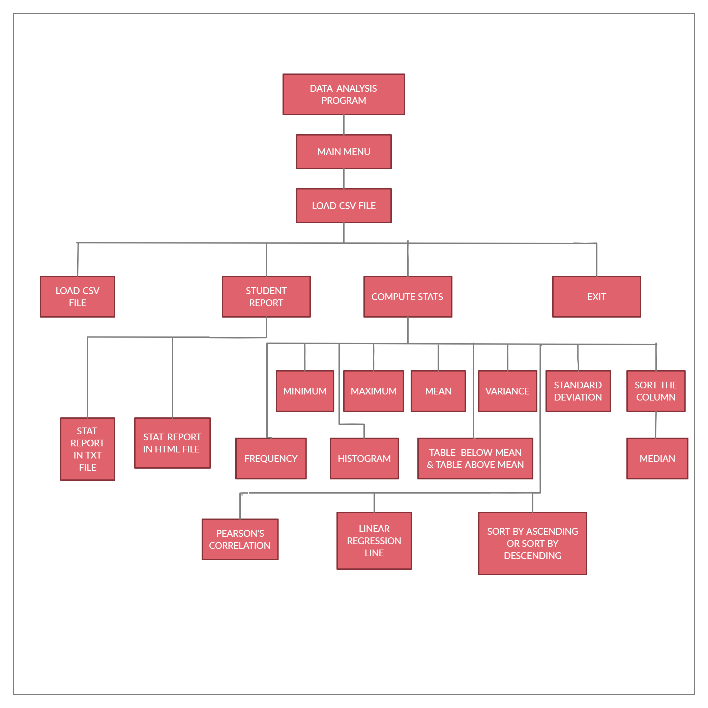

**Instructions on how to compile the program.**

The IDE that we used was the Code::Blocks IDE which supports compilers such as GNU GCC (MinGW) which was used to compile this program. Keep the source program ready, it is very easy to compile and run the C++ program. Assuming that you've installed GCC compiler, and you have cpp files that you want to compile, follow the following instructions to compile and run it.

Step 1 − Open the source code file in the Code::Blocks IDE.

Step 2 − While on the IDE window, click the build and run option on the top bar of your screen to

compile and execute the program.

Step 3 − The program will compile and run itself.

**Instructions on how to use your program. Some screenshots at the important screens will be very helpful.**

|  |  |
| --- | --- |
| 1. **Firstly the Main Menu will be displayed. The user must enter their respective number based on the order to go to that function. Let us say that the user picks Compute Stats by entering number 3.** | 1. **Once the user picks Compute Stats, the program will ask the user to choose a subject for the computations. Let’s say the user picks Mathematics.** |
|  |  |
| 1. **The program will now show all the 12 Calculations where the user can choose any of it to know the value of each computation. Let us say that the user has picked frequency by entering digit 7.** | 1. **This is the data for frequency where the mark is on the left and the frequency occurred is at its right.** |
|  |  |
| 1. **Once the calculation has been provided it will bring the user back to the Stats Menu. Let’s say the user decided to exit by entering 14.** | 1. **The End.** |
|  |  |

**Section 7: Sample input files and outputs generated (screenshots for all function inputs and outputs with step by step results)**

Function name: **title**

Input:

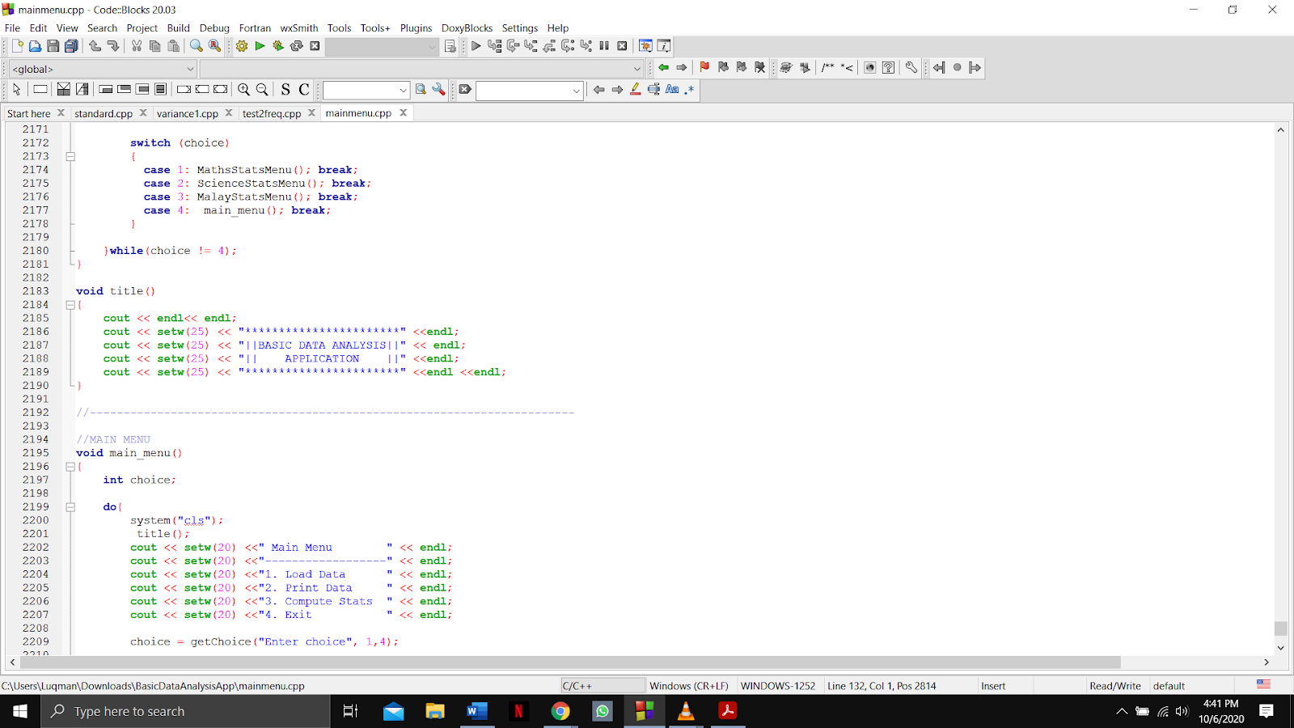

Output:

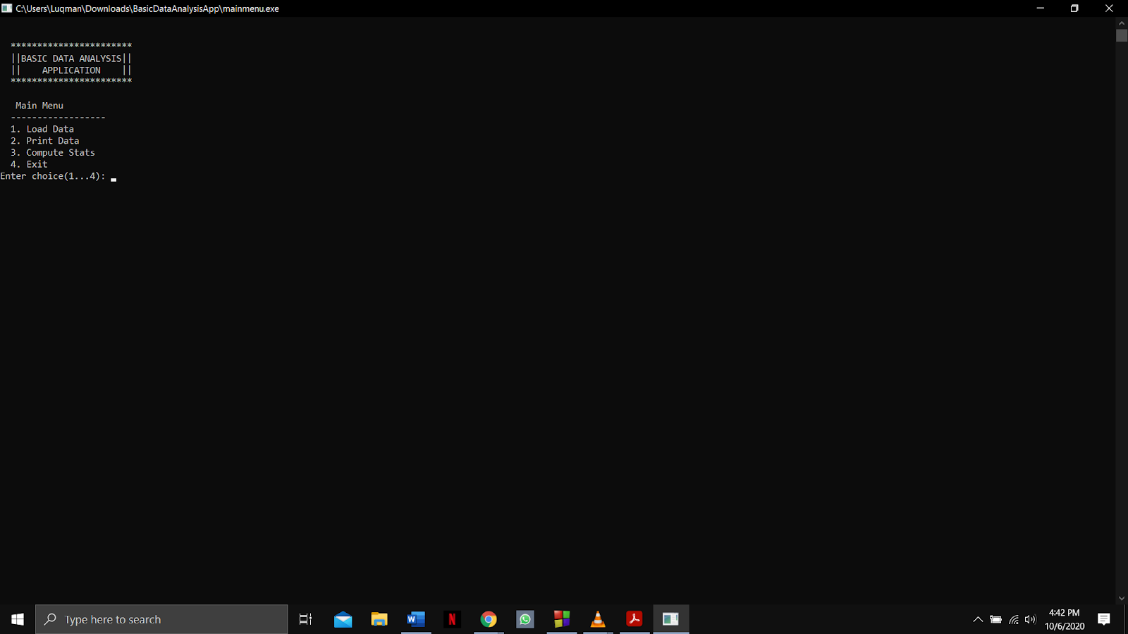

Function name: **main, main_menu and getChoice**

Input:

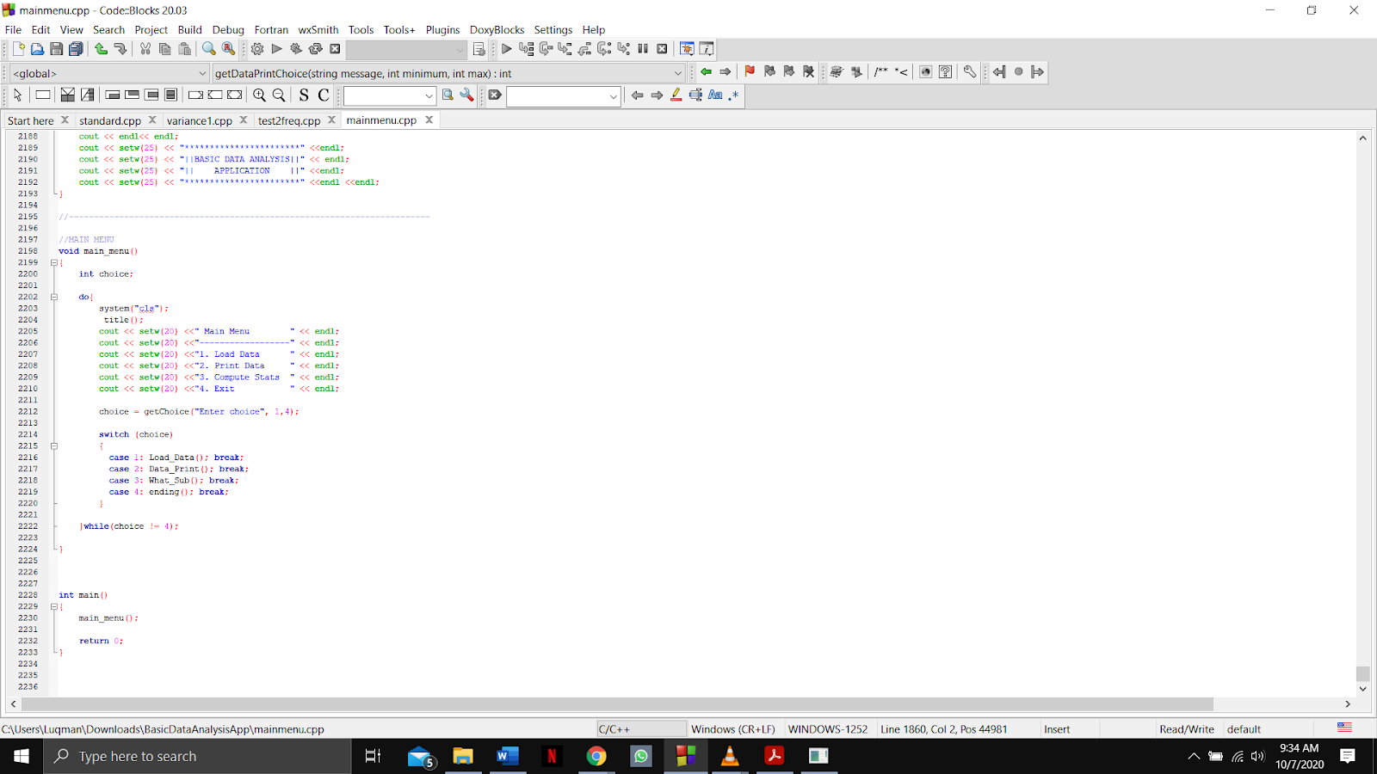

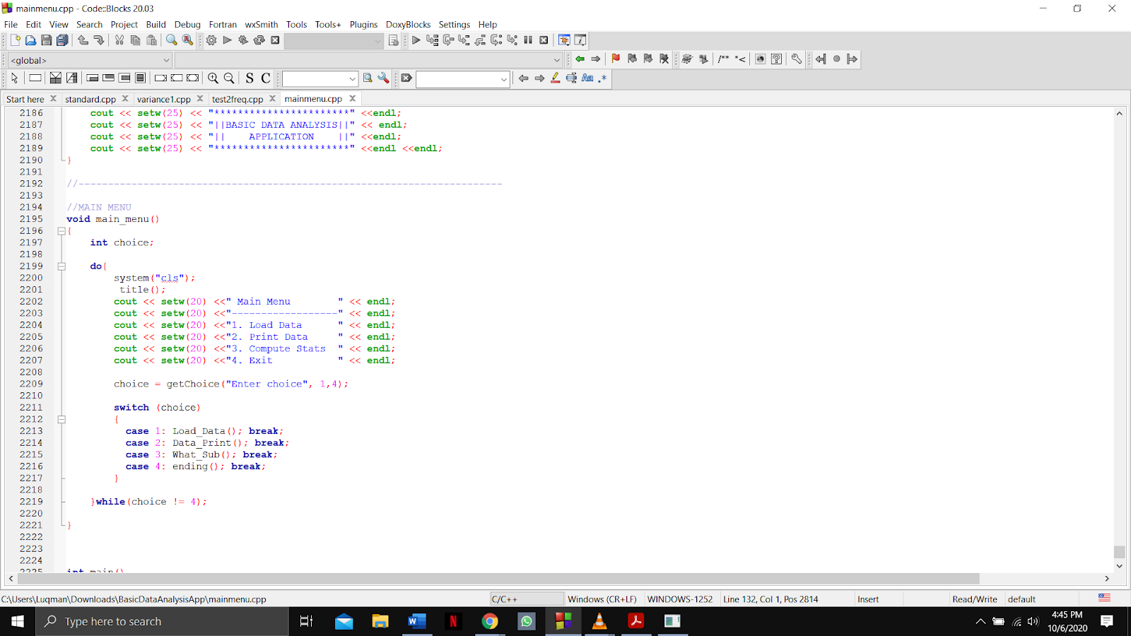

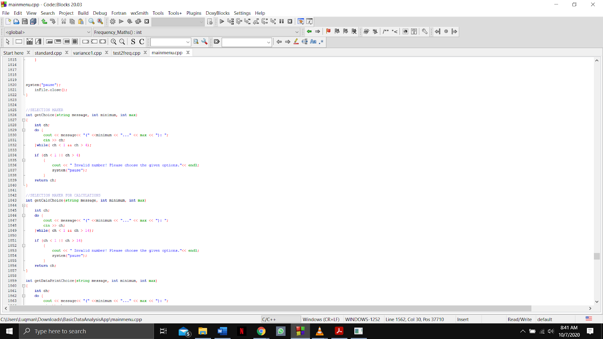

Output:

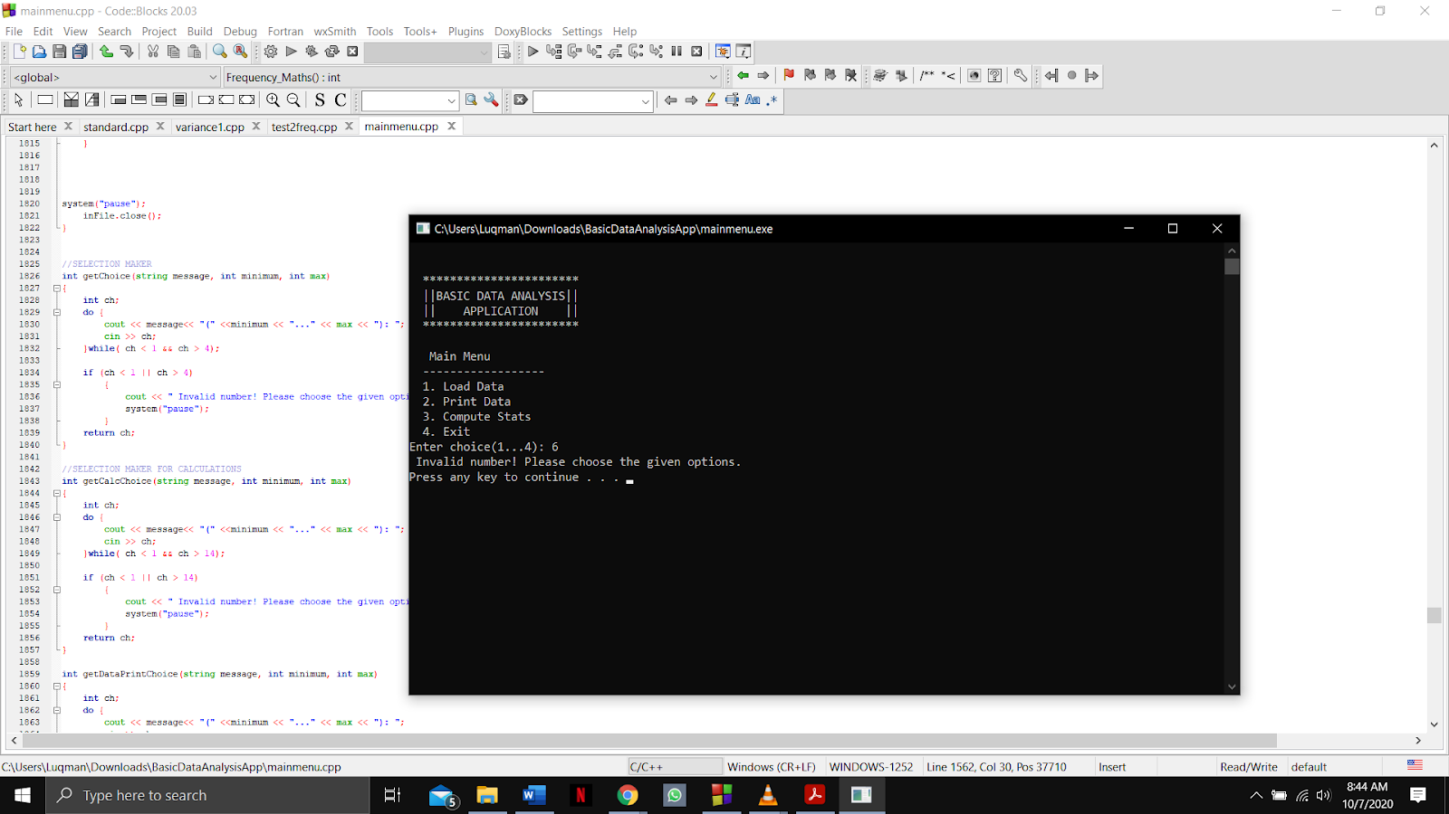

Function name: **What_sub and getChoice**

Input:

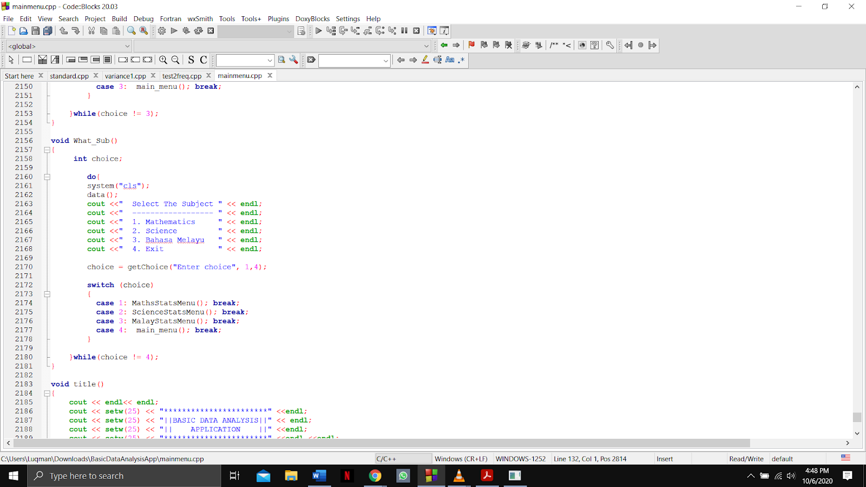



Output:

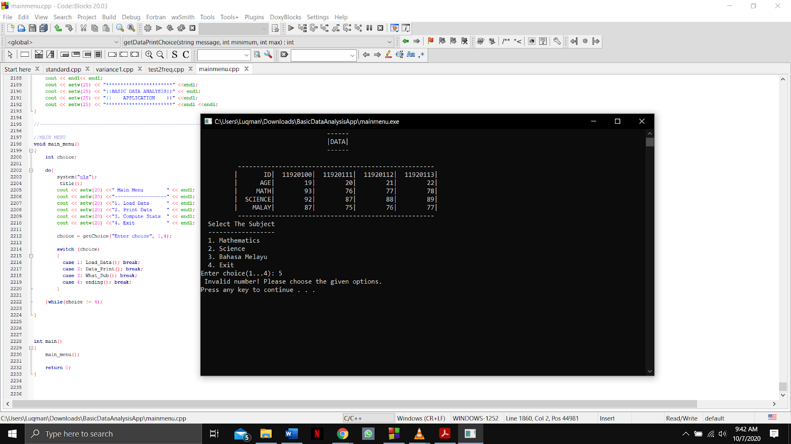

Function name: **Data_print and getDataPrintChoice**

Input: 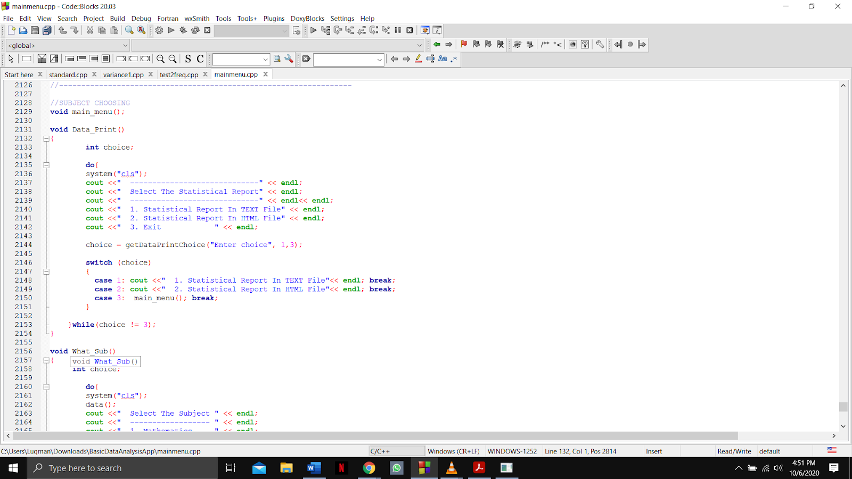

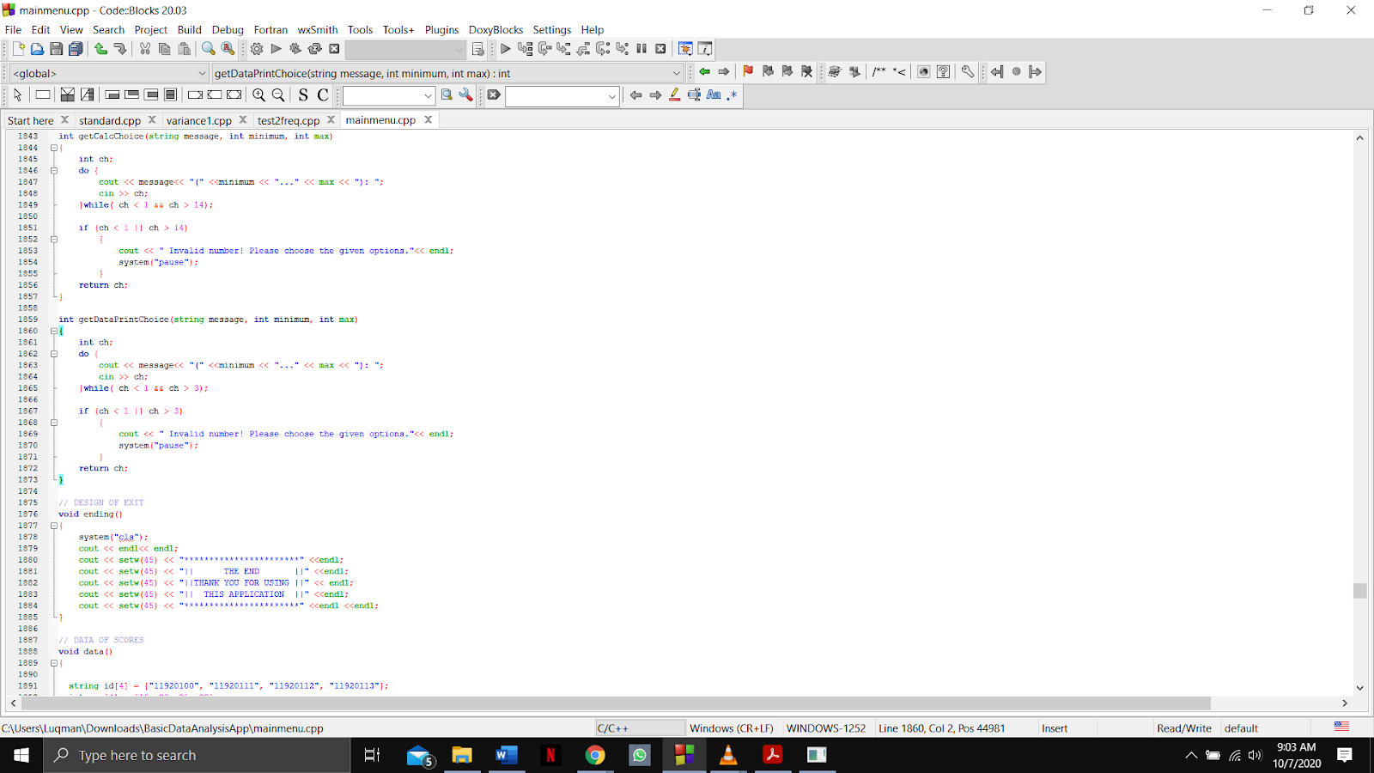

Output:

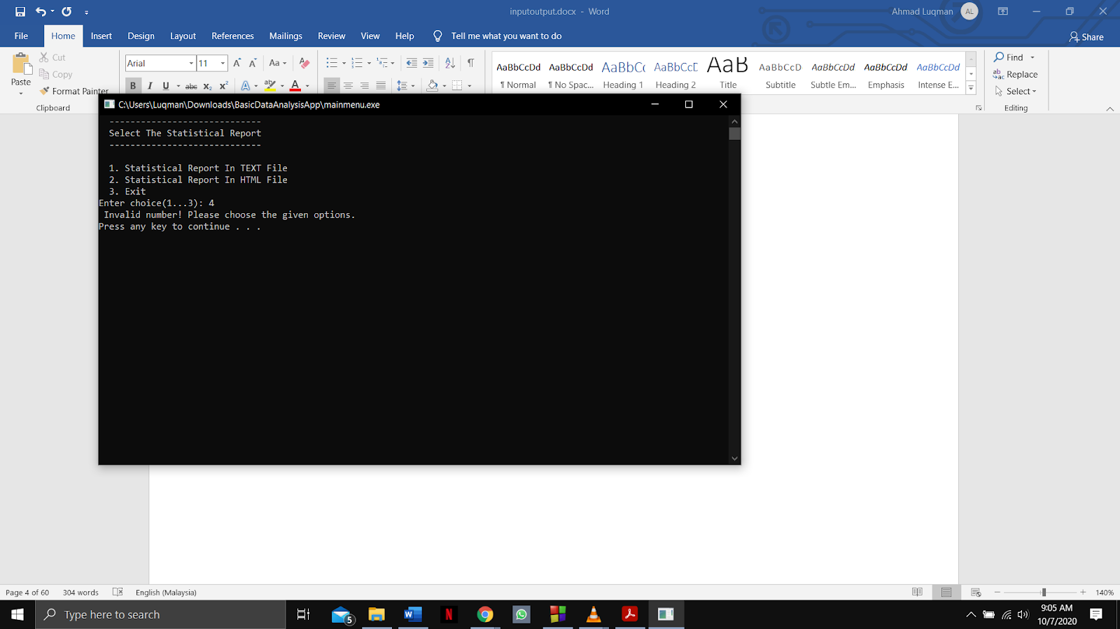

Function name: **Load_Data**

Input: 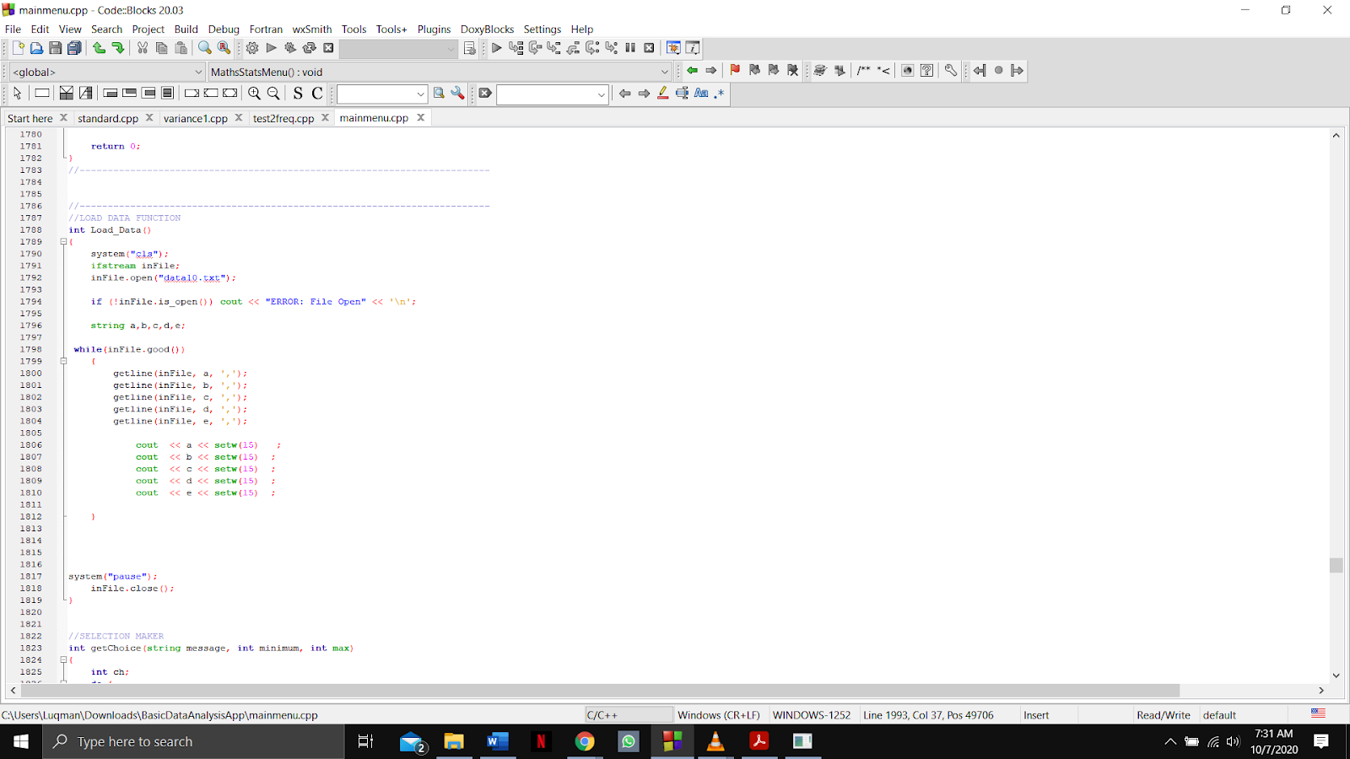

Output:

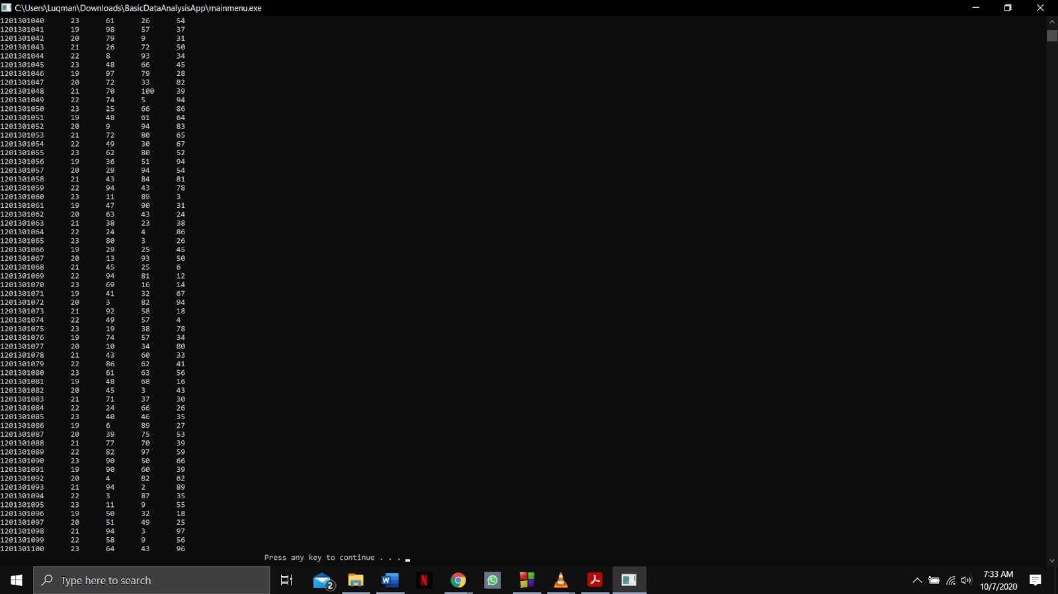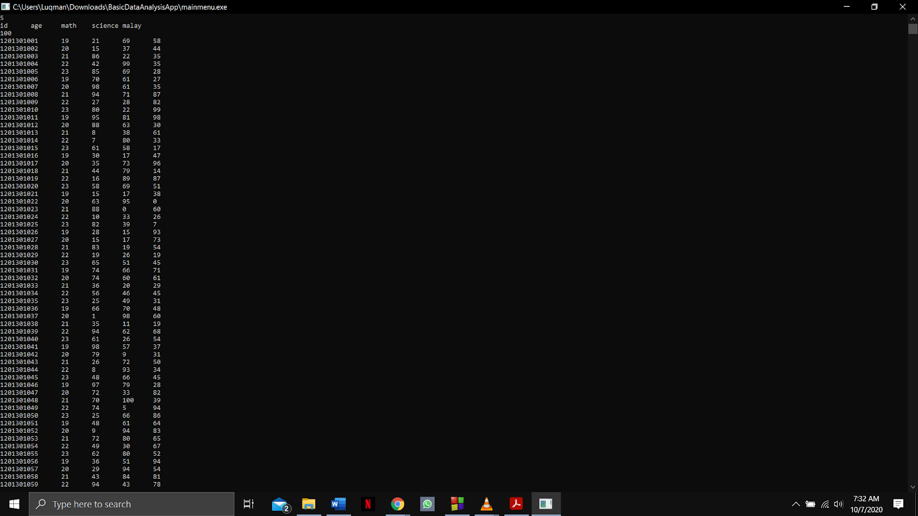

Function name: **MathsStatsMenu and getCalcChoice**

Input: 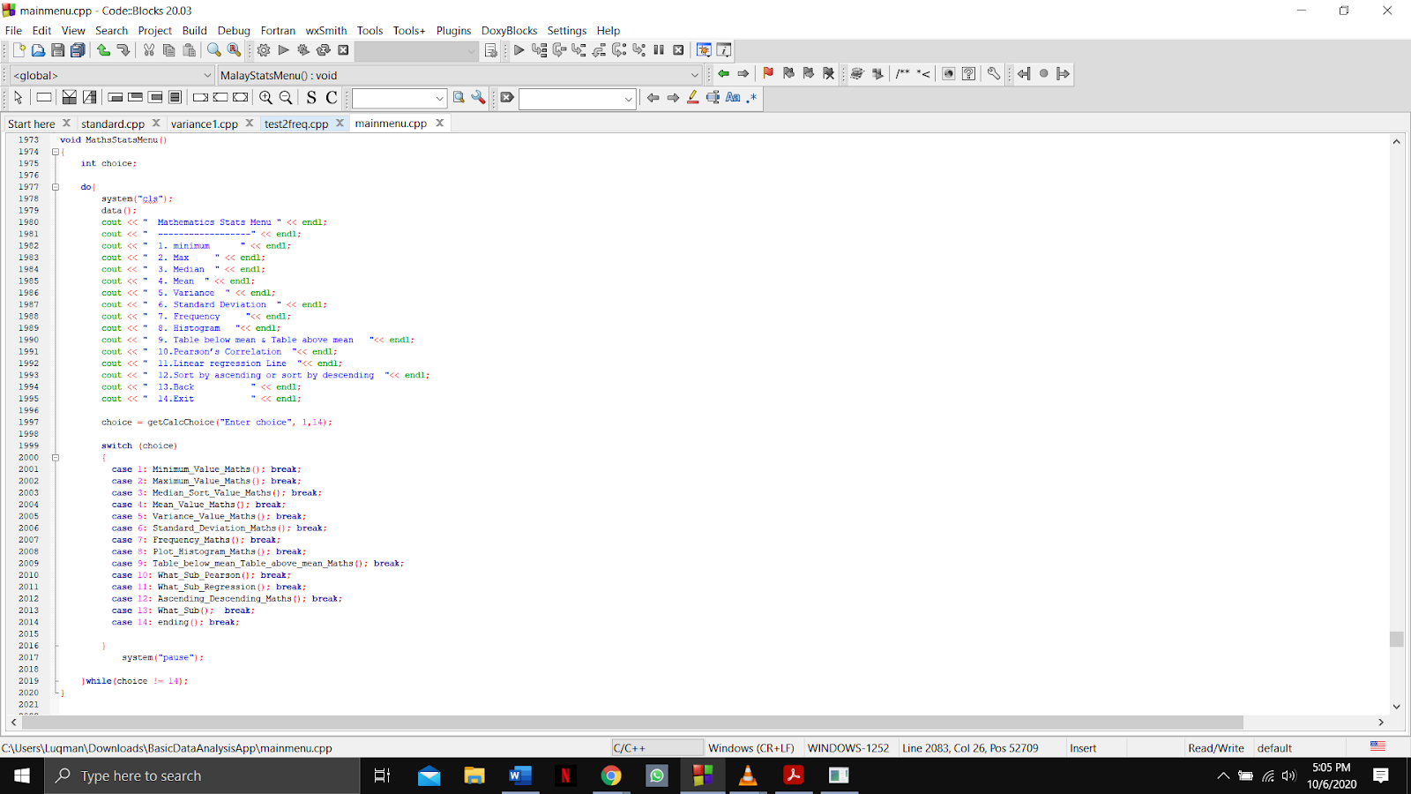

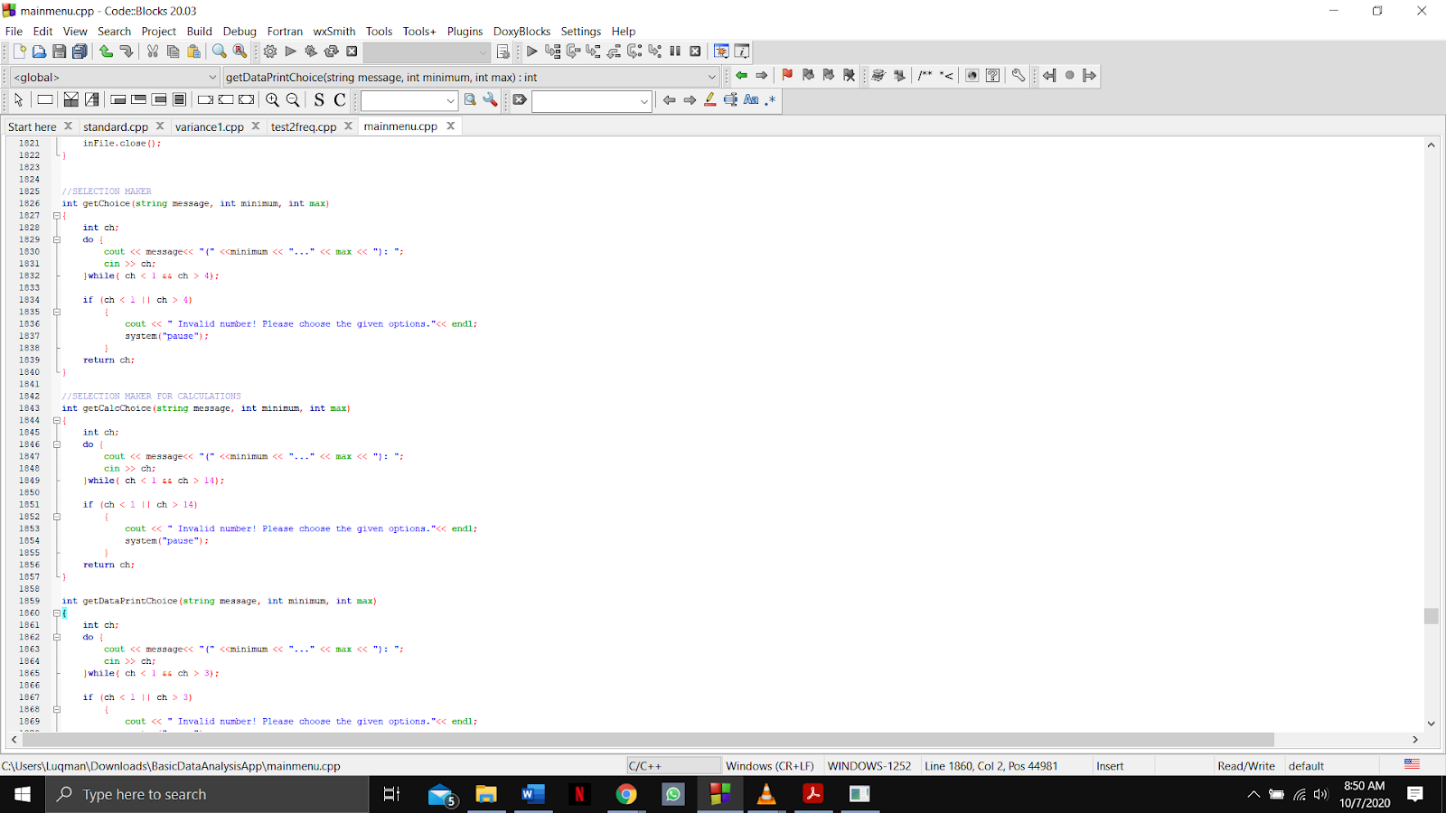

Output:

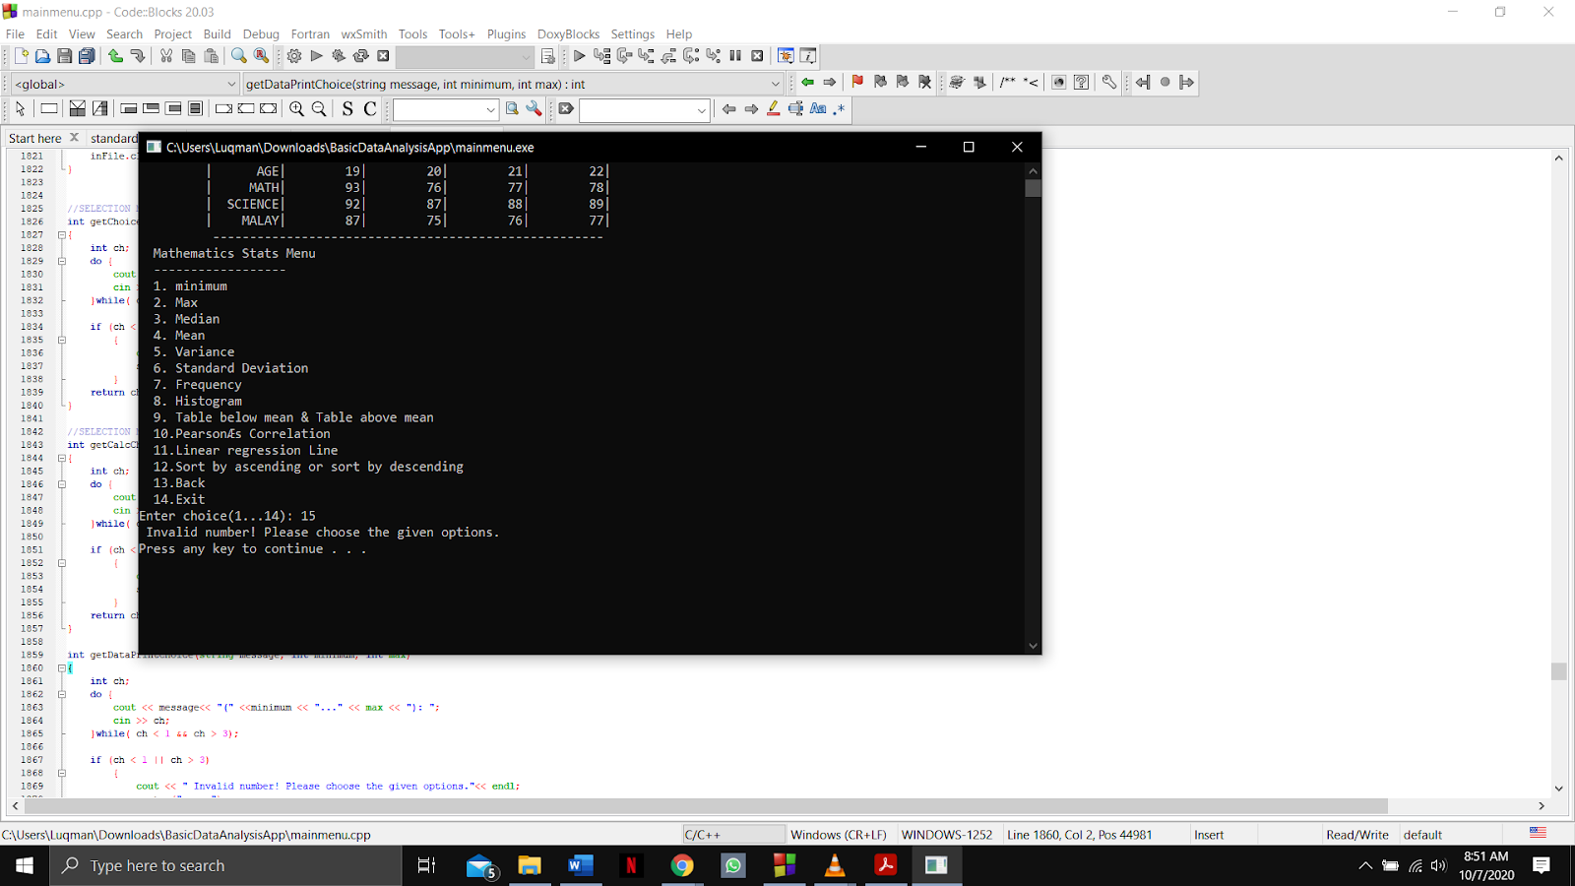

Function name: **mean, distinctmean and Table_below_mean_Table_above_mean_Maths**

Input:

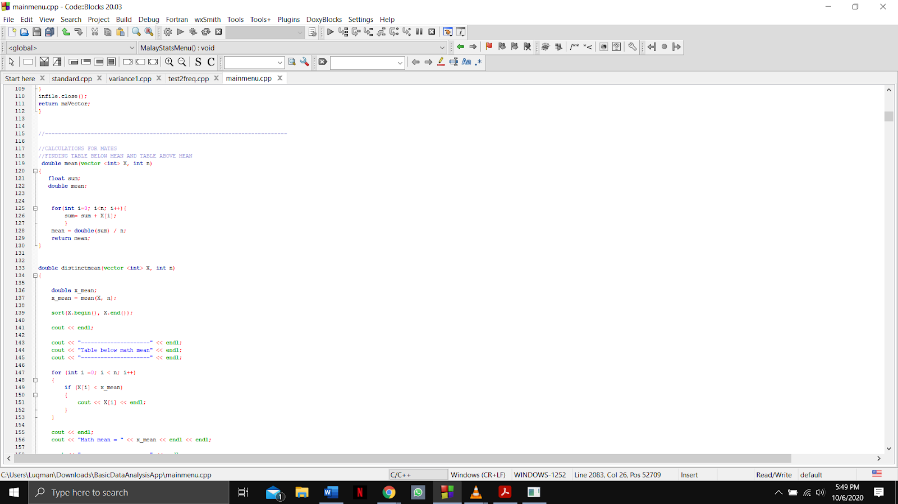

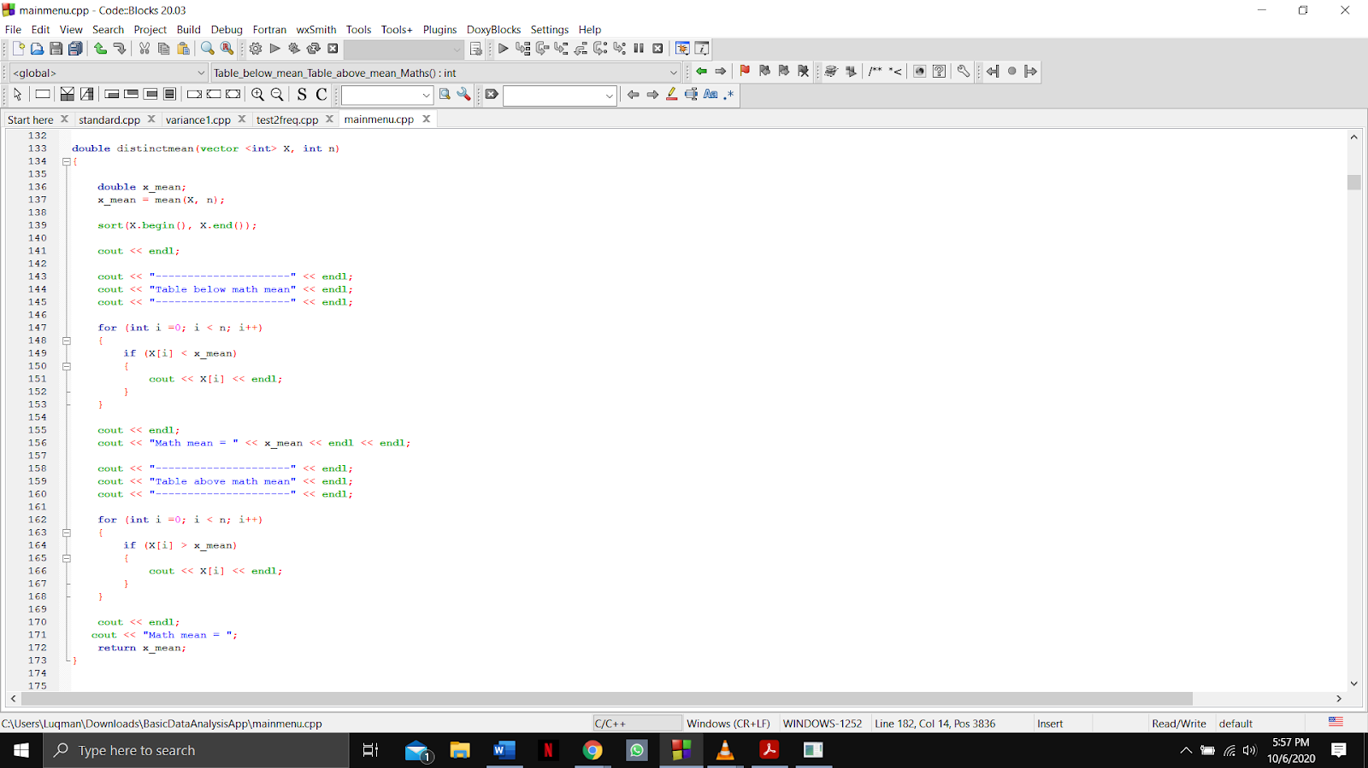

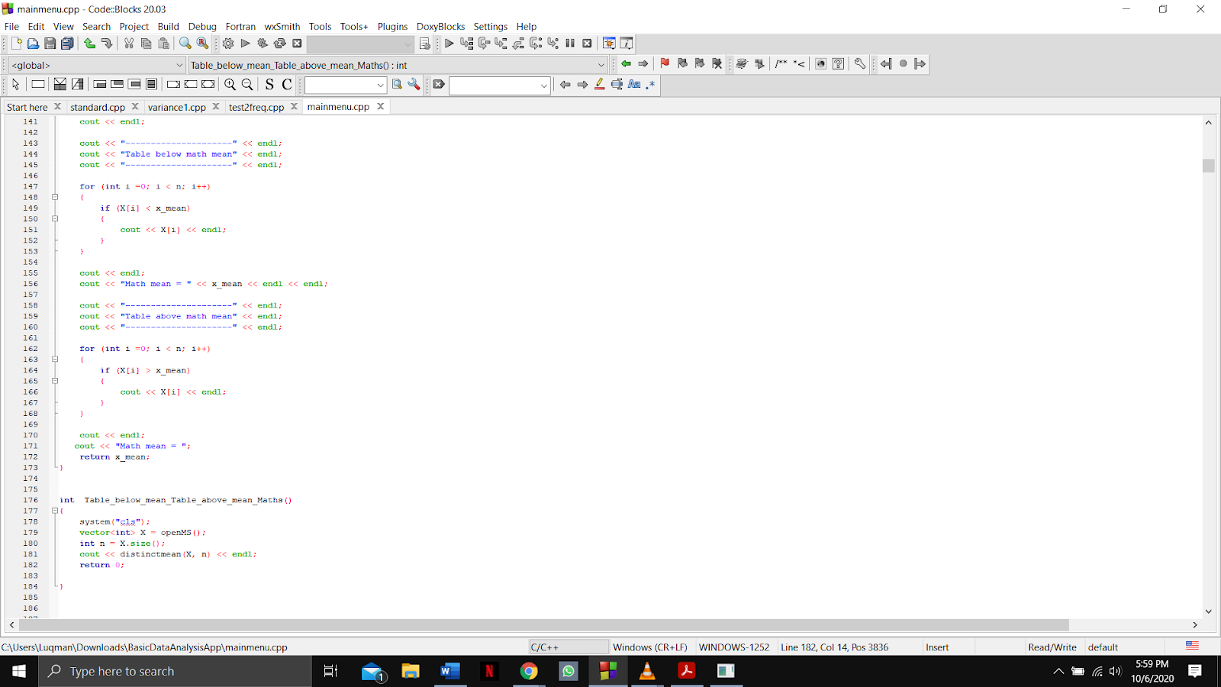

Output:

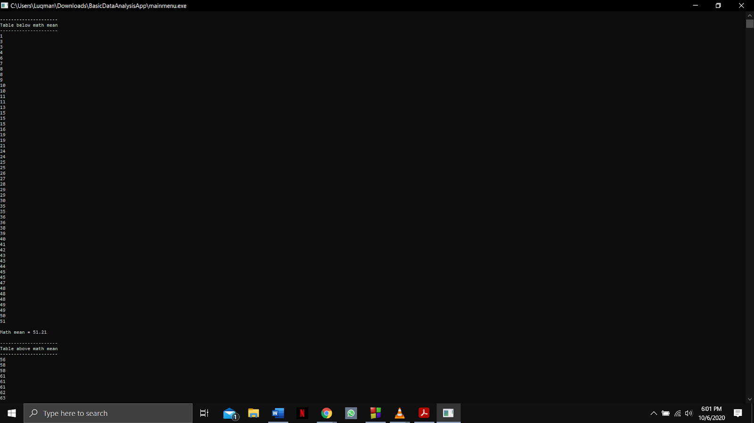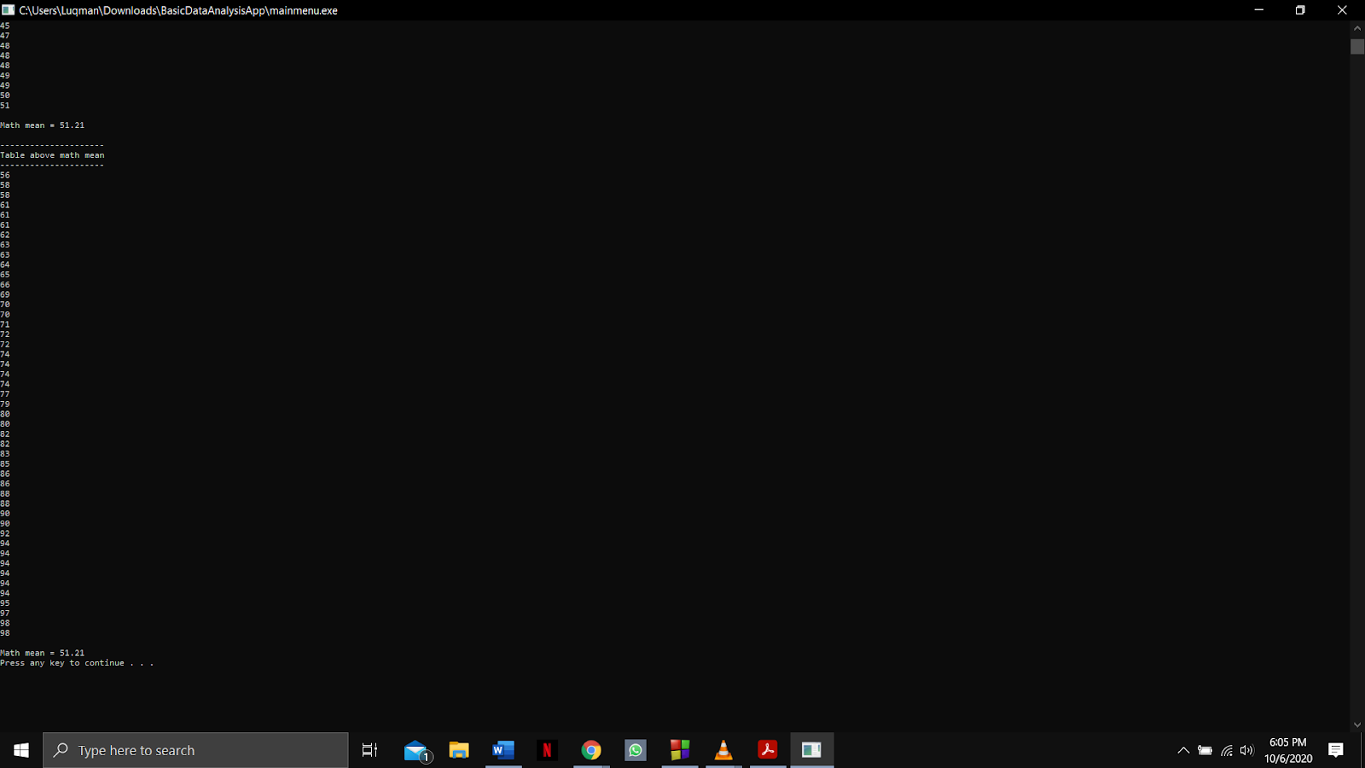

Function name: **variance and Variance_Value_Maths**

Input:

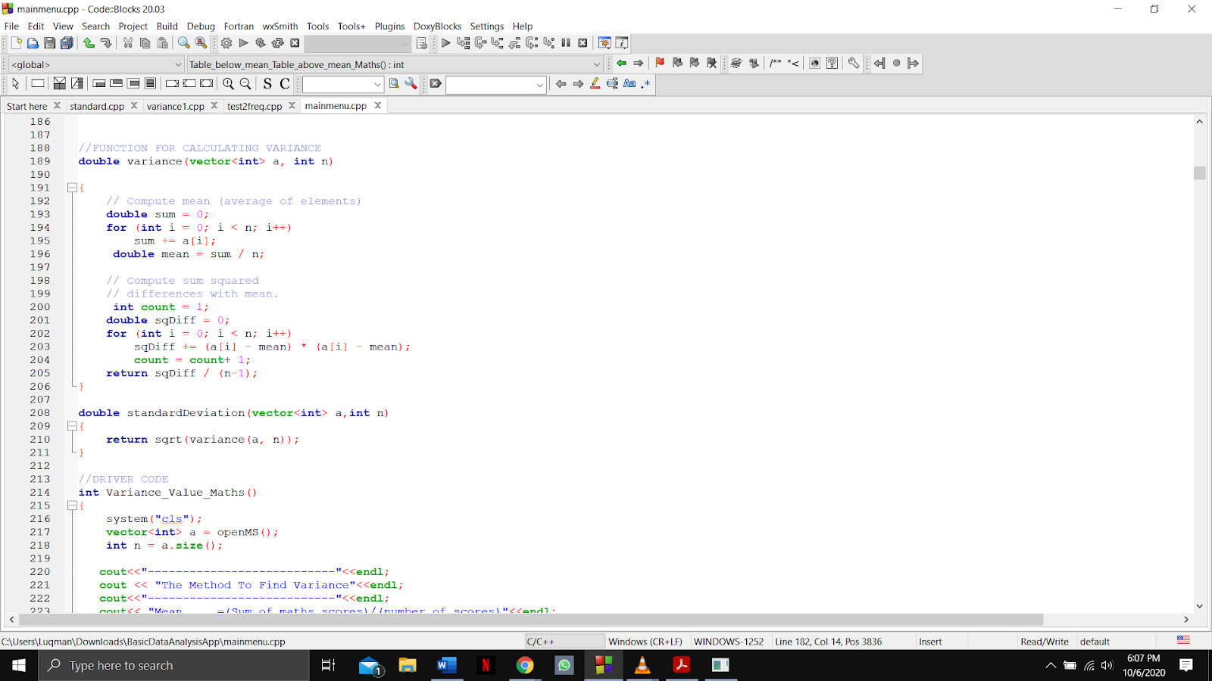

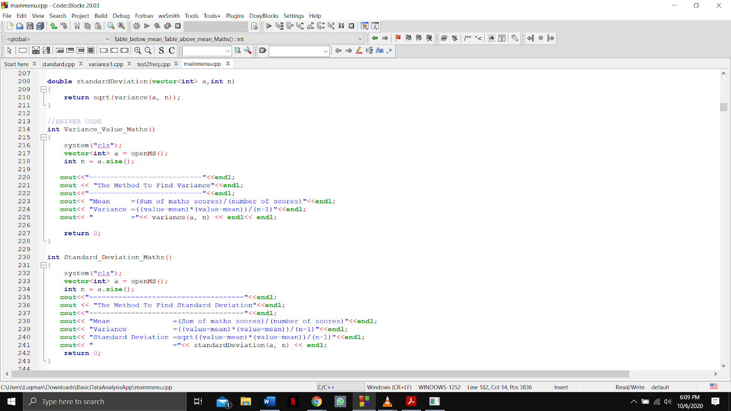

Output:

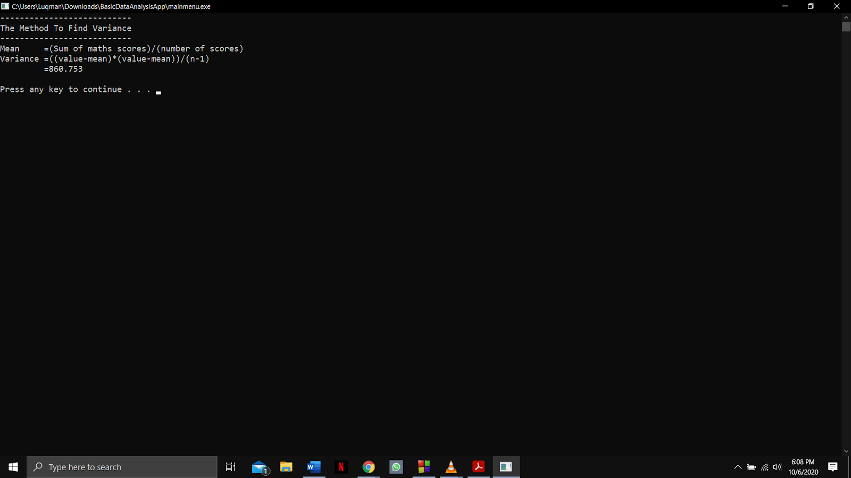

Function name: **standardDeviation and Standard_Deviation_Maths**

Input:

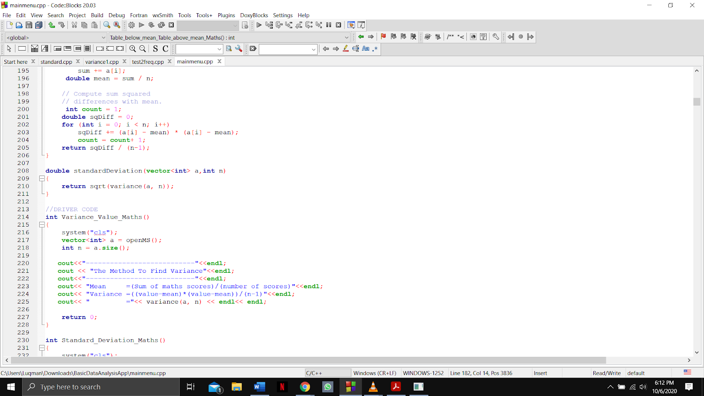

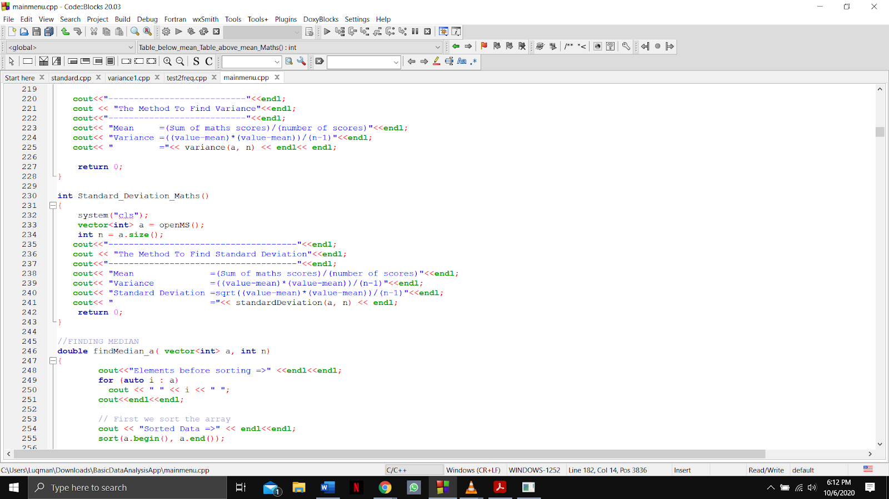

Output:

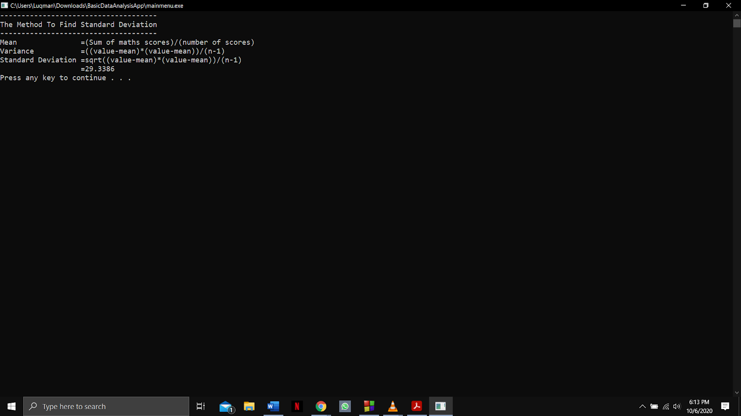

Function name: **findMedian_a and Median_Sort_Value_Maths**

Input: 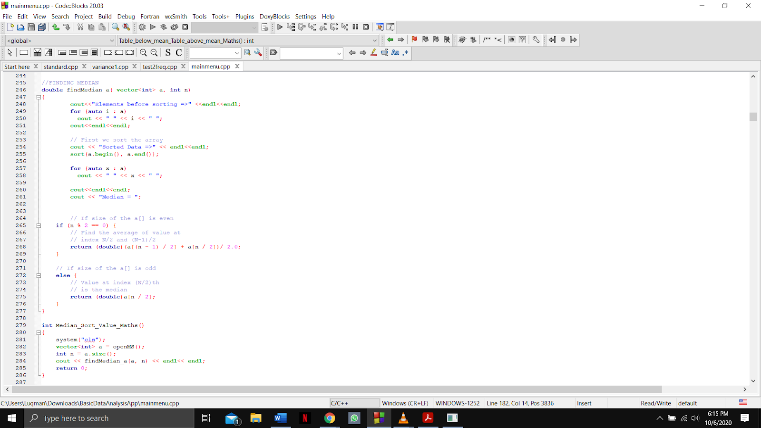

Output:

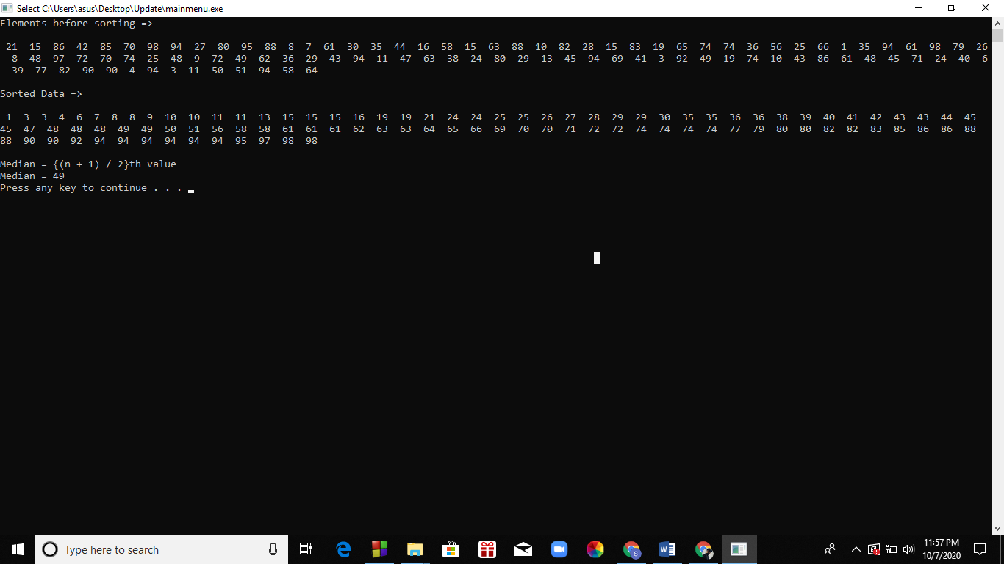

Function name: **findAverage_a and Mean_Value_Maths**

Input:

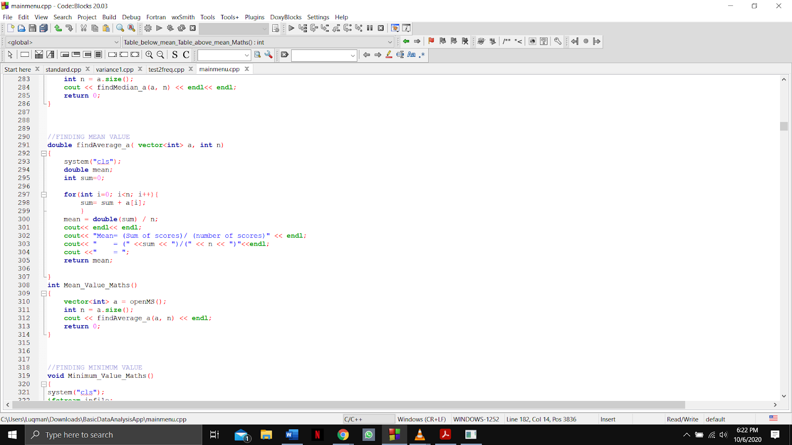

Output:

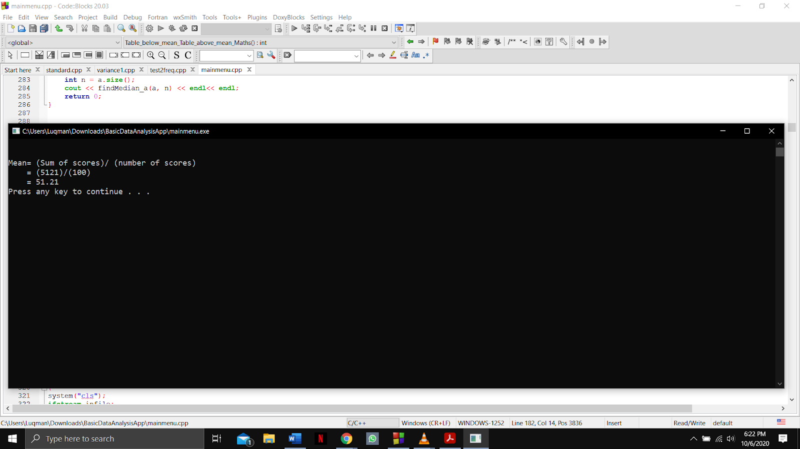

Function name: **Minimum_Value_Maths**

Input:

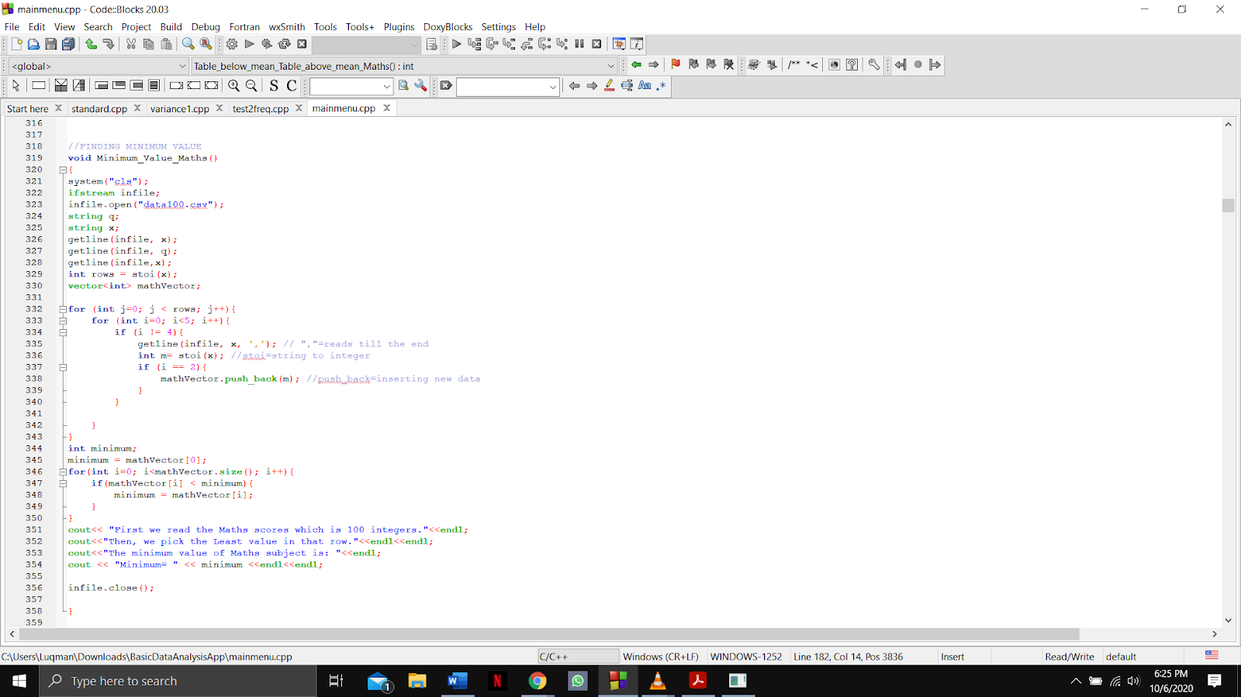

Output:

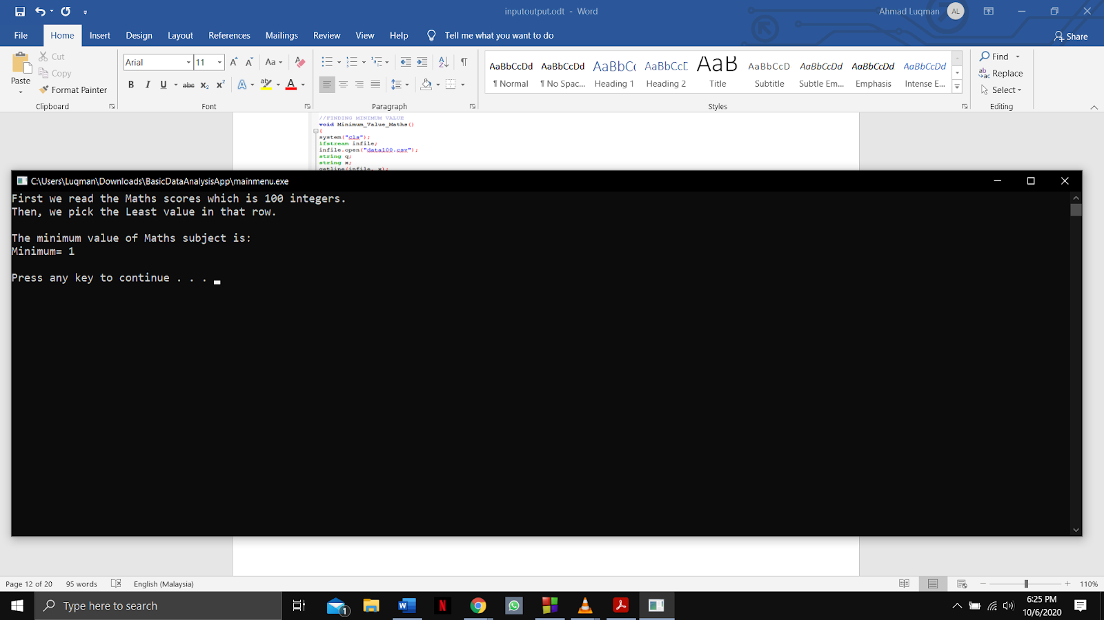

Function name: **Maximum_Value_Maths**

Input:

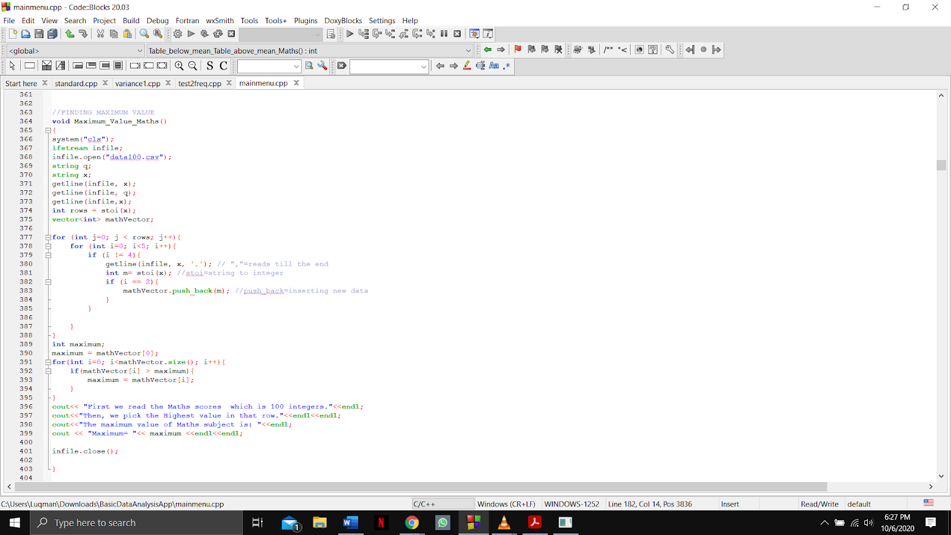

Output:

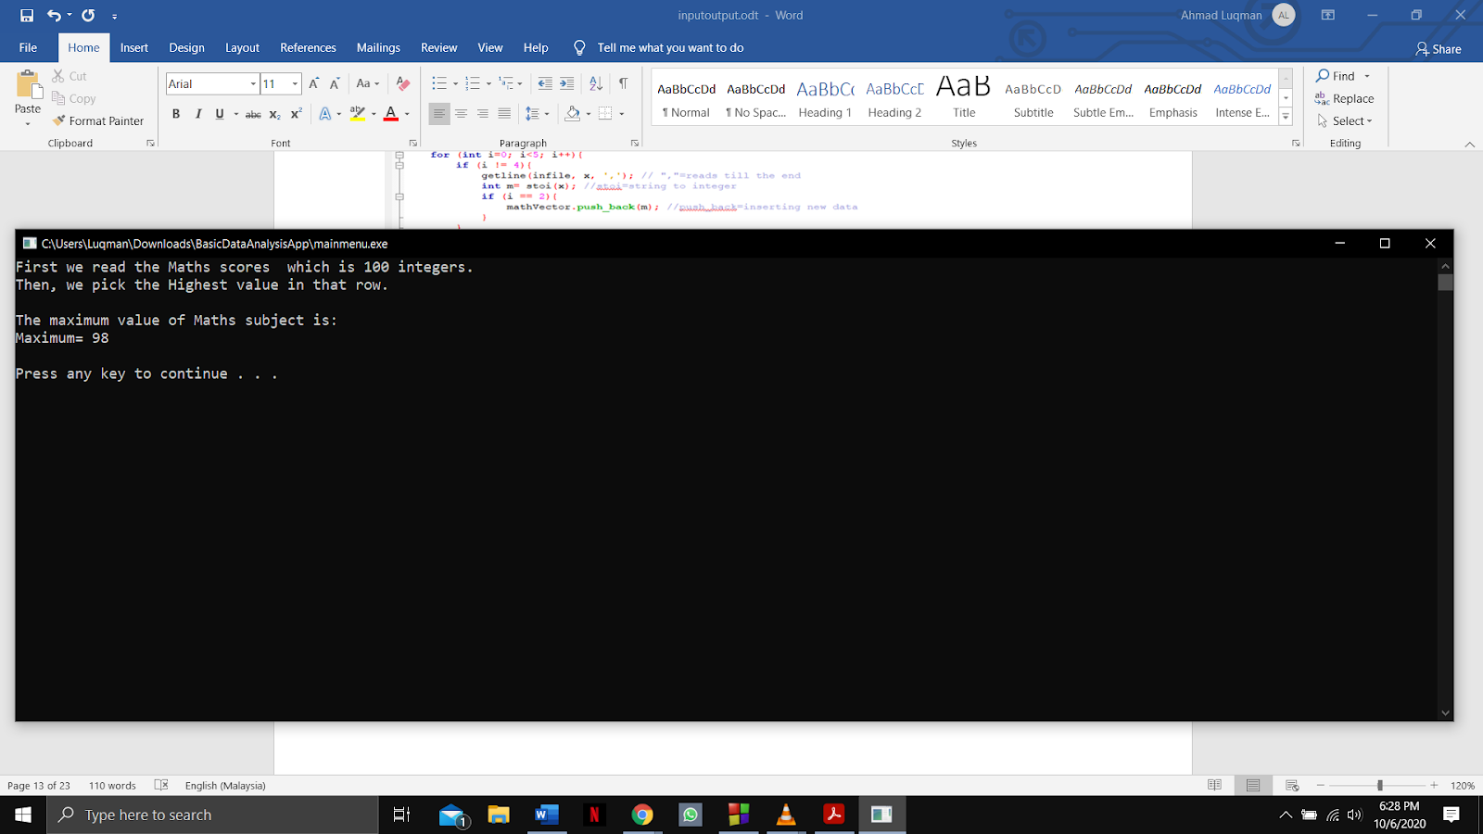

Function name: **Frequency_Maths**

Input:

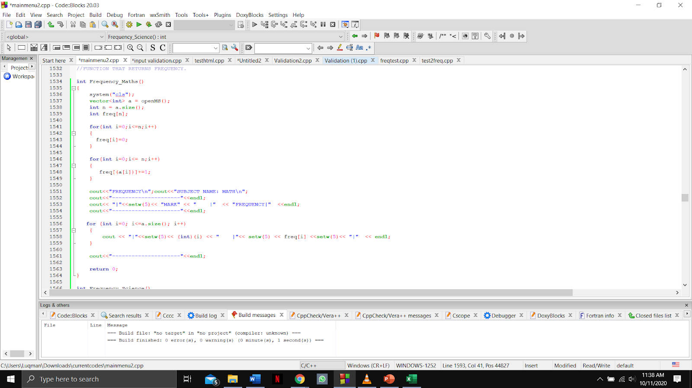

Output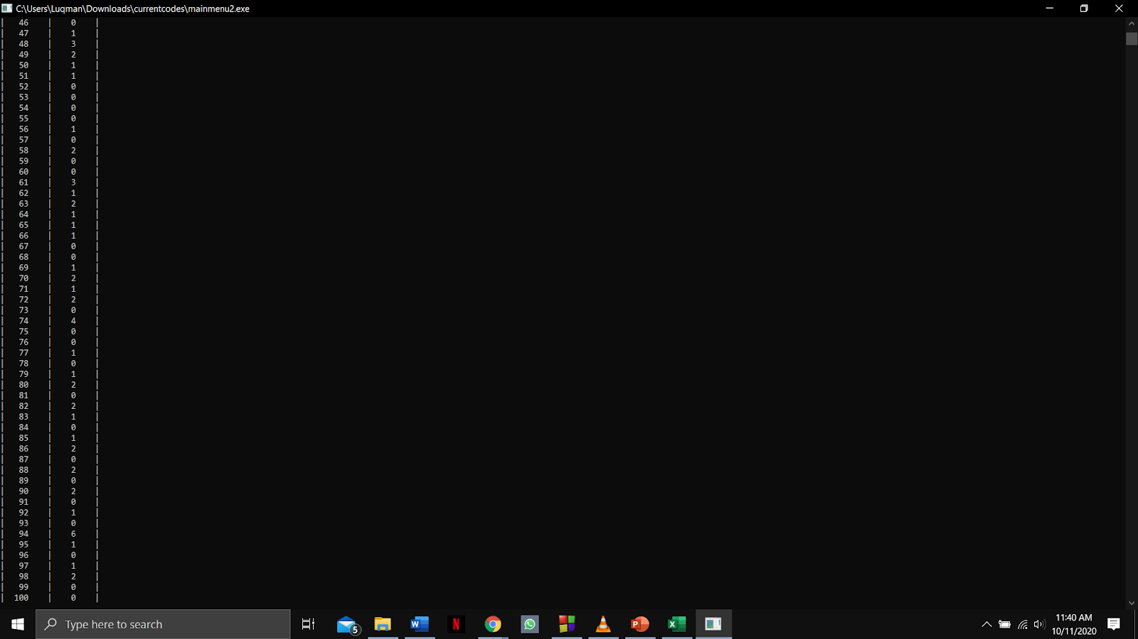

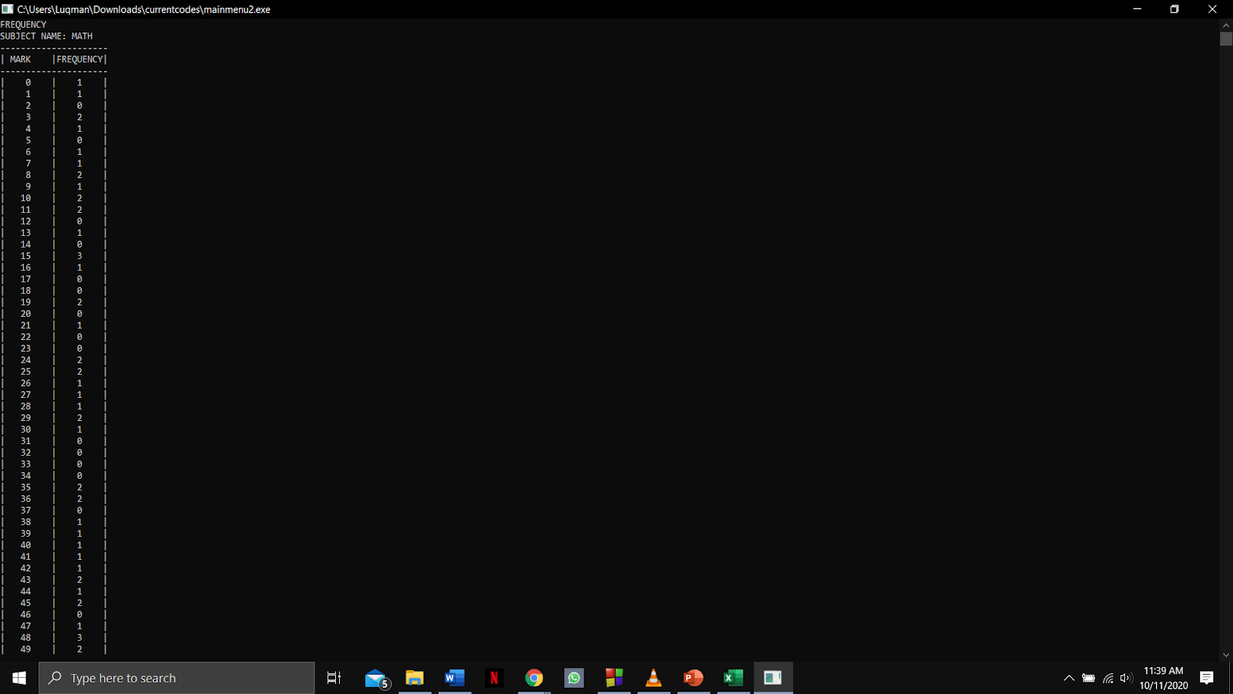

Function name: **findmaxFirst, histogramfreq and Plot_Histogram_Maths**

Input:

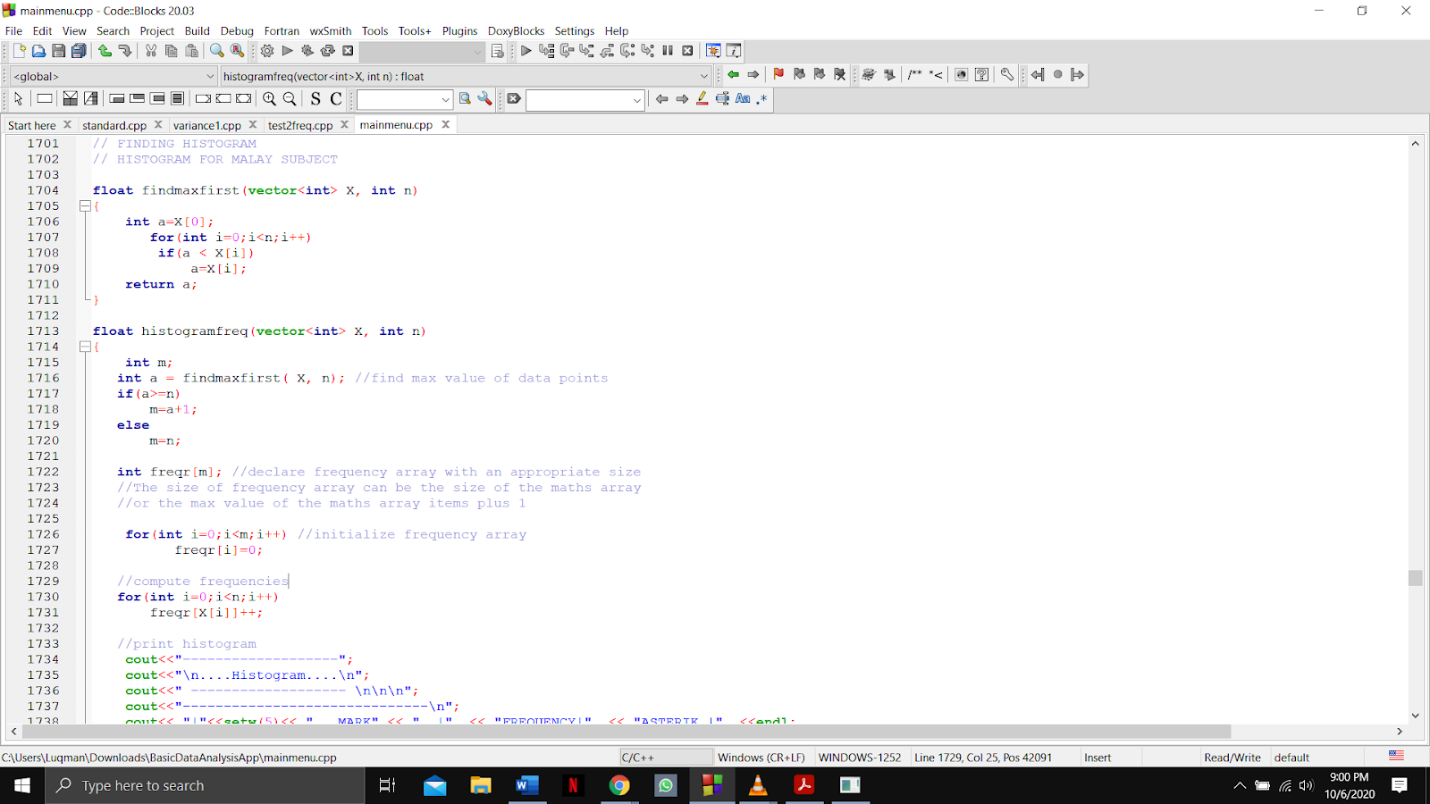

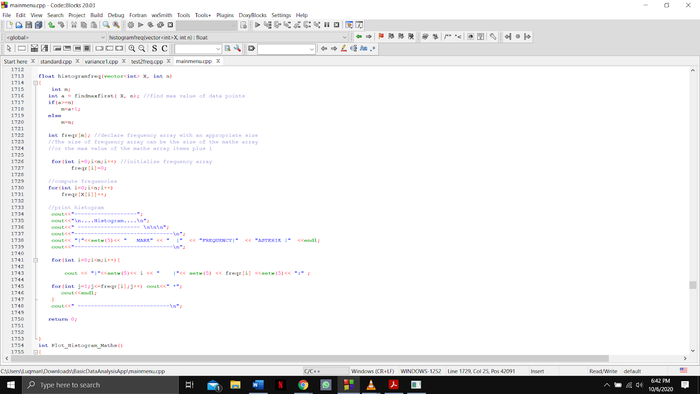

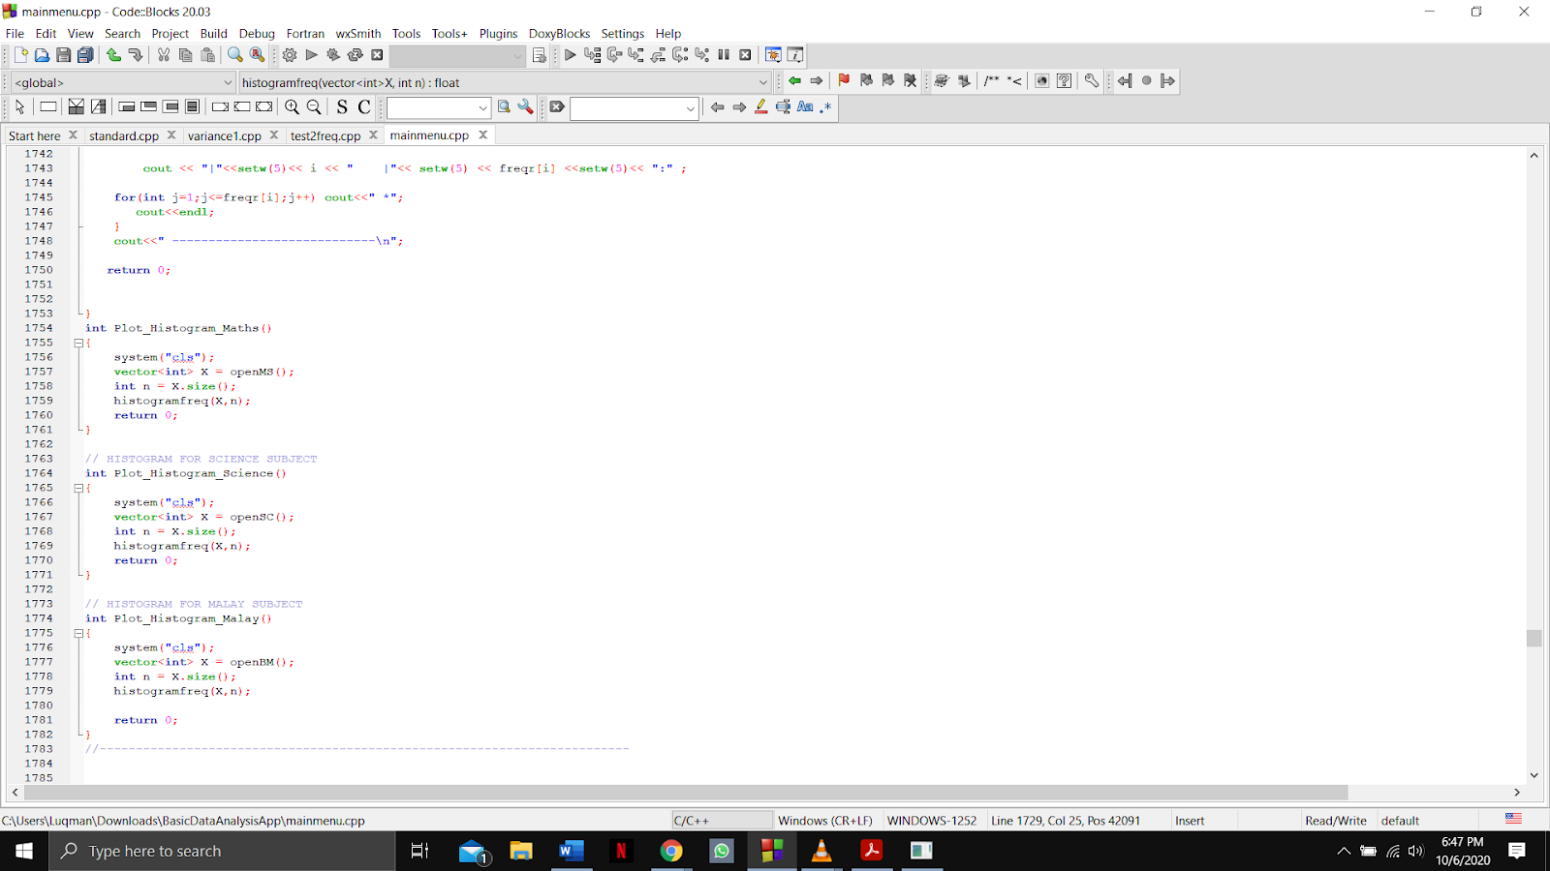

Output:

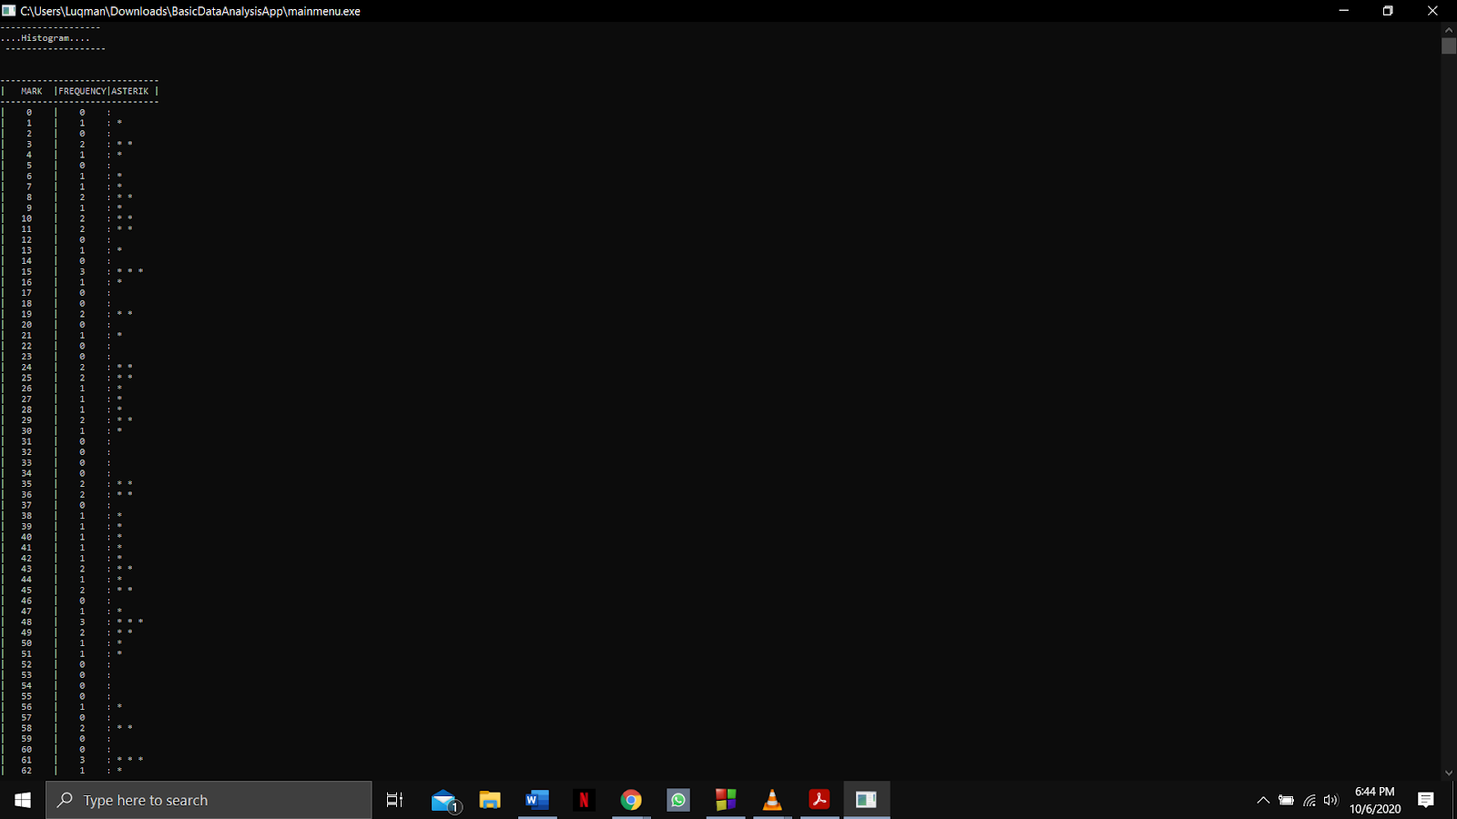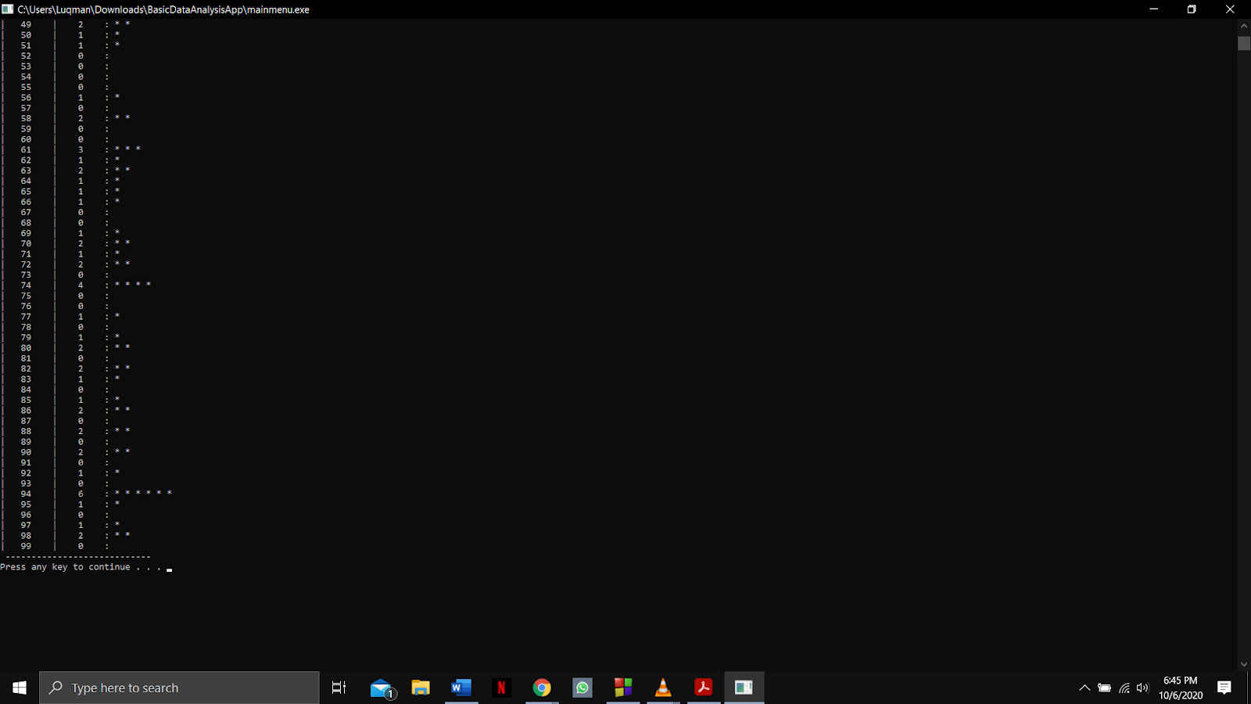

Function name: **ascending, descending and Ascending_Descending_Maths**

Input:

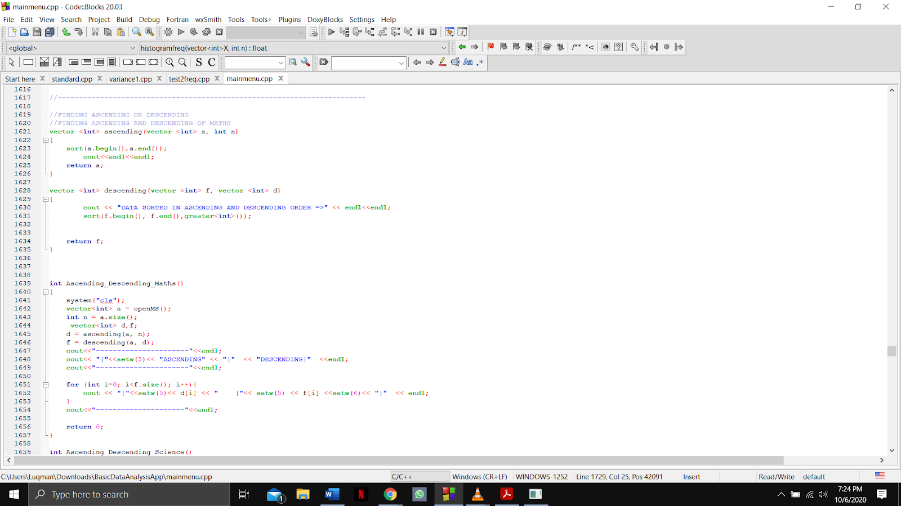

Output:

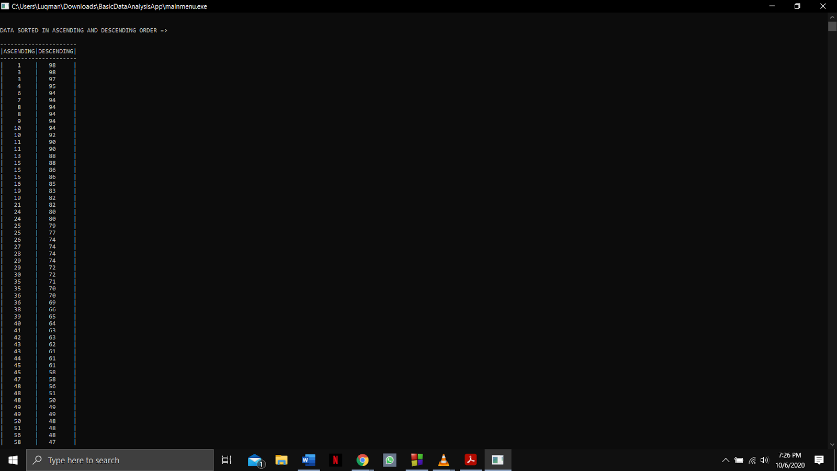

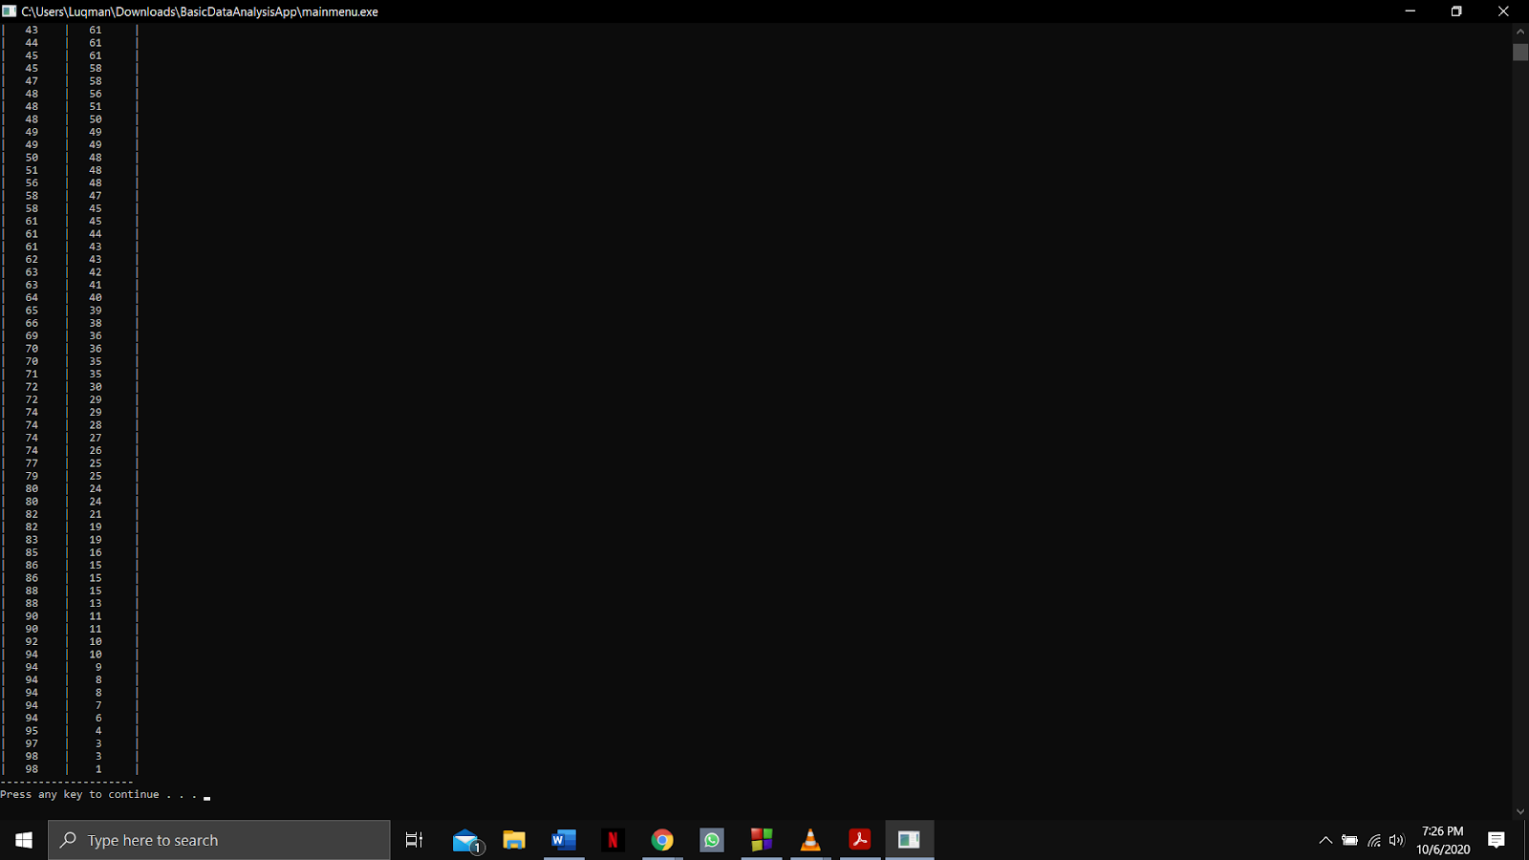

Function name: **ScienceStatsMenu and getCalcChoice**

Input:

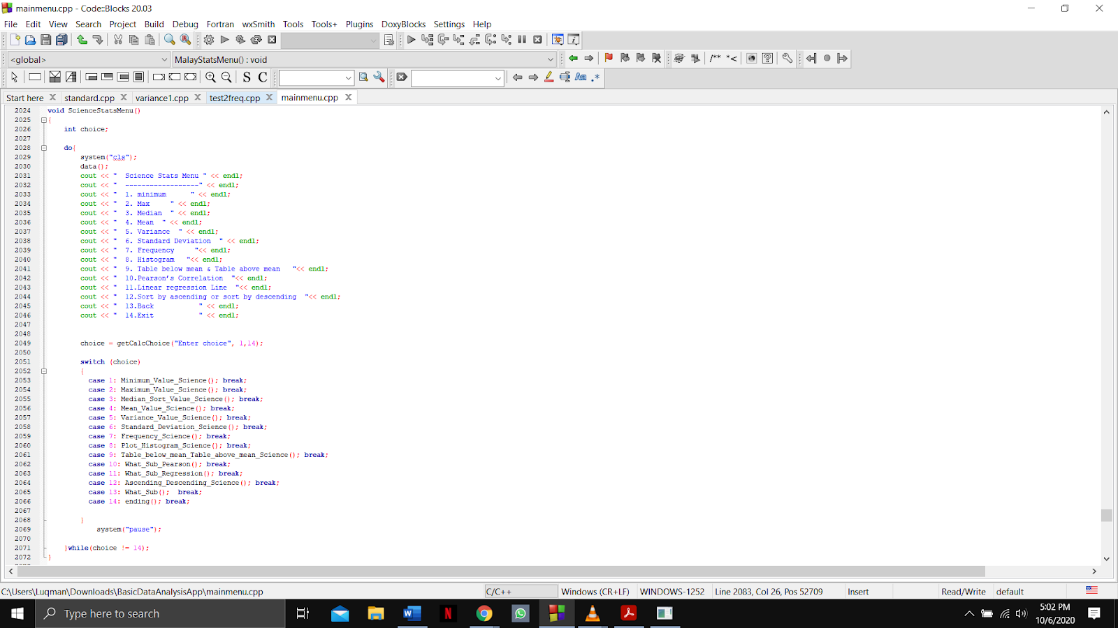



Output:

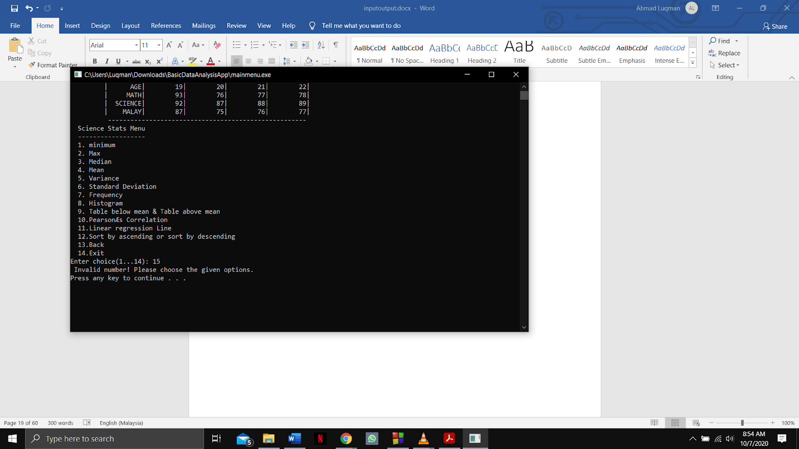

Function name: **mean2, distinctmean2 and Table_below_mean_Table_above_mean_Science**

Input:

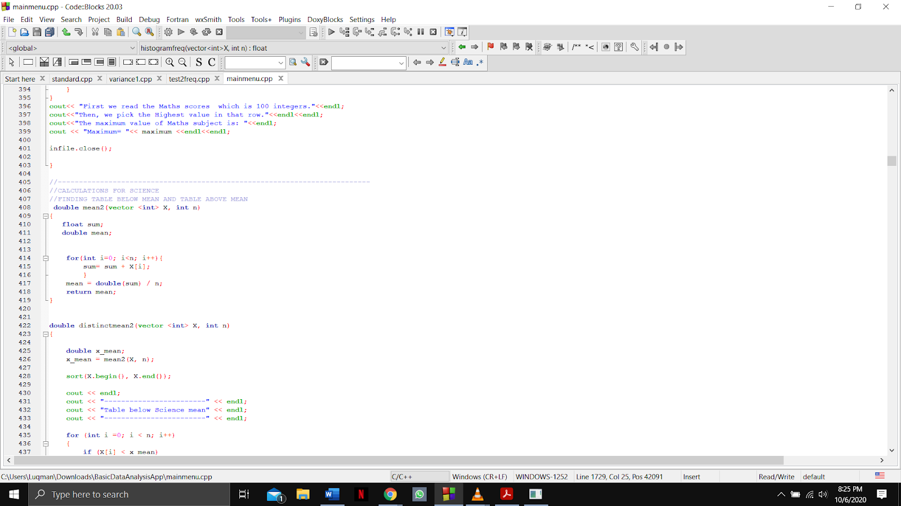

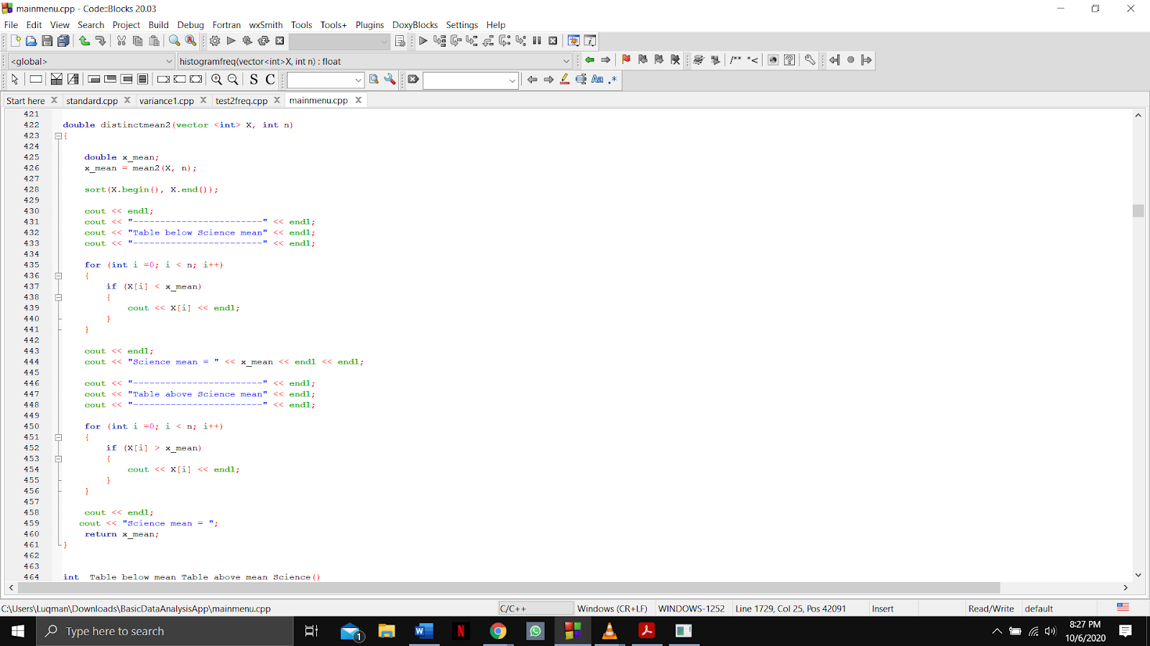

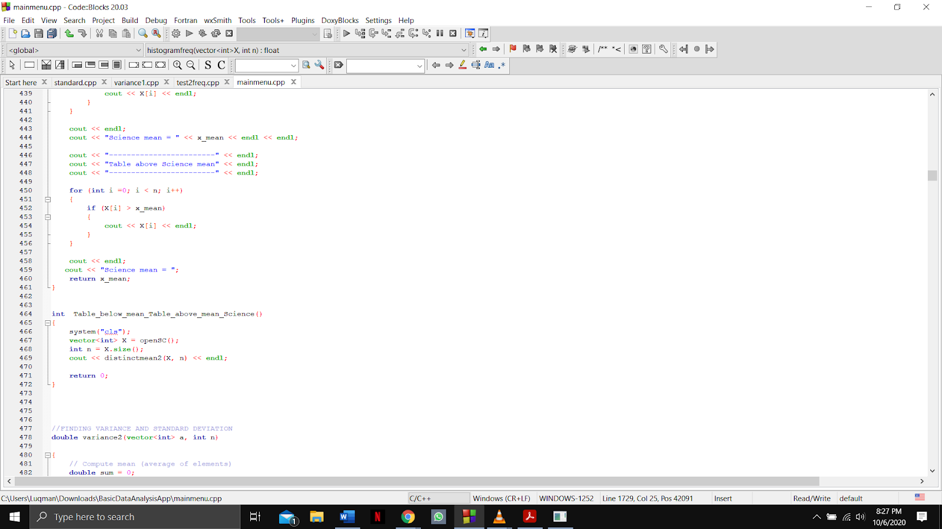

Output:

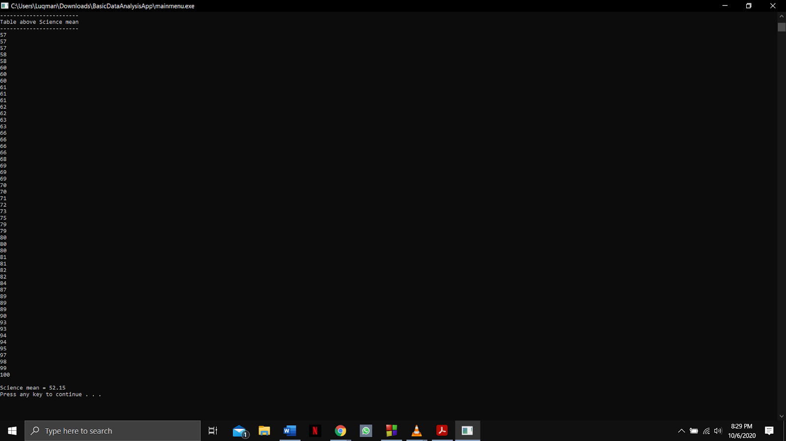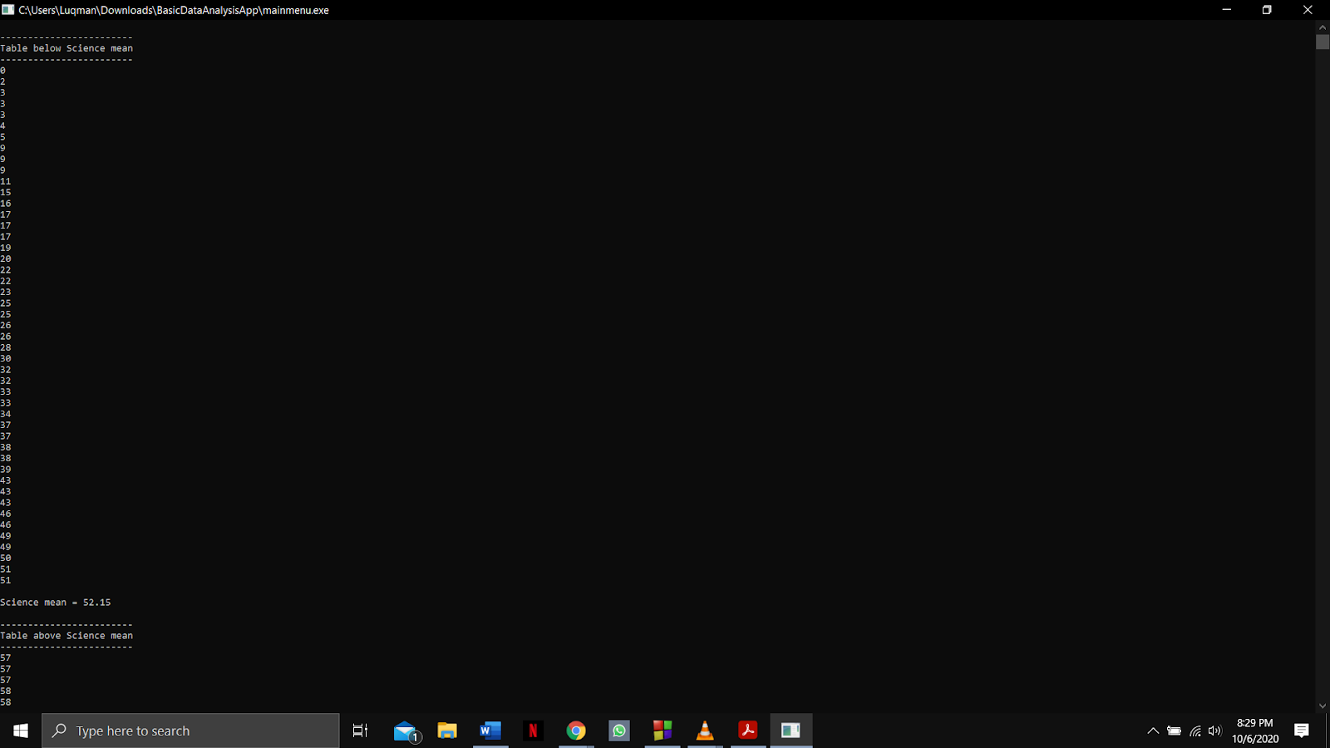

Function name: **variance2 and Variance_Value_Science**

Input:

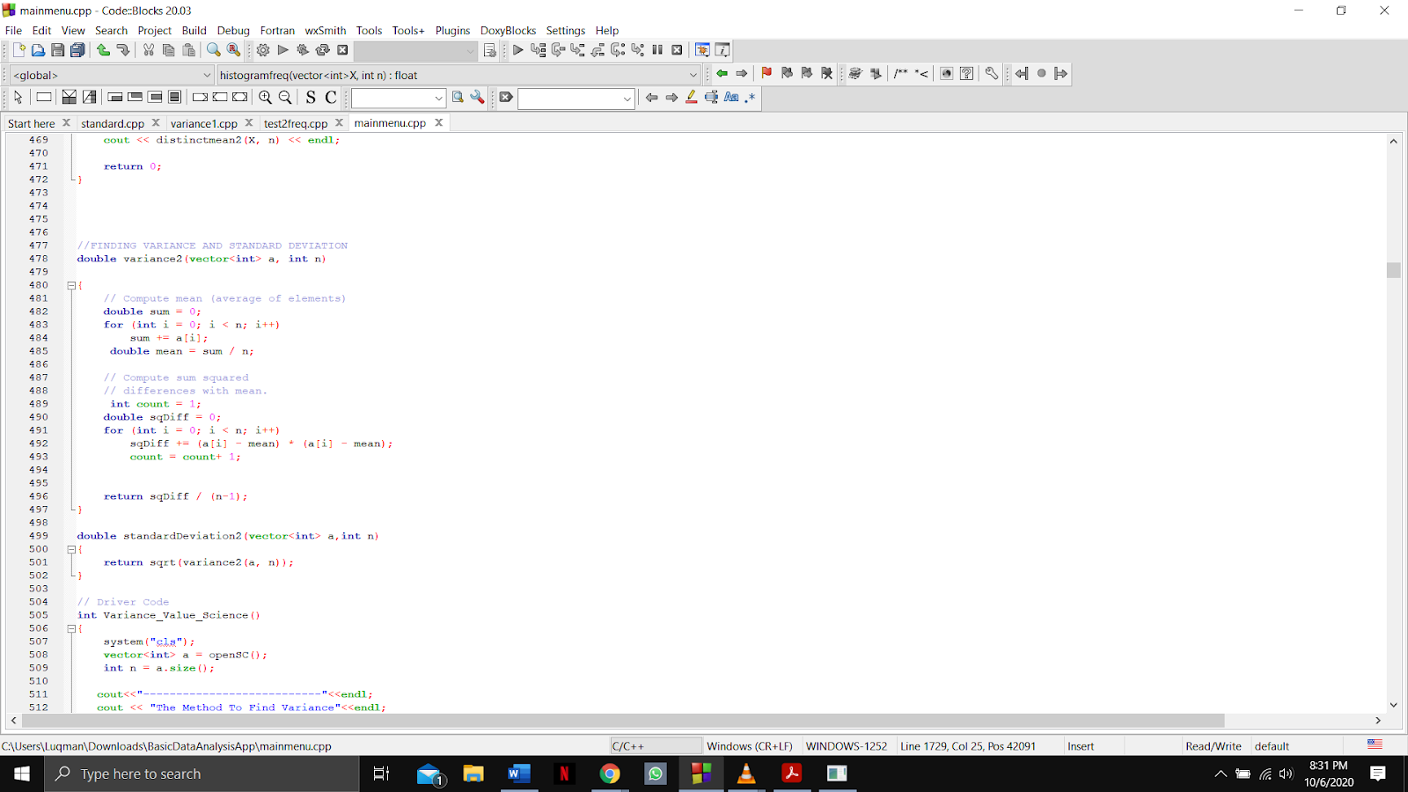

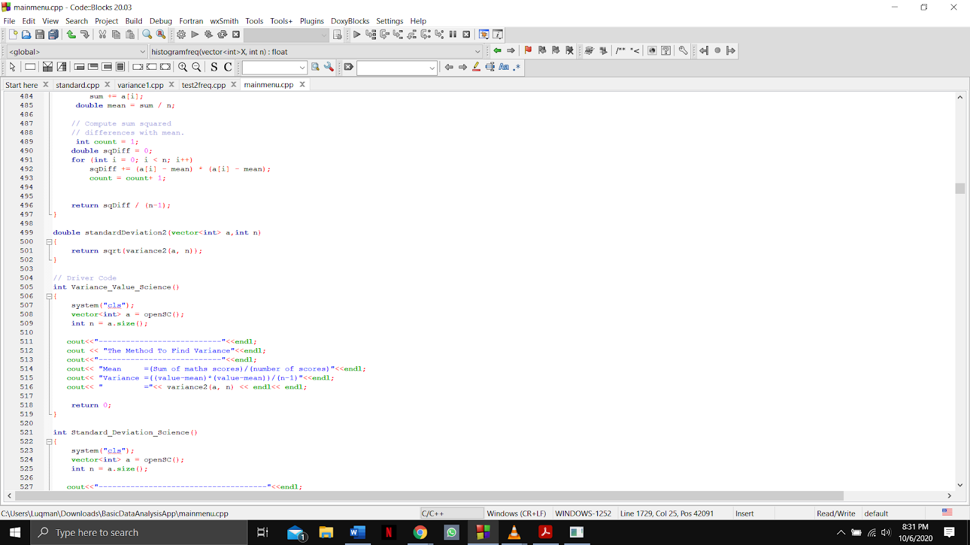

Output:

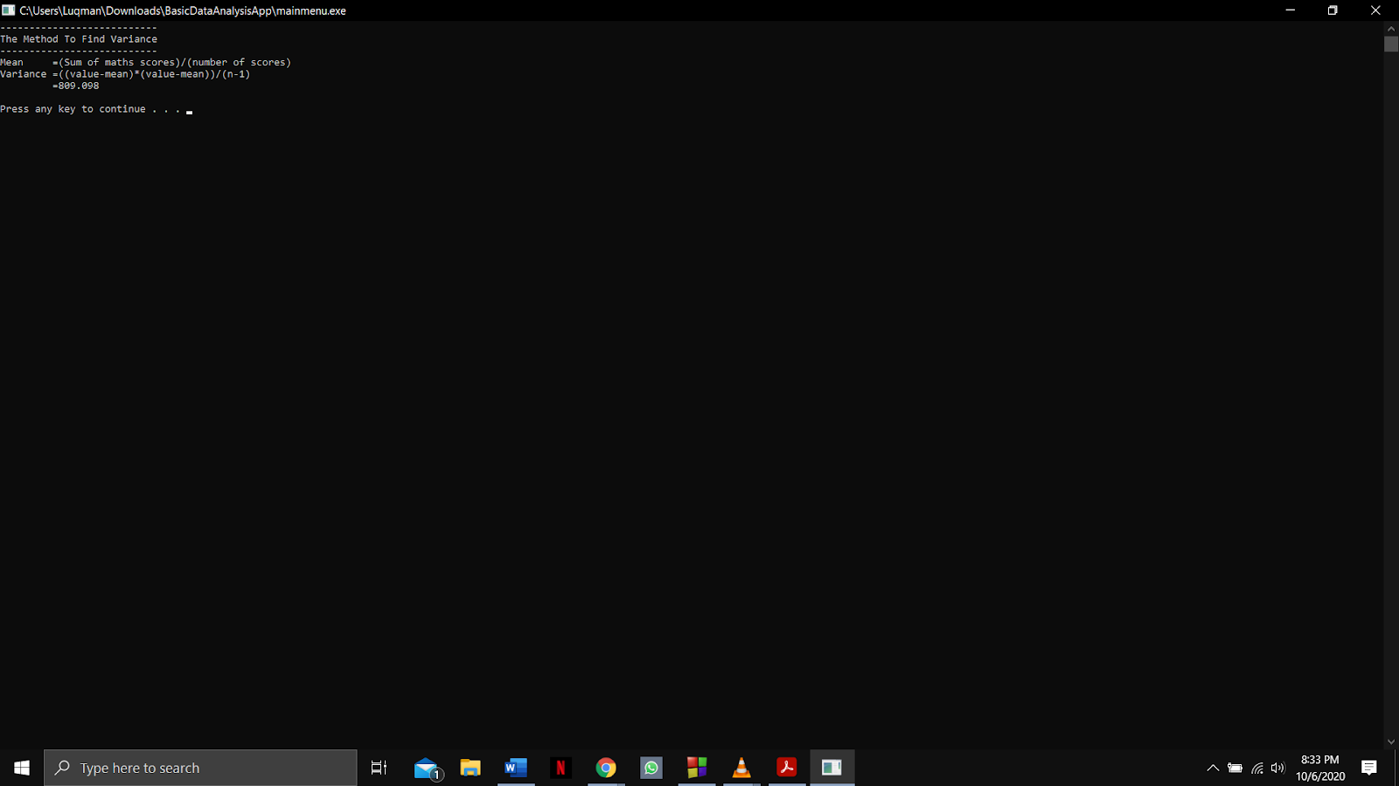

Function name: **standardDeviation2 and Standard_Deviation_Science**

Input:

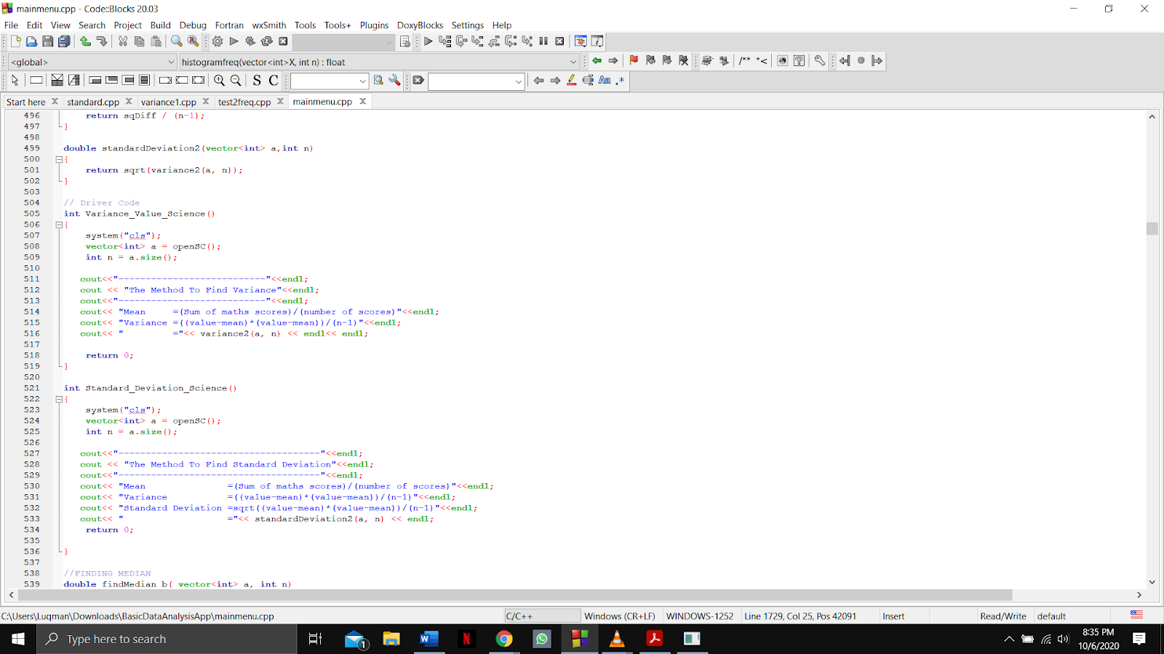

Output:

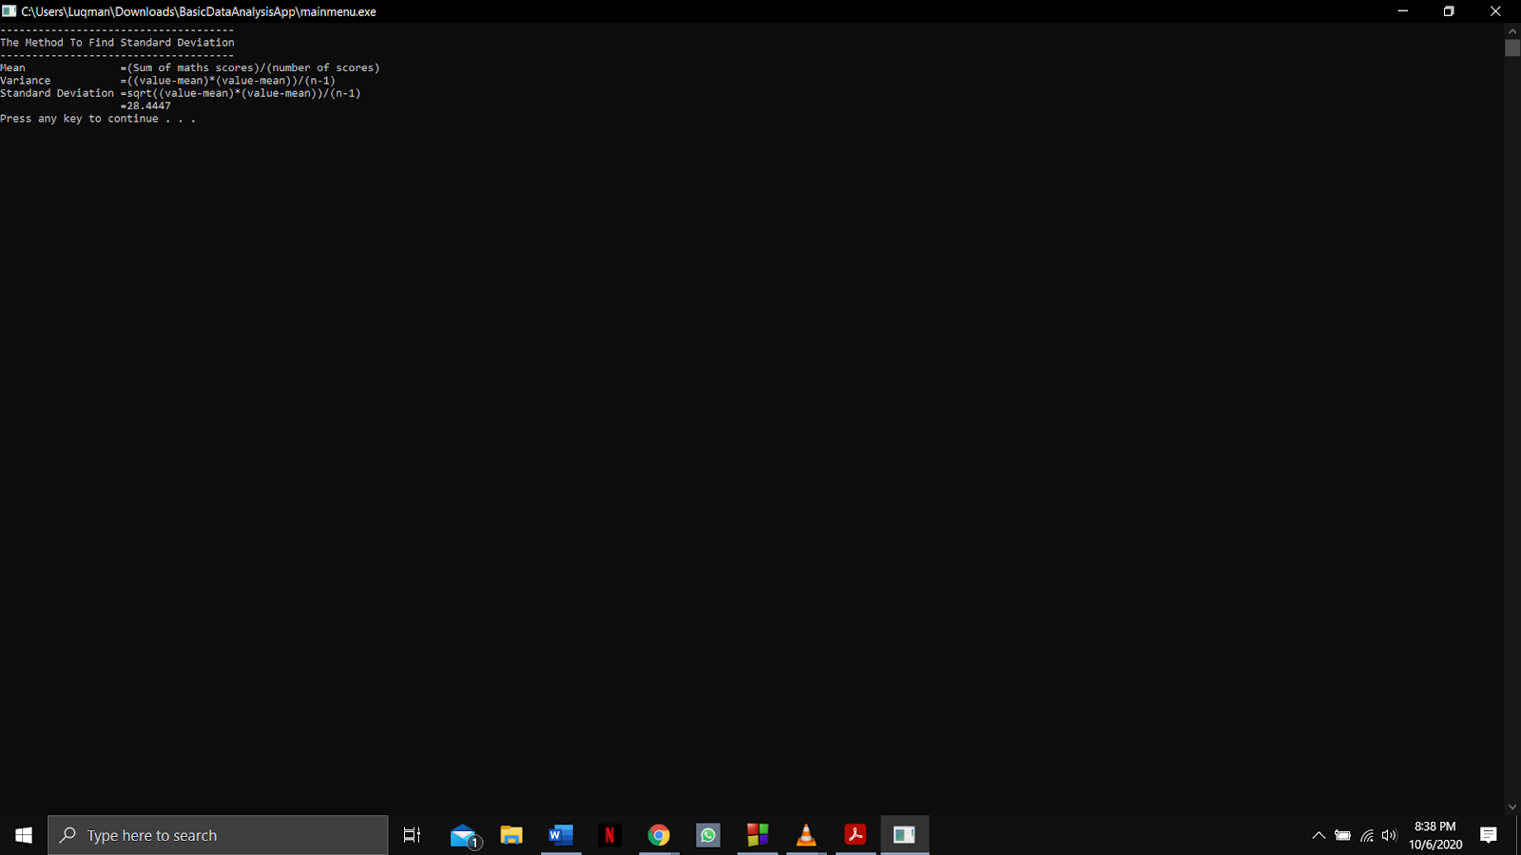

Function name: **findMedian_b and Median_Sort_Value_Science**

Input:

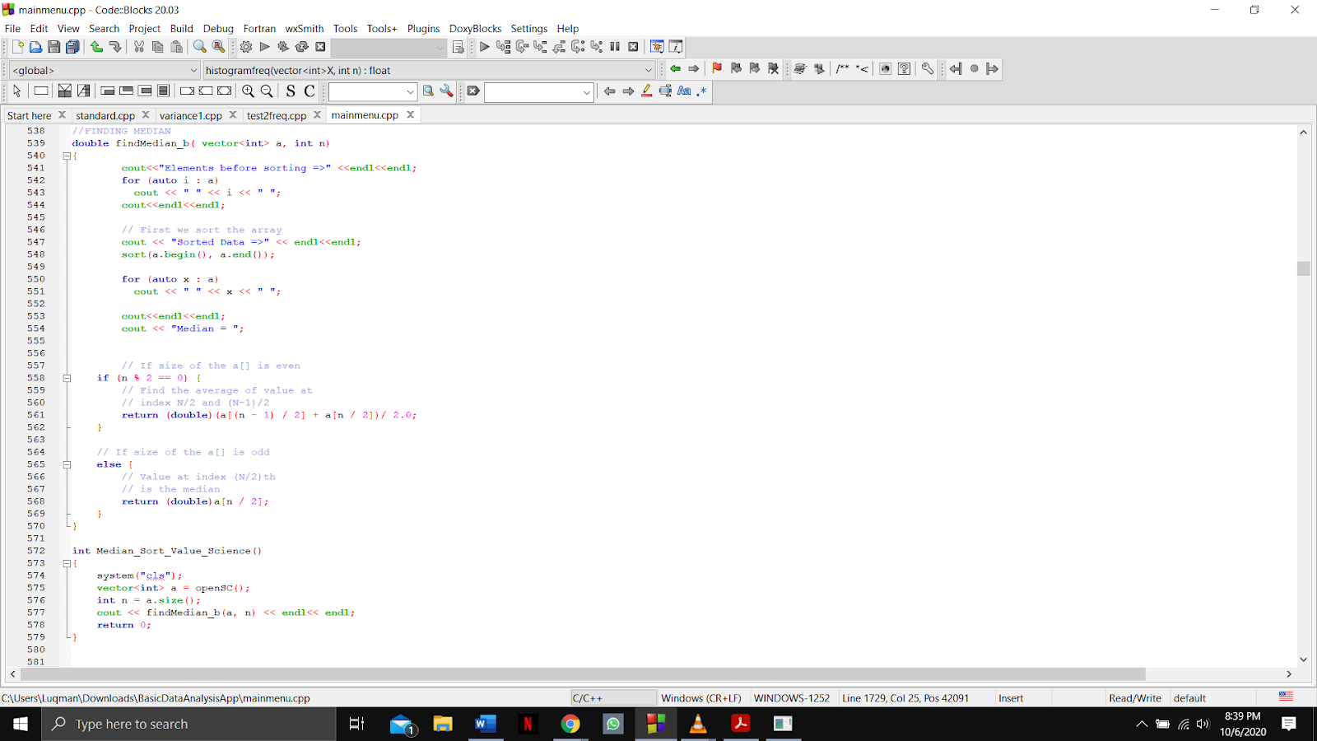

Output:

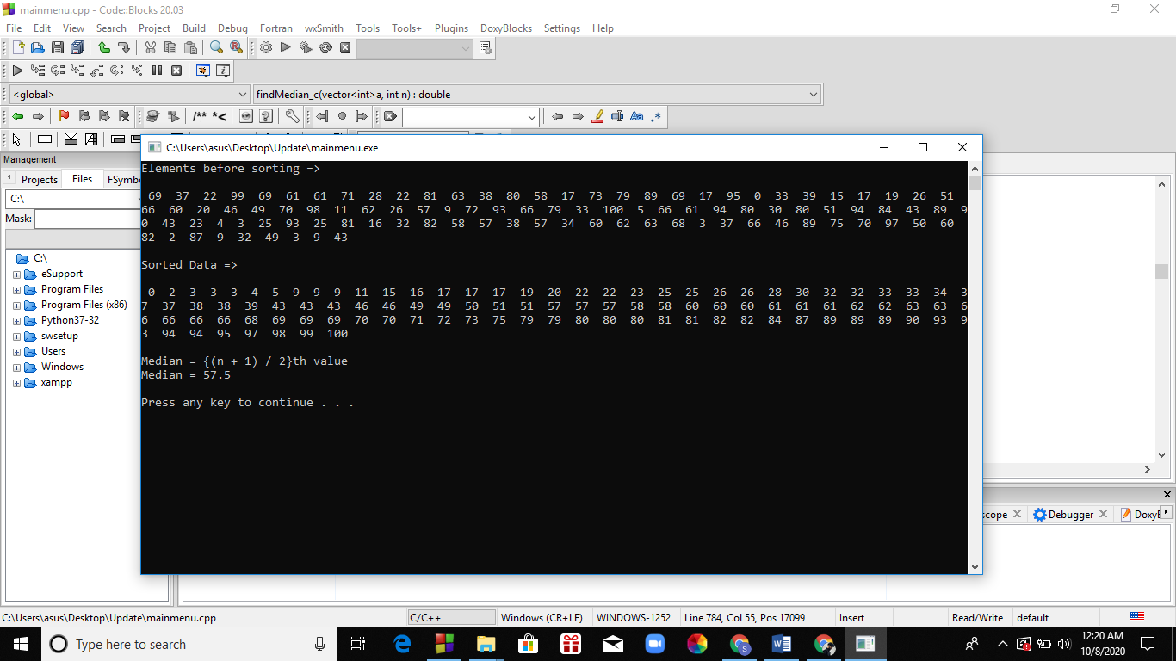

Function name: **findAverage_b and Mean_Value_Science**

Input:

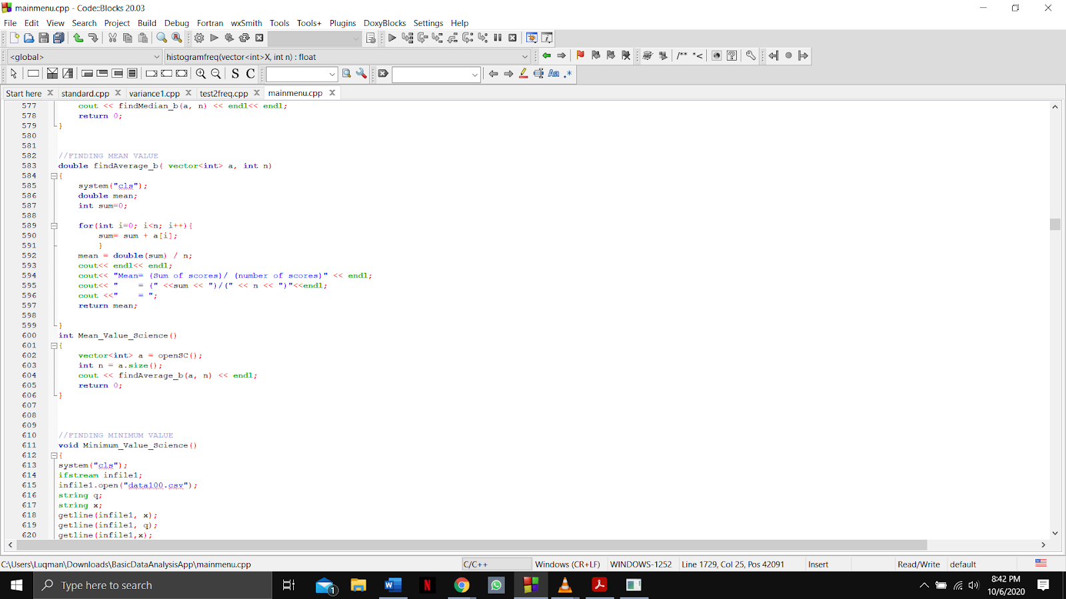

Output:

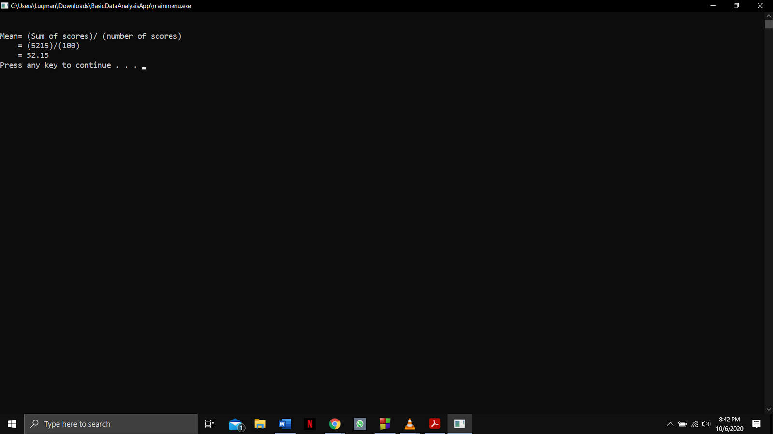

Function name: **Minimum_Value_Science**

Input:

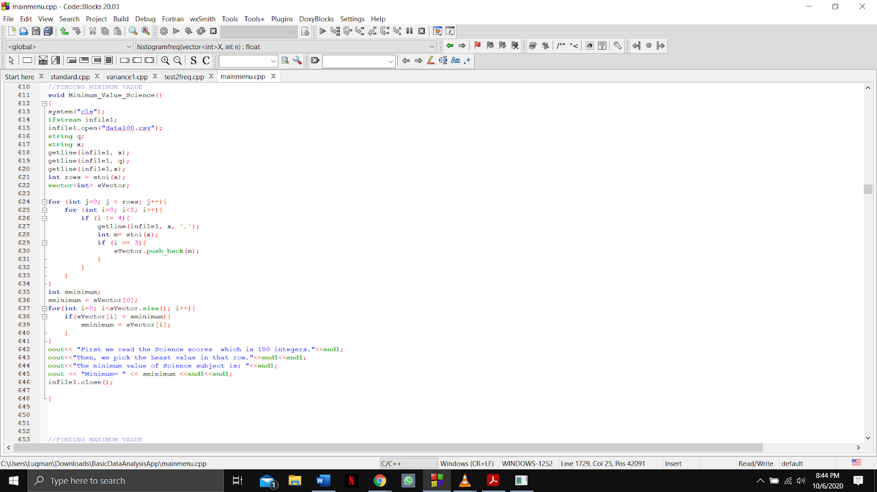

Output:

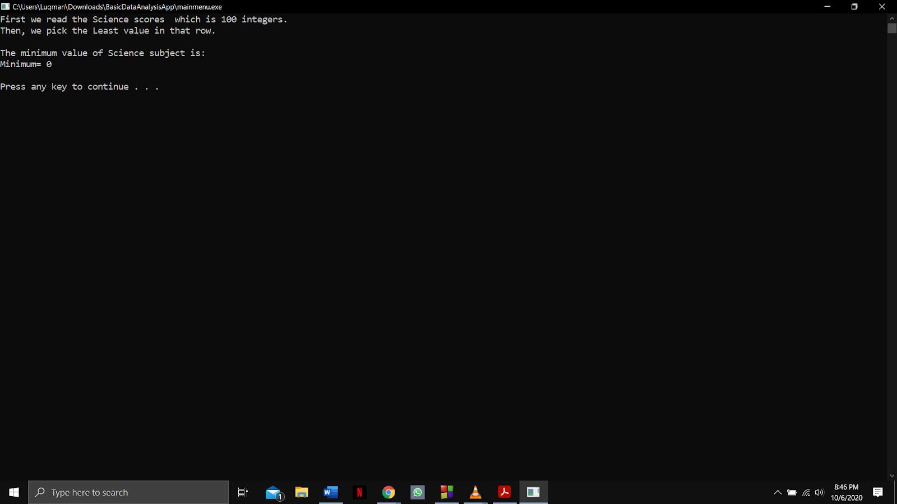

Function name:  **Maximum_Value_Science**

Input:

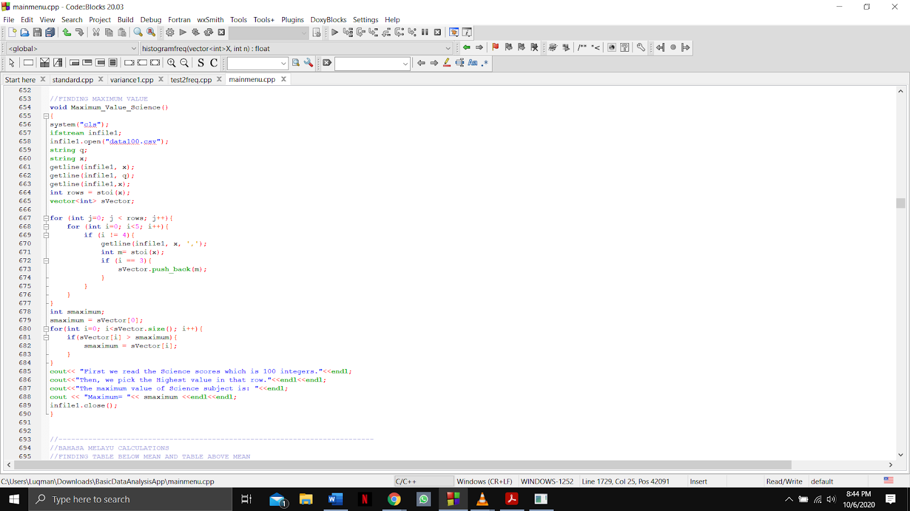

Output:

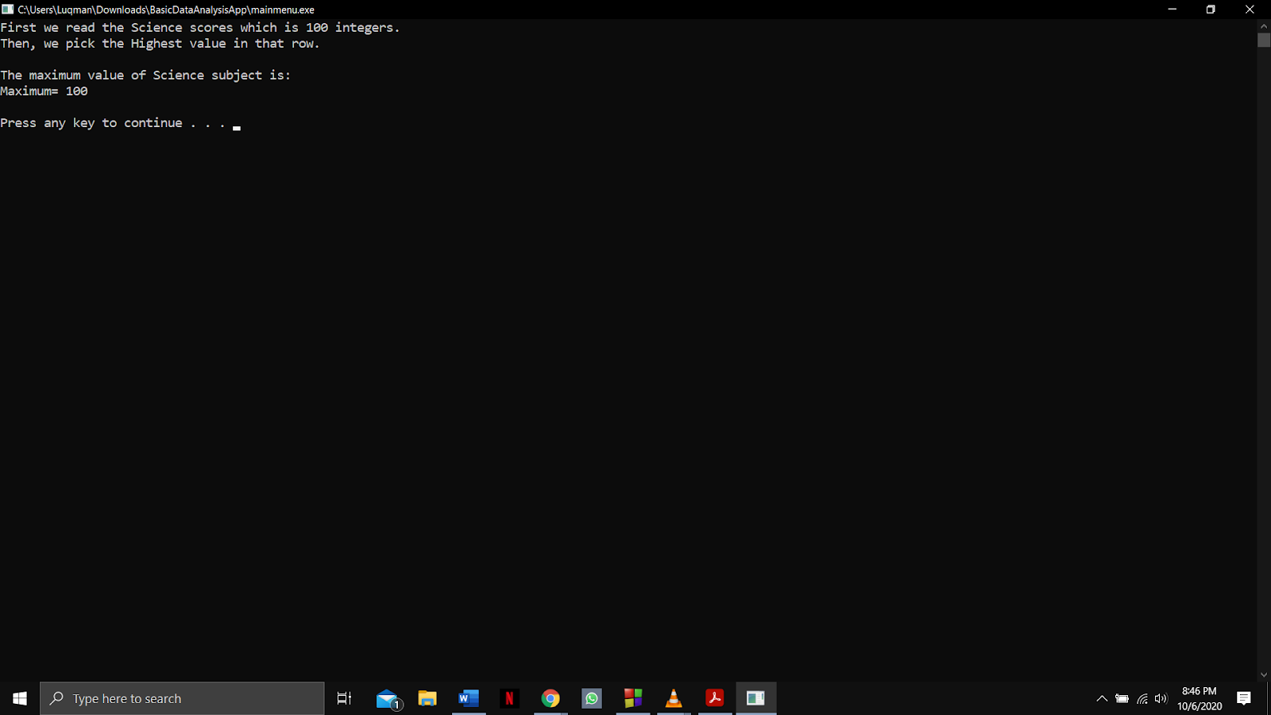

Function name: **Frequency_Science**

Input:

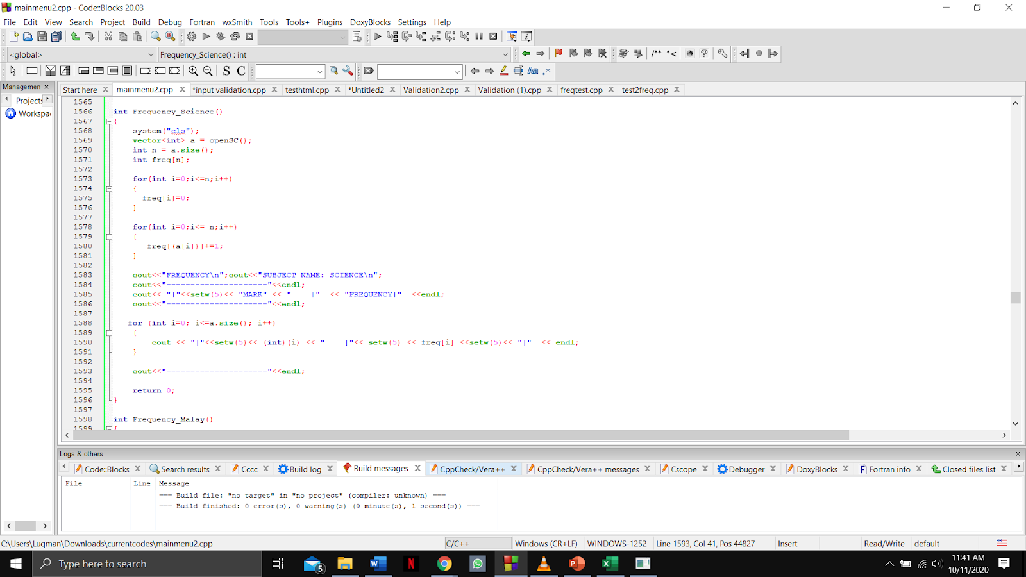

Output

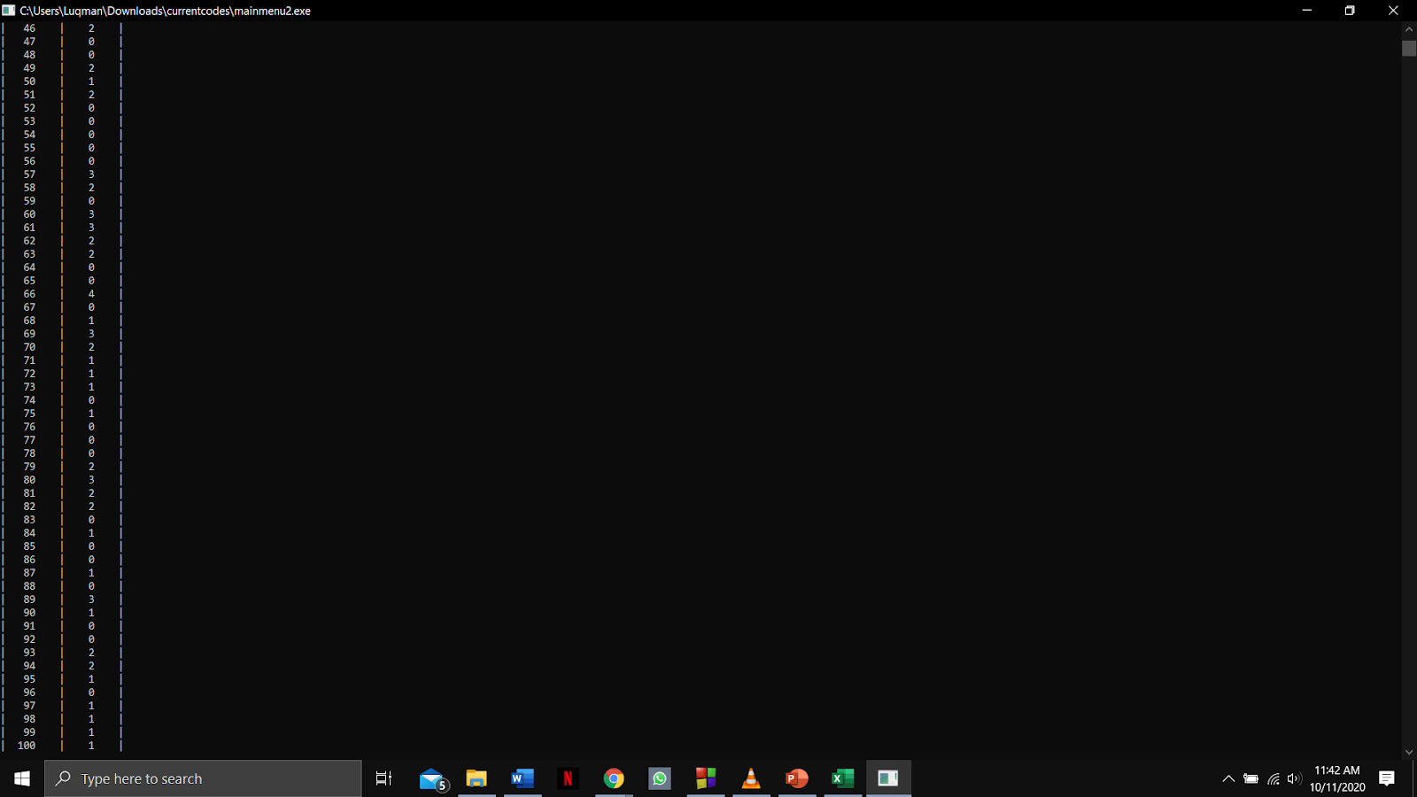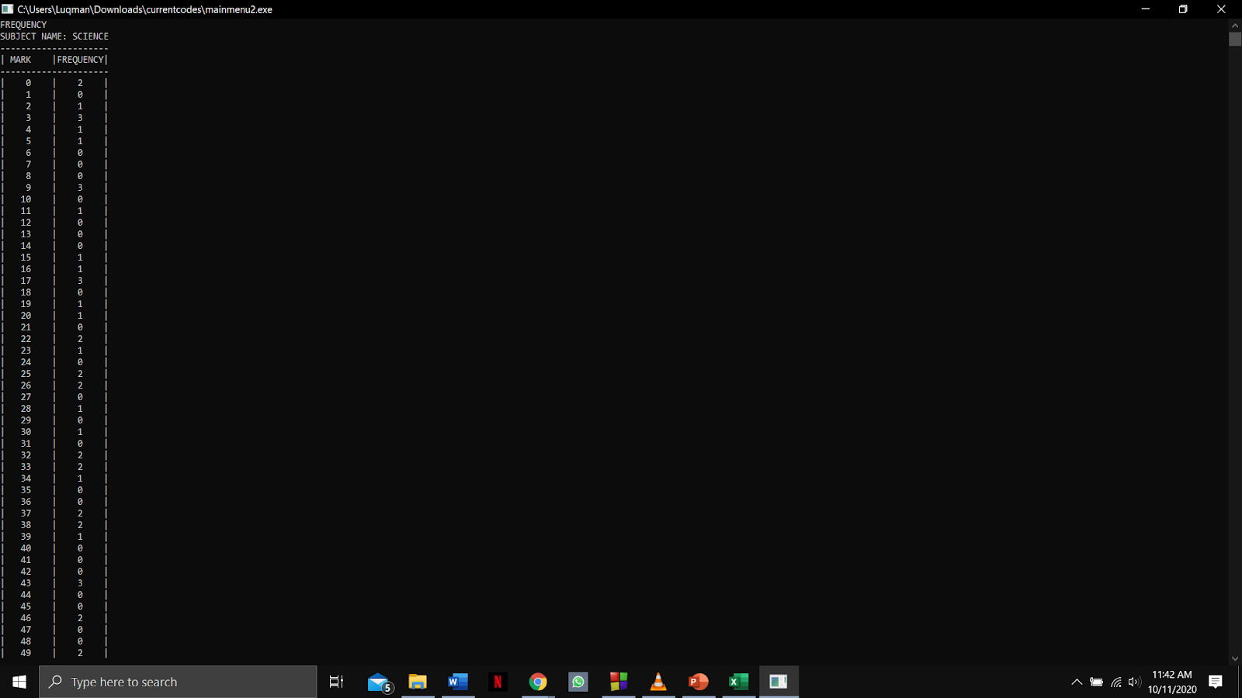

Function name: **findmaxFirst, histogramfreq and Plot_Histogram_Science**

Input:



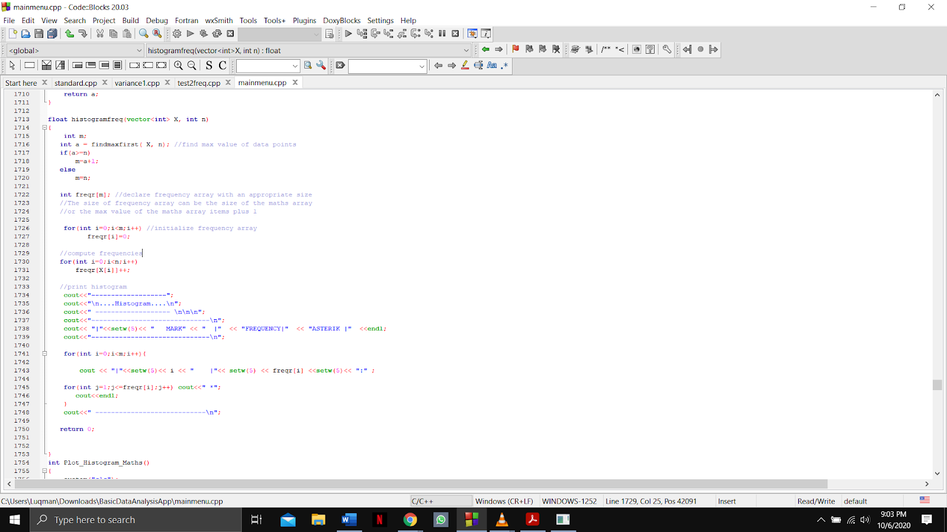

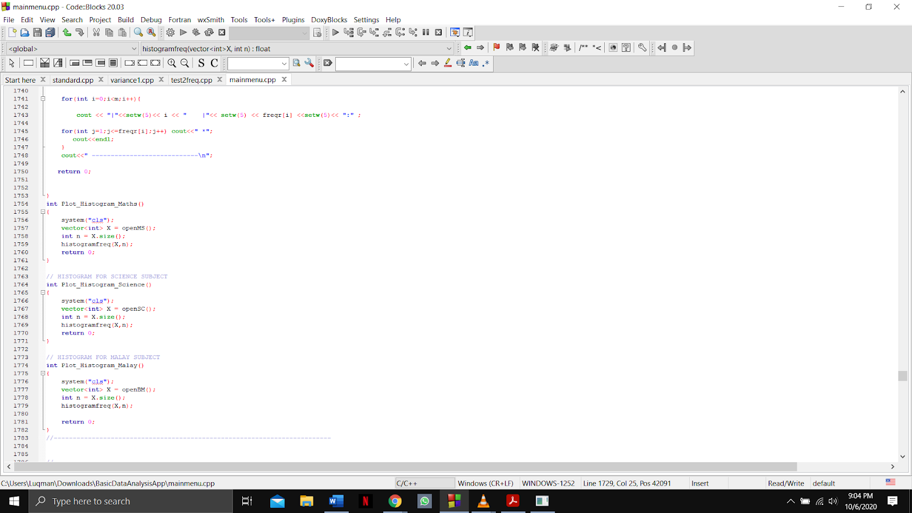

Output:

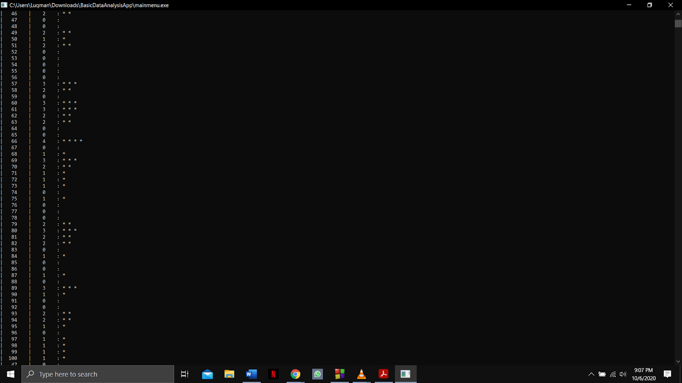

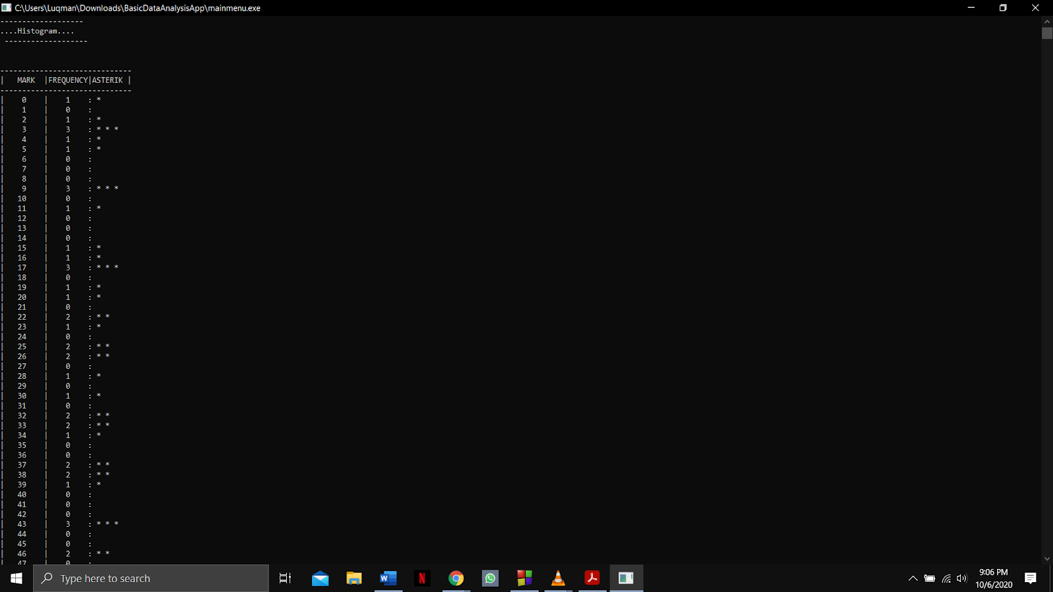

Function name: **ascending, descending and Ascending_Descending_Science**

Input:

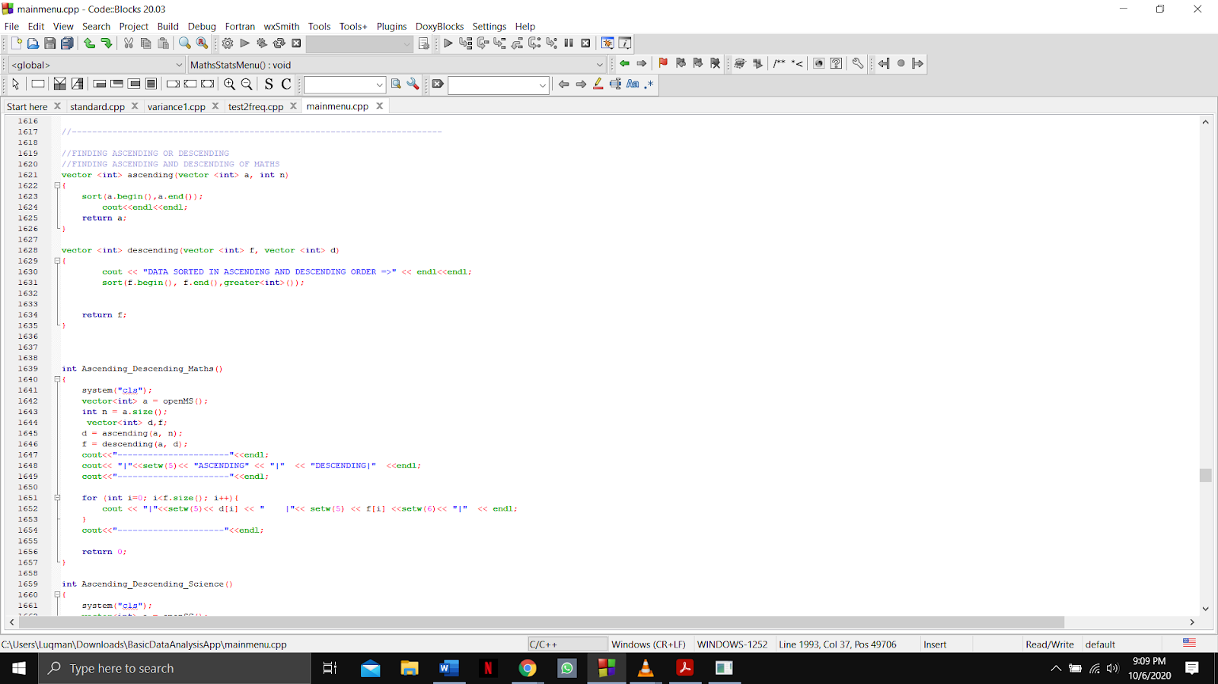

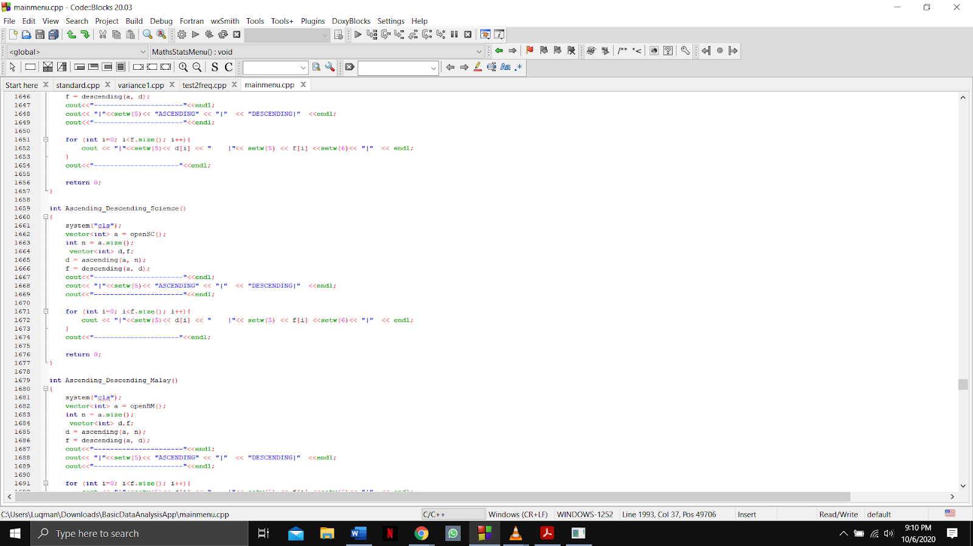

Output:

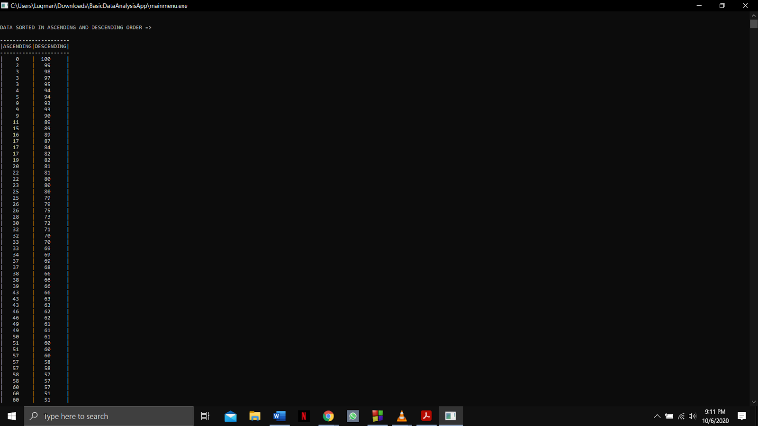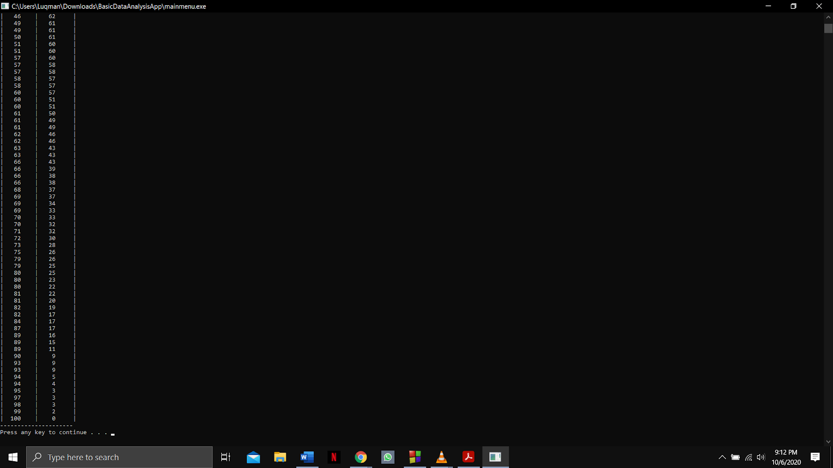

Function name **MalayStatsMenu and getCalcChoice**

Input:

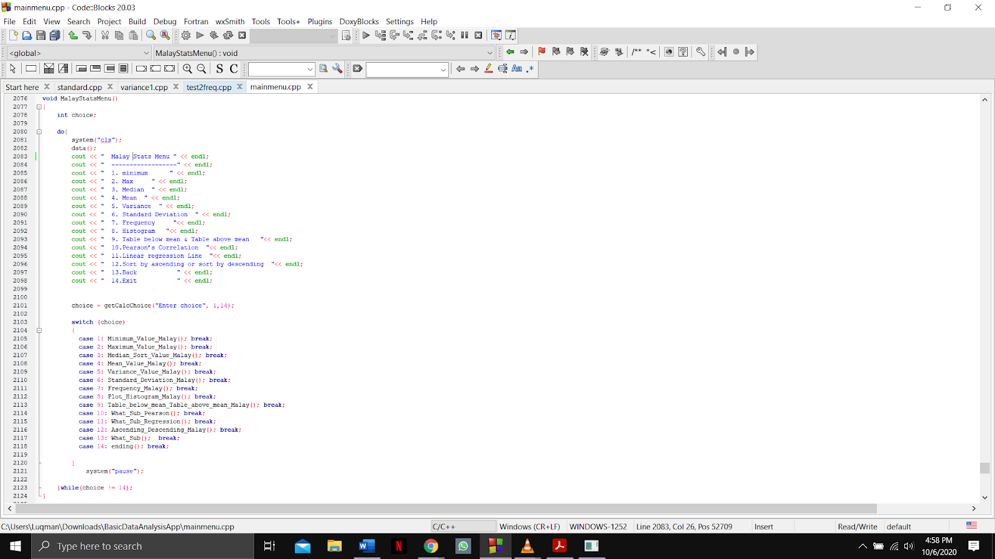



Output:

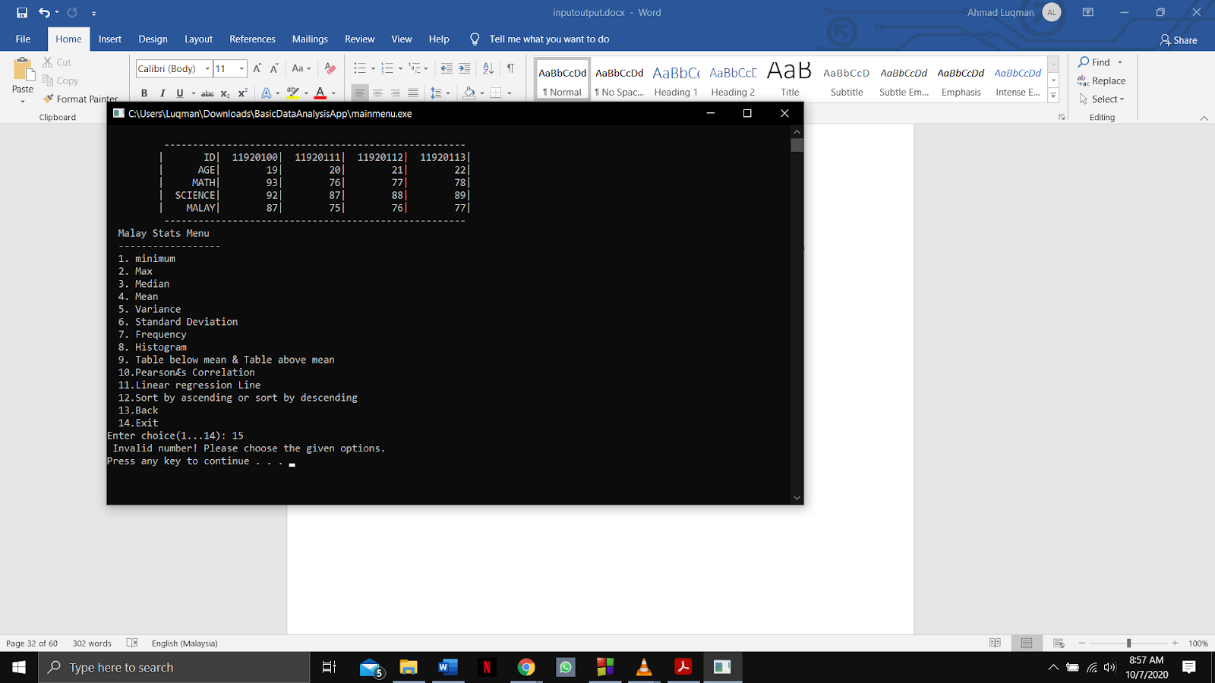

Function name: **mean3, distinctmean3 and Table_below_mean_Table_above_mean_Malay**

Input:

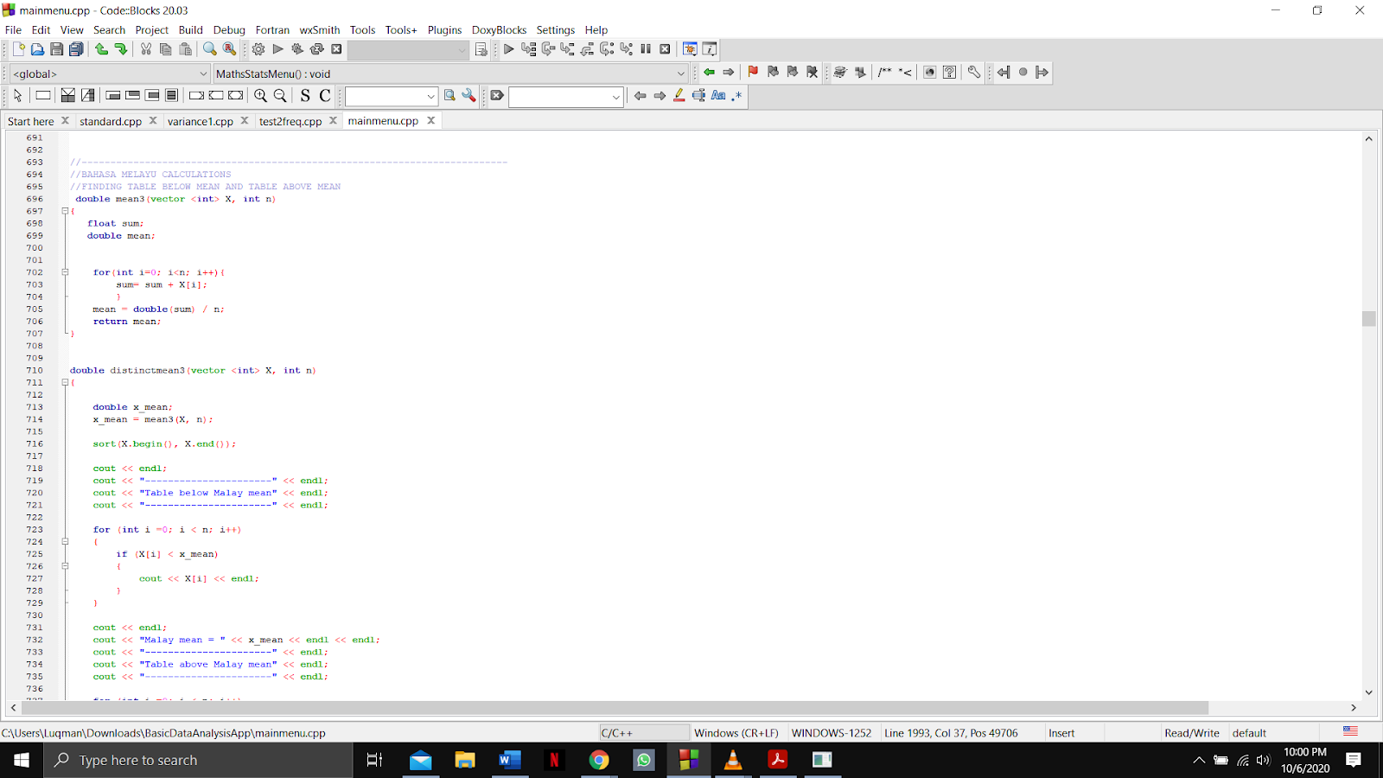

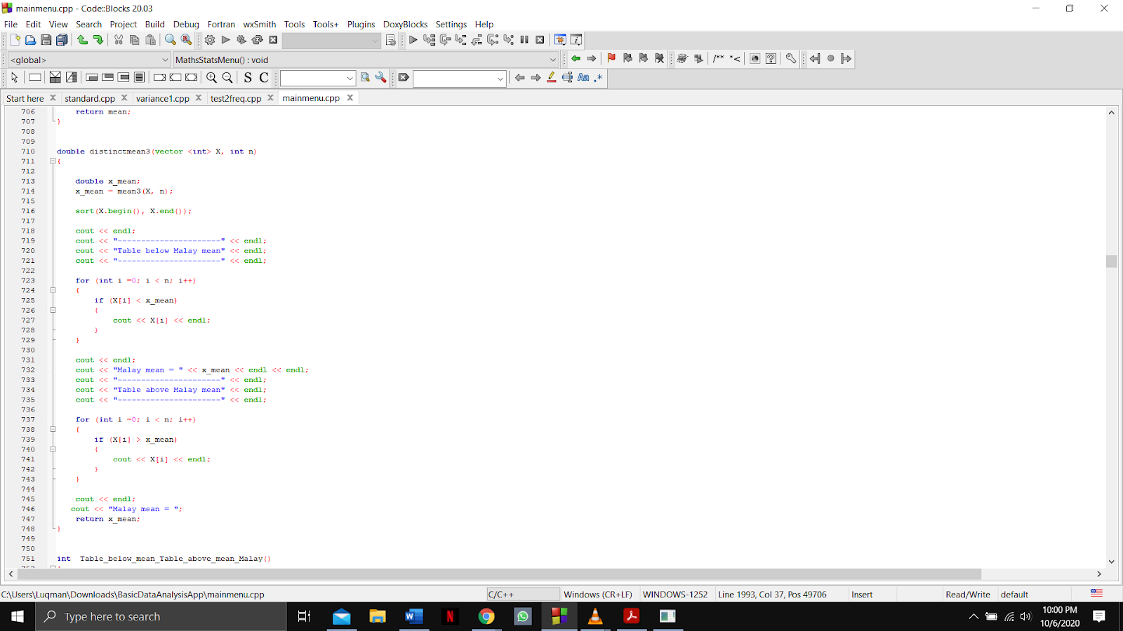

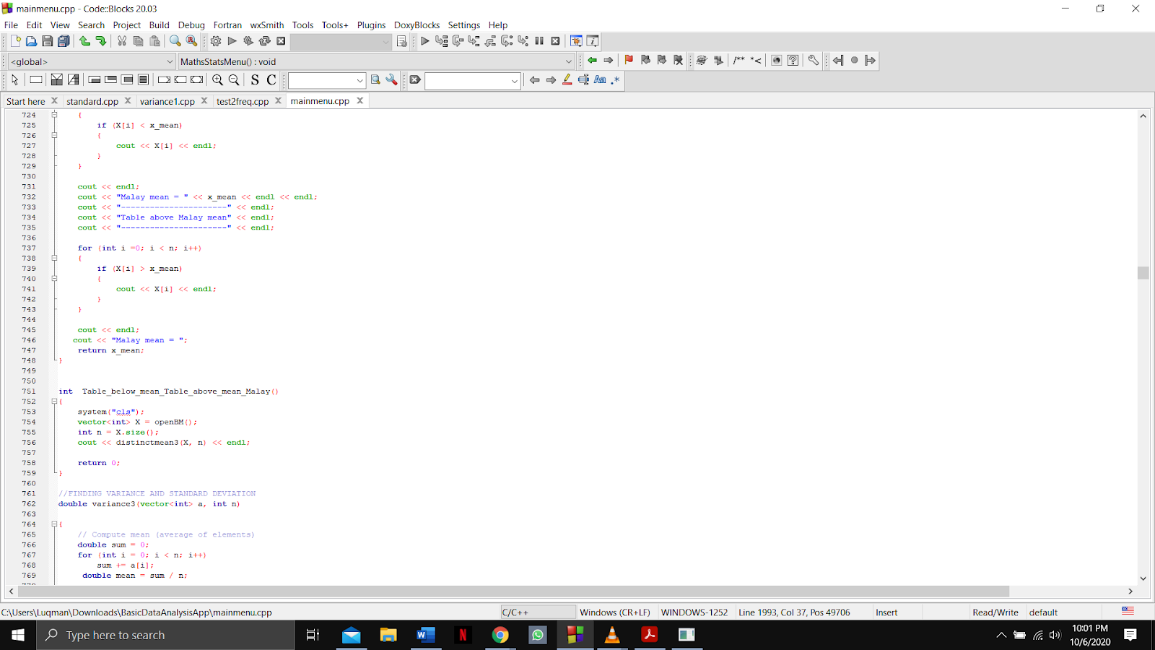

Output:

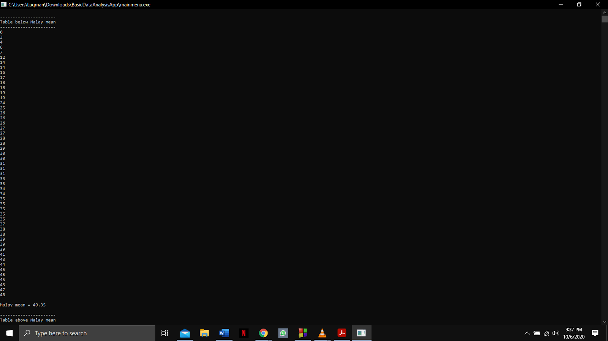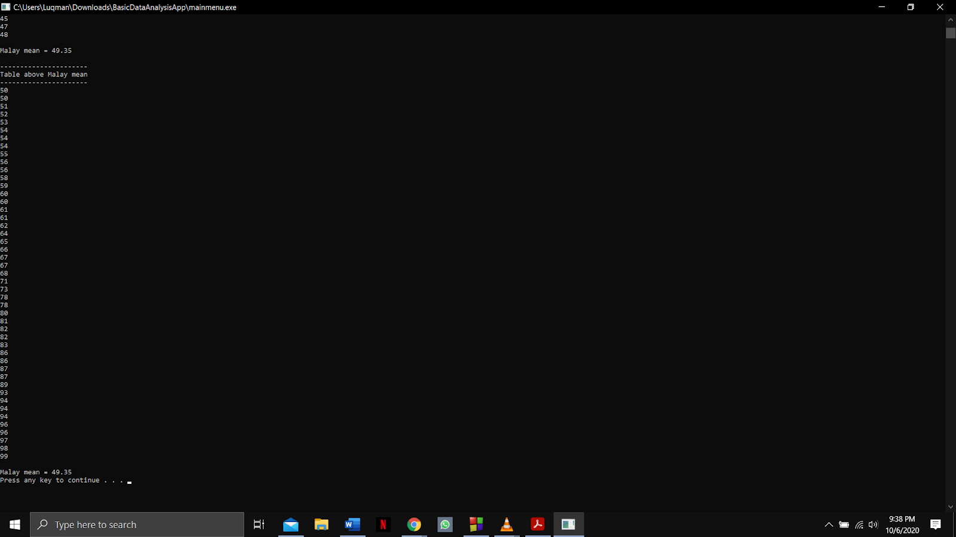

Function name: **variance3 and Variance_Value_Malay**

Input:

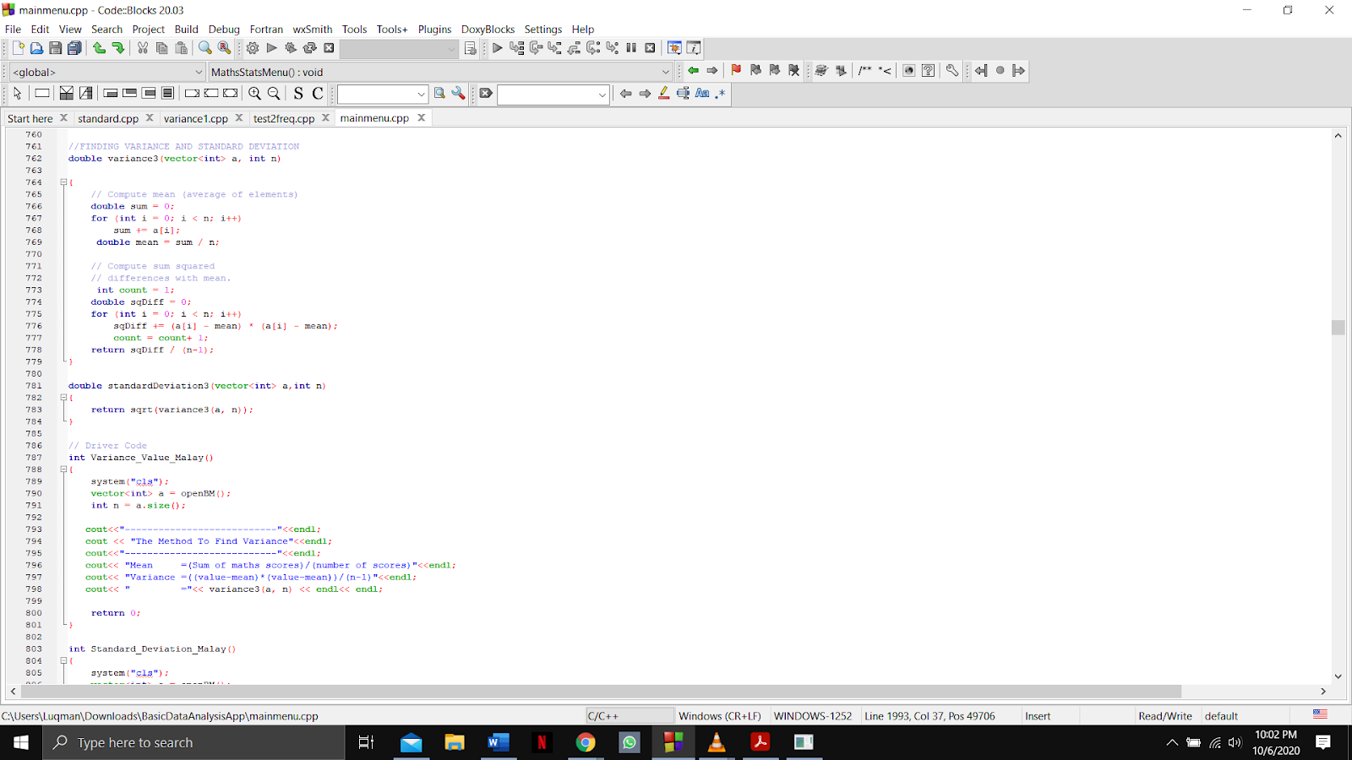



Output:

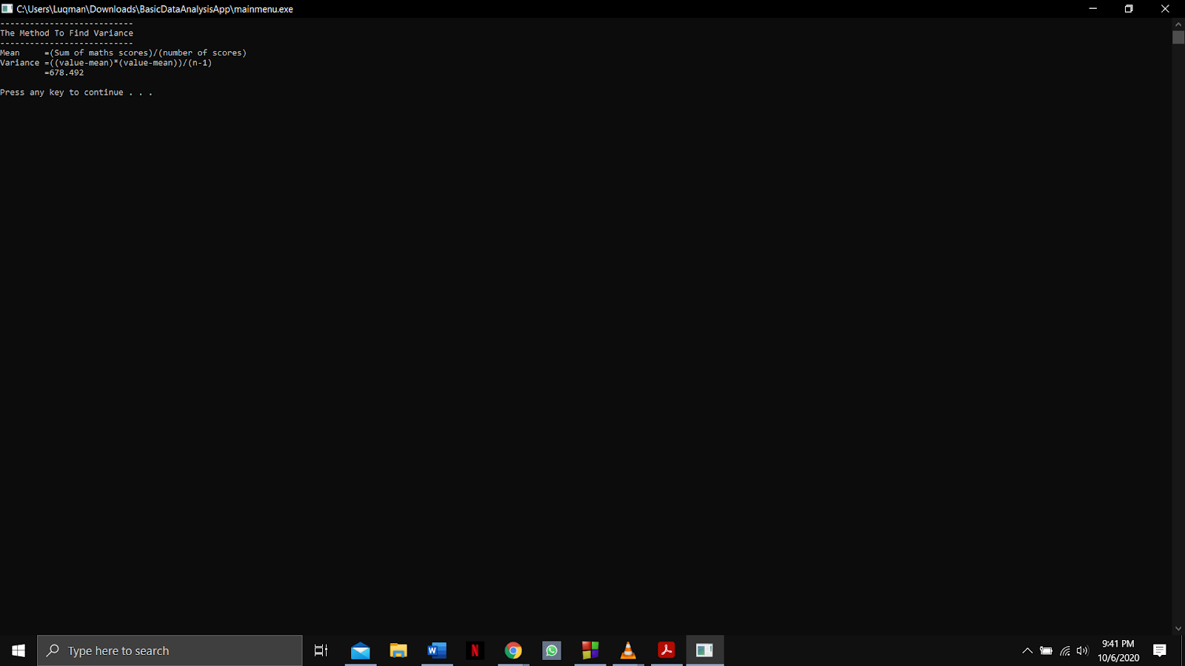

Function name: **standardDeviation3 and Standard_Deviation_Malay**

Input:

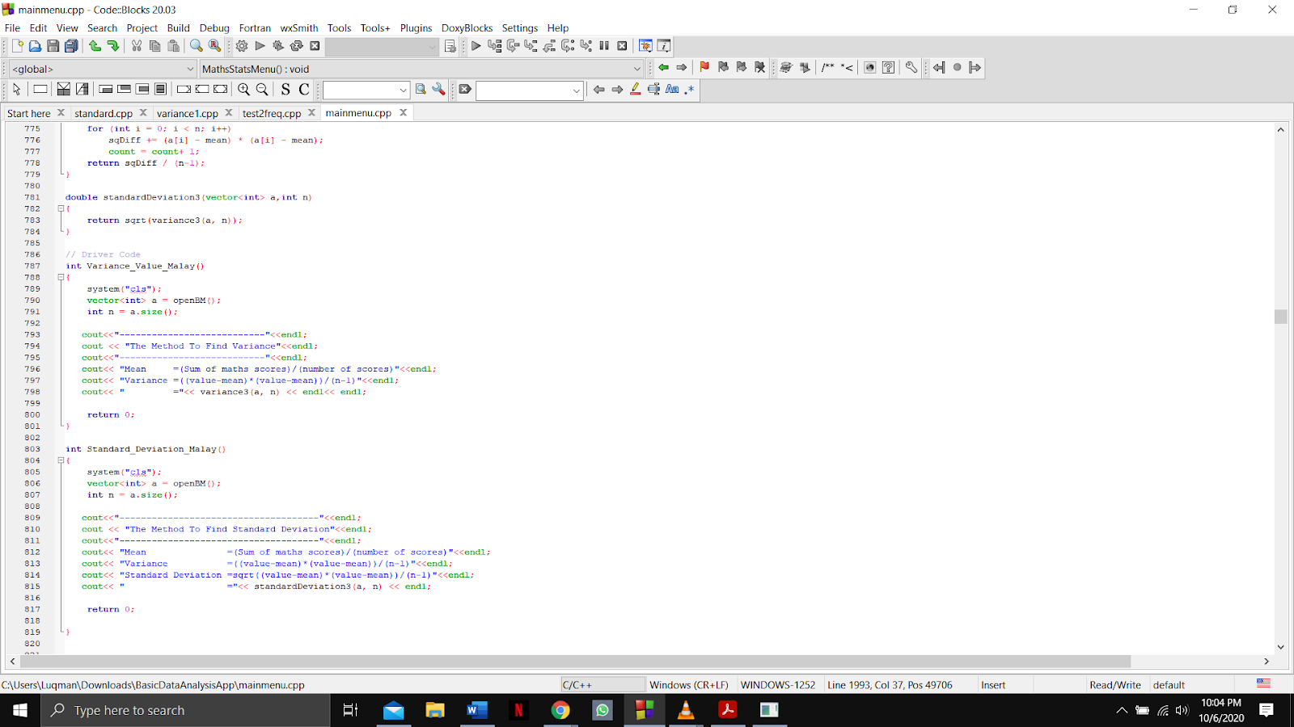



Output:

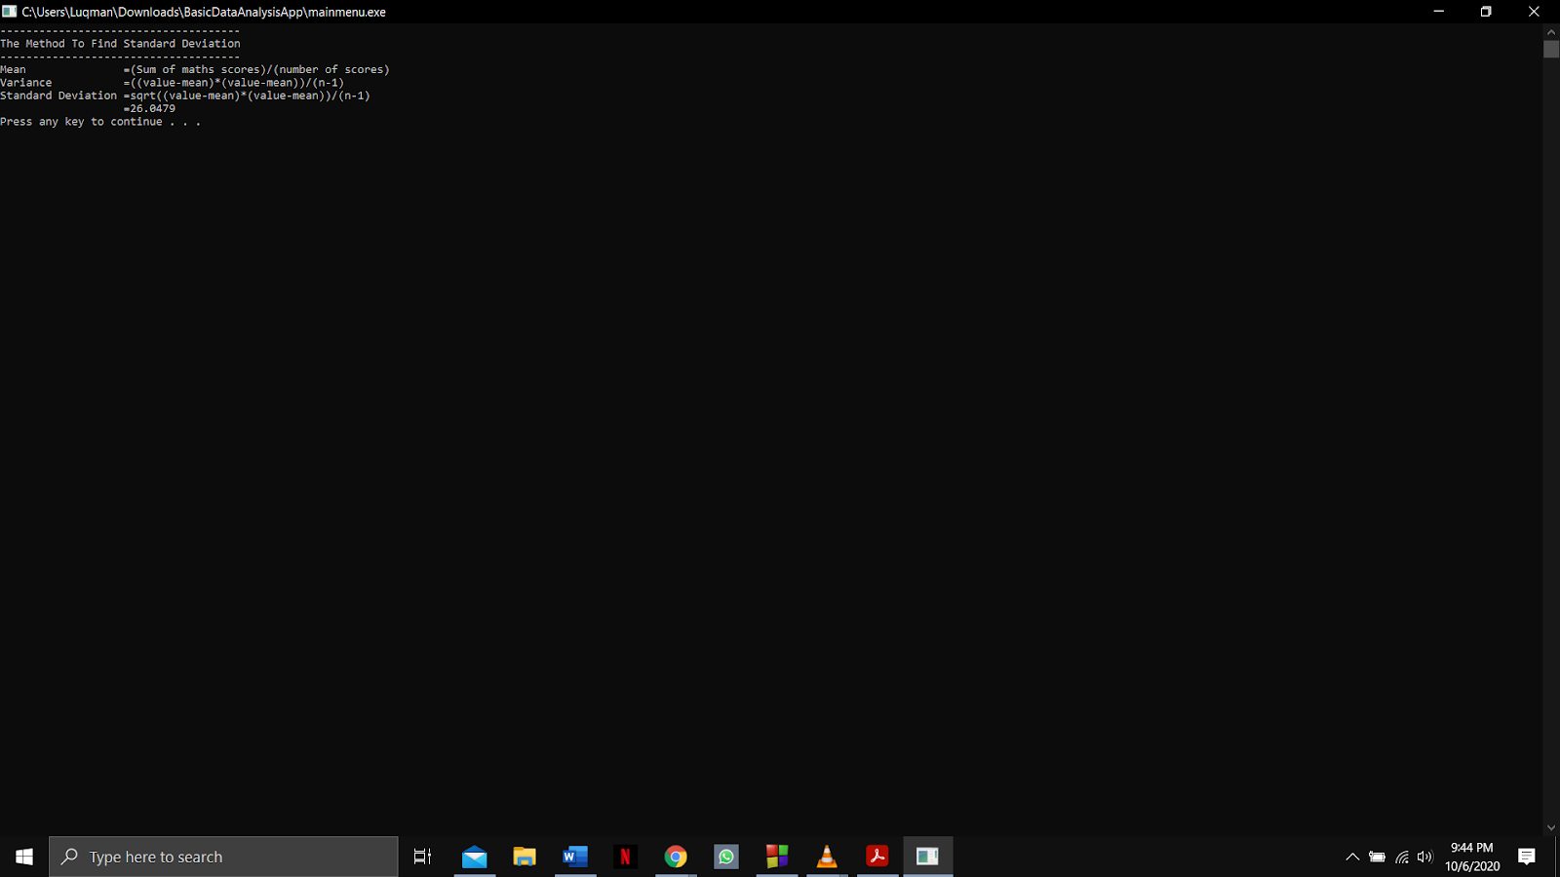

Function name: **findMedian_c and Median_Sort_Value_Malay**

Input:

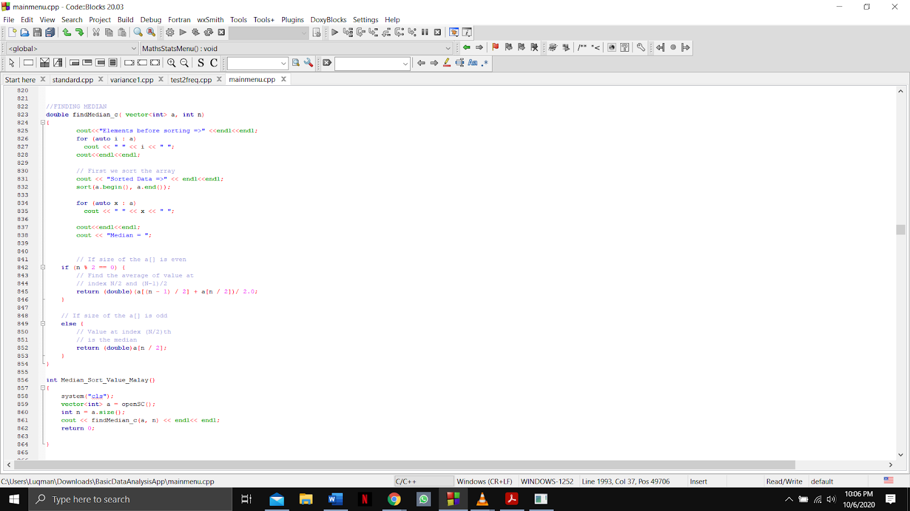

Output:

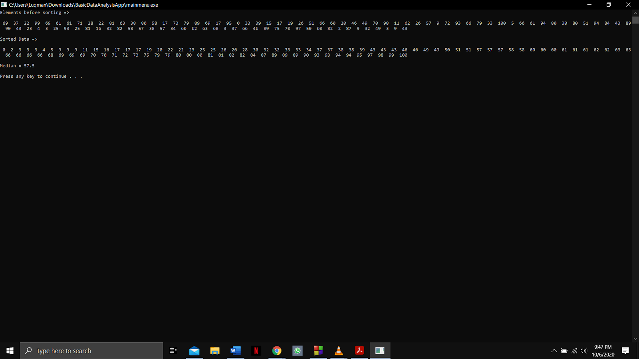

Function name: **findAverage_c and Mean_Value_Malay**

Input:

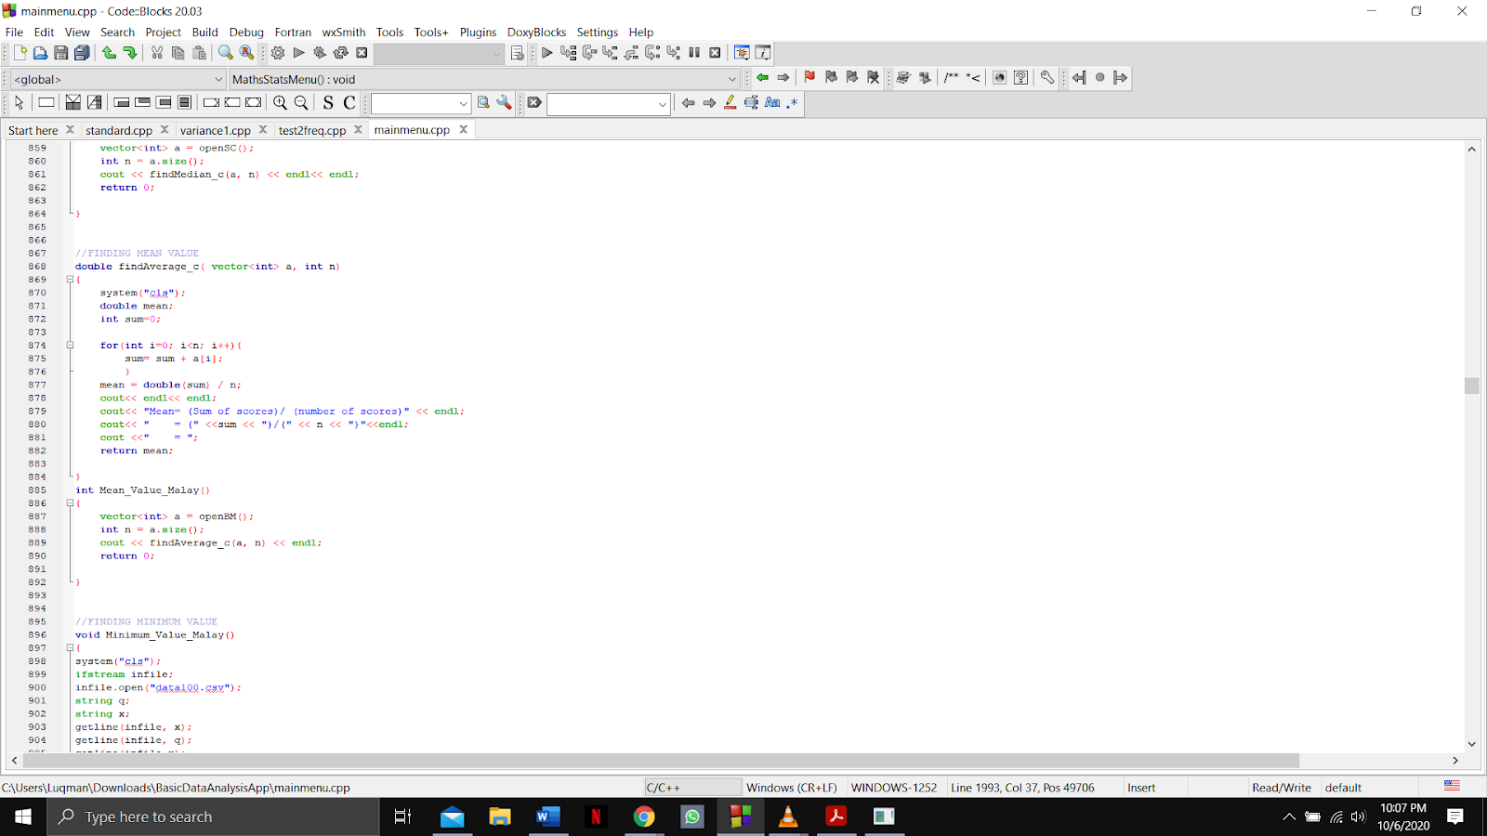

Output: 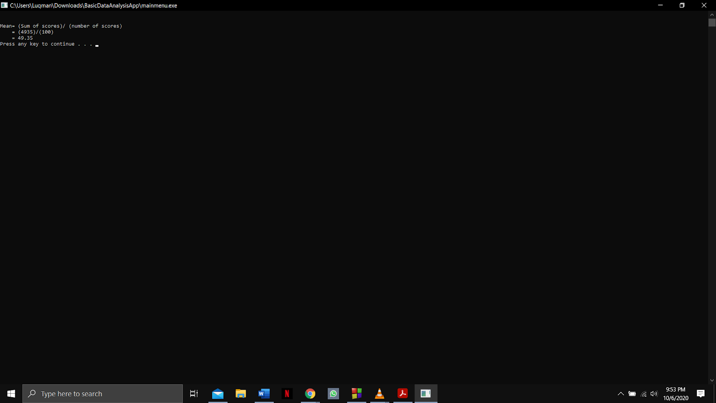

Function name: **Minimum_Value_Malay**

Input:

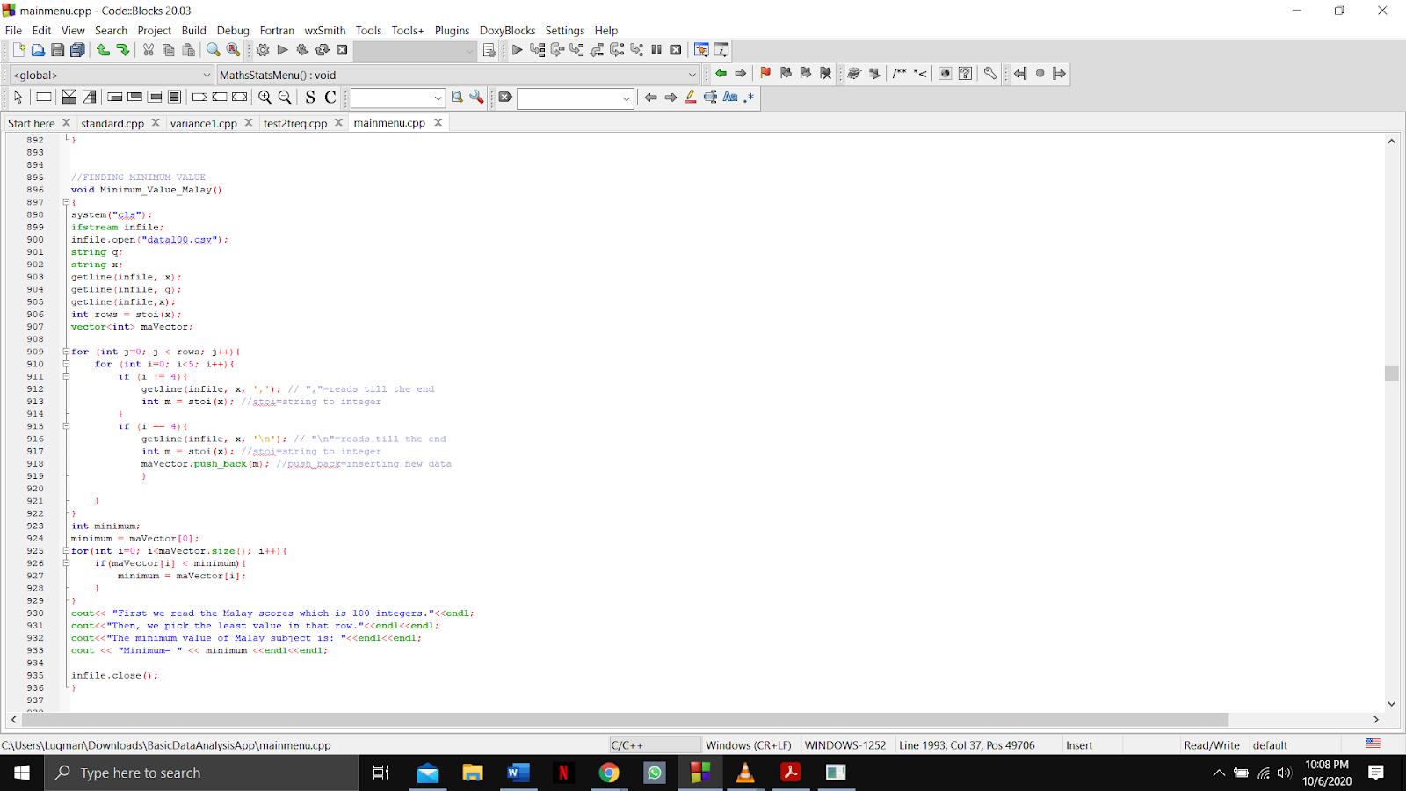

Output:

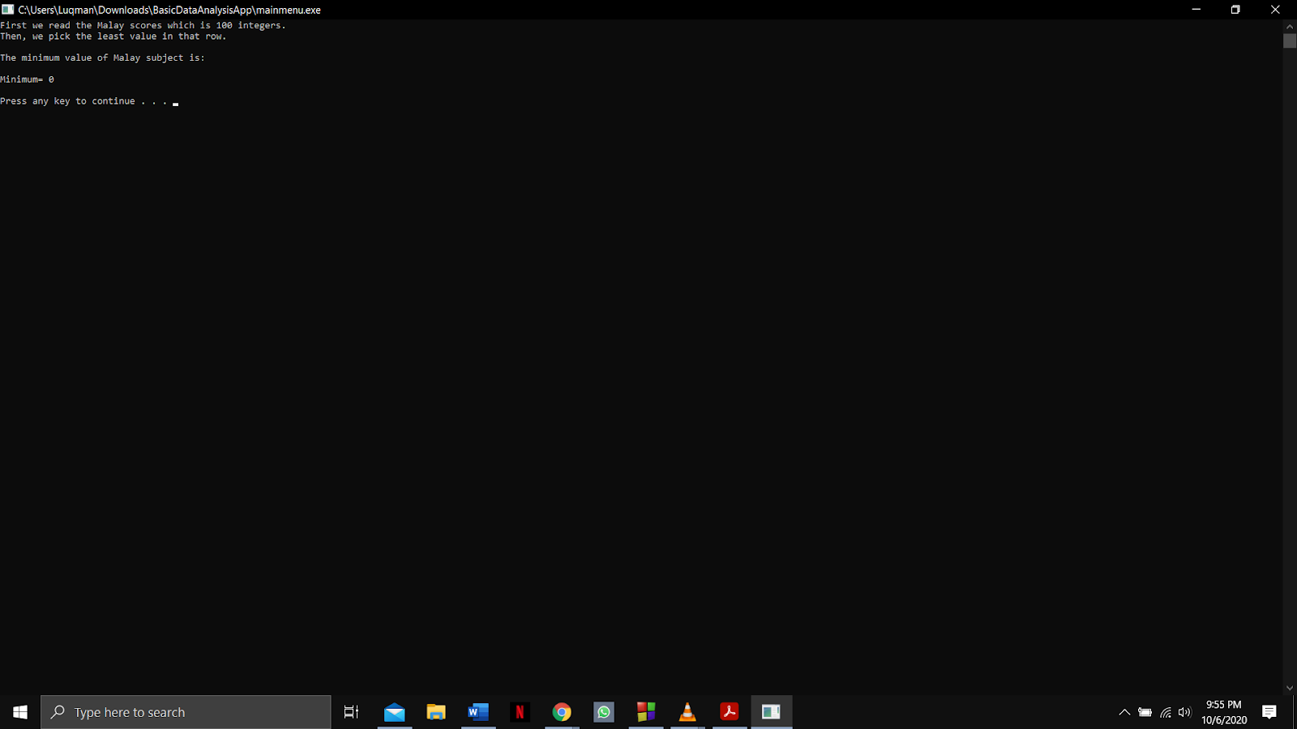

Function name: **Maximum_Value_Malay**

Input:

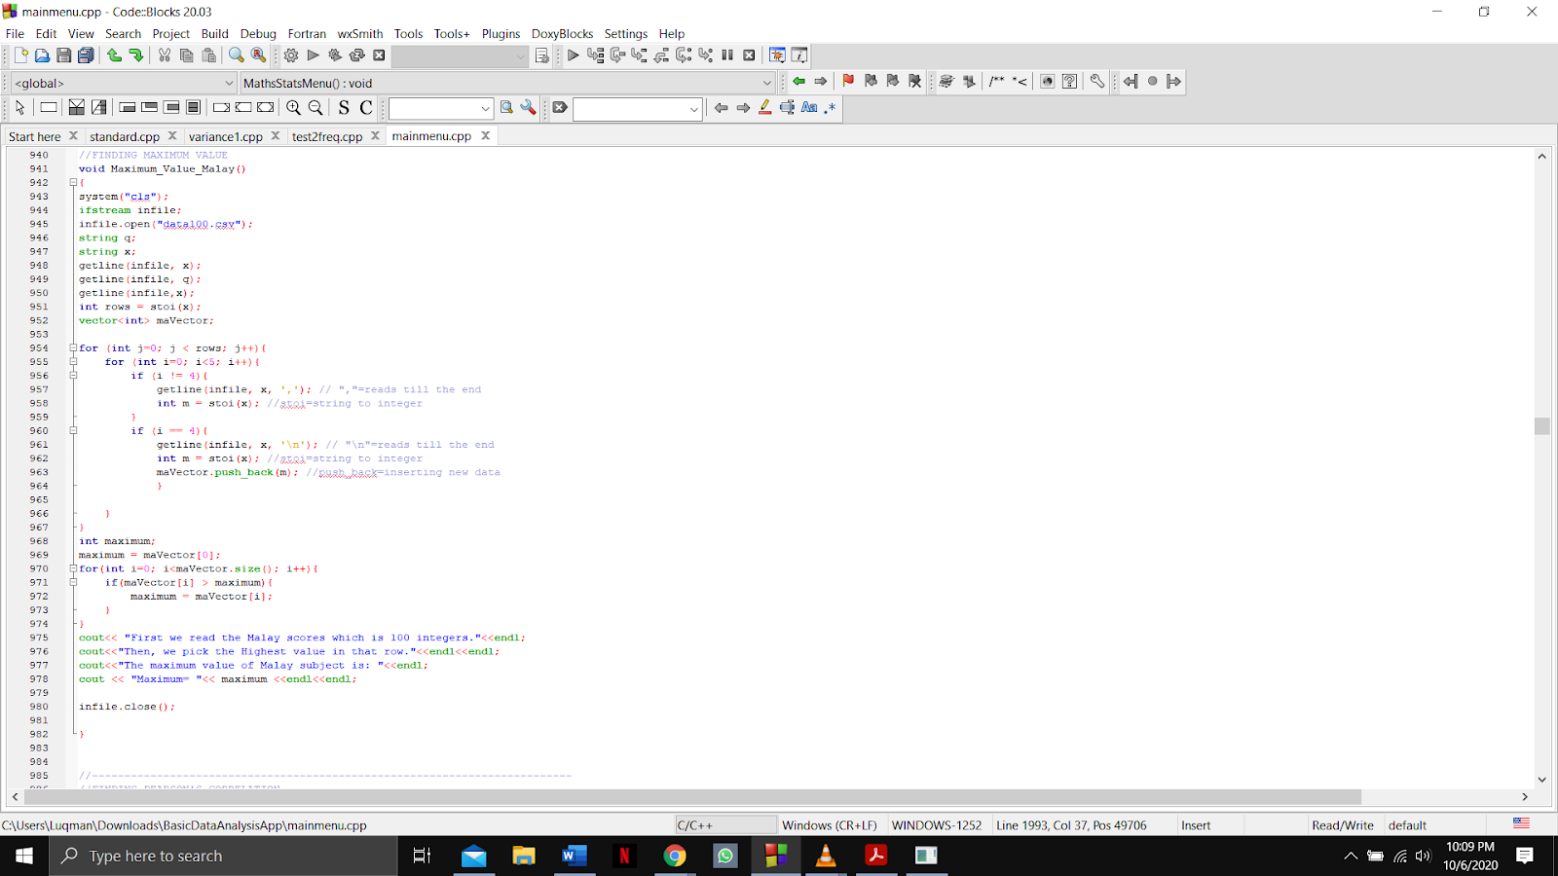

Output:

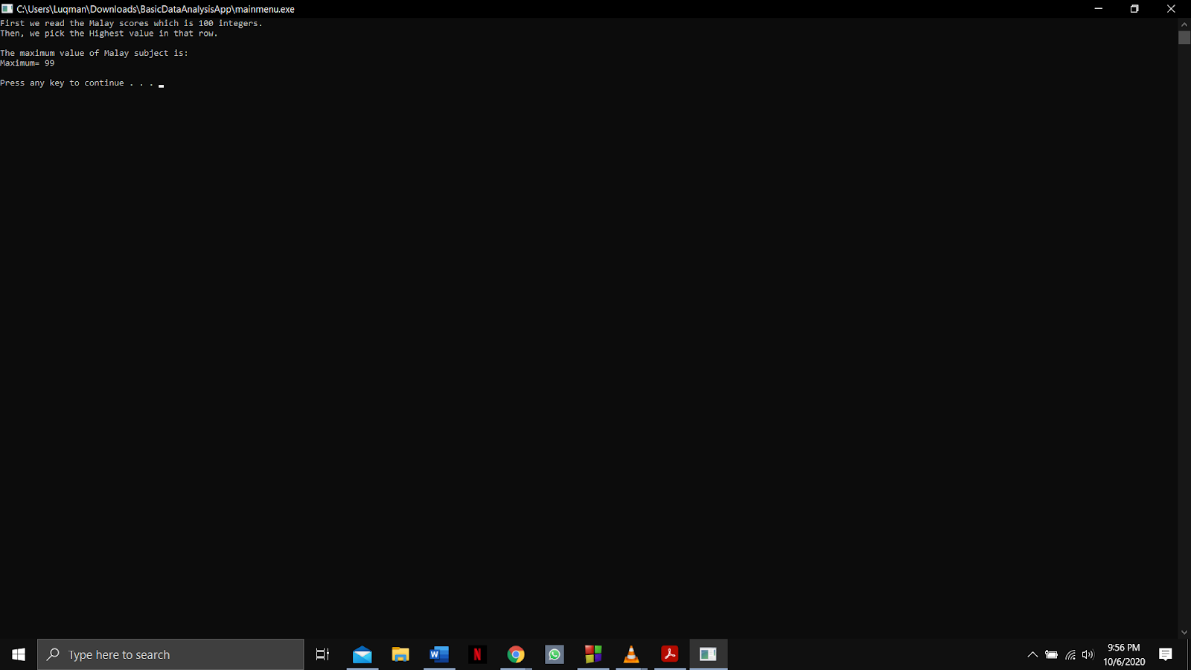

Function name: **Frequency_Malay**

Input:

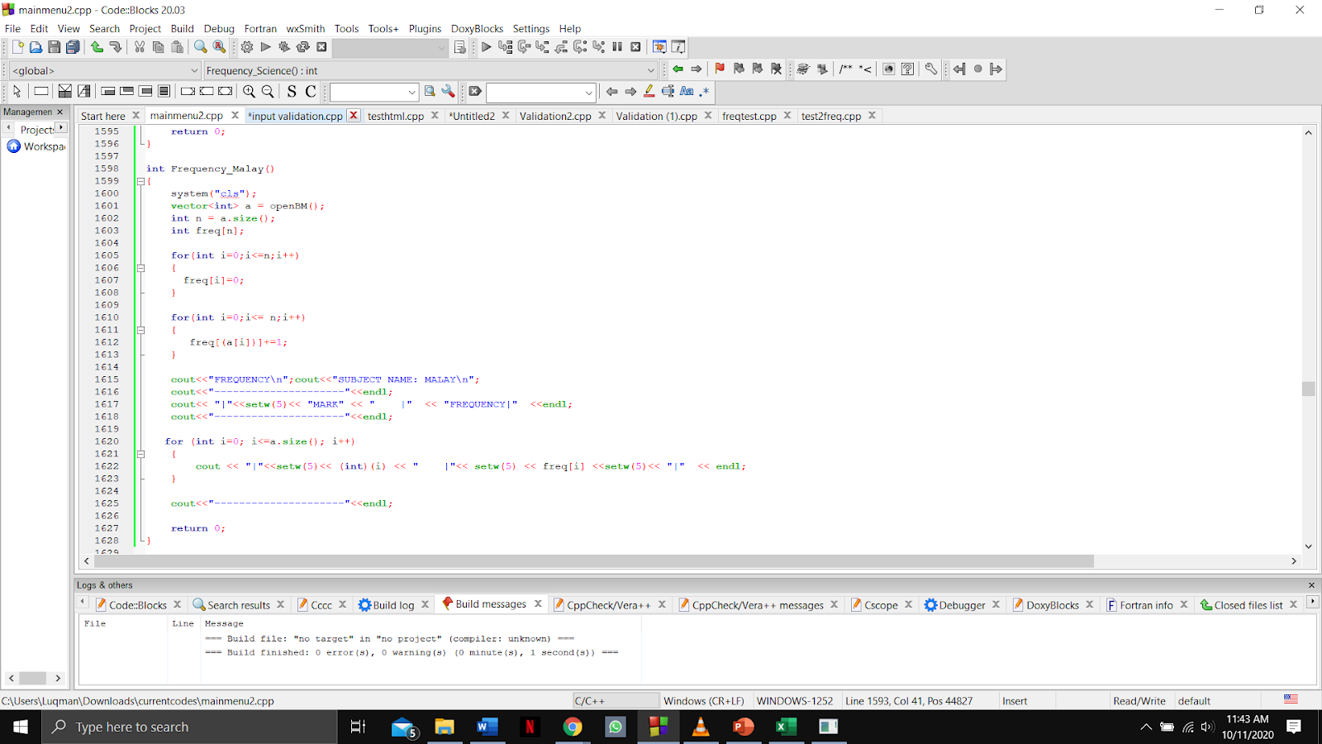

Output: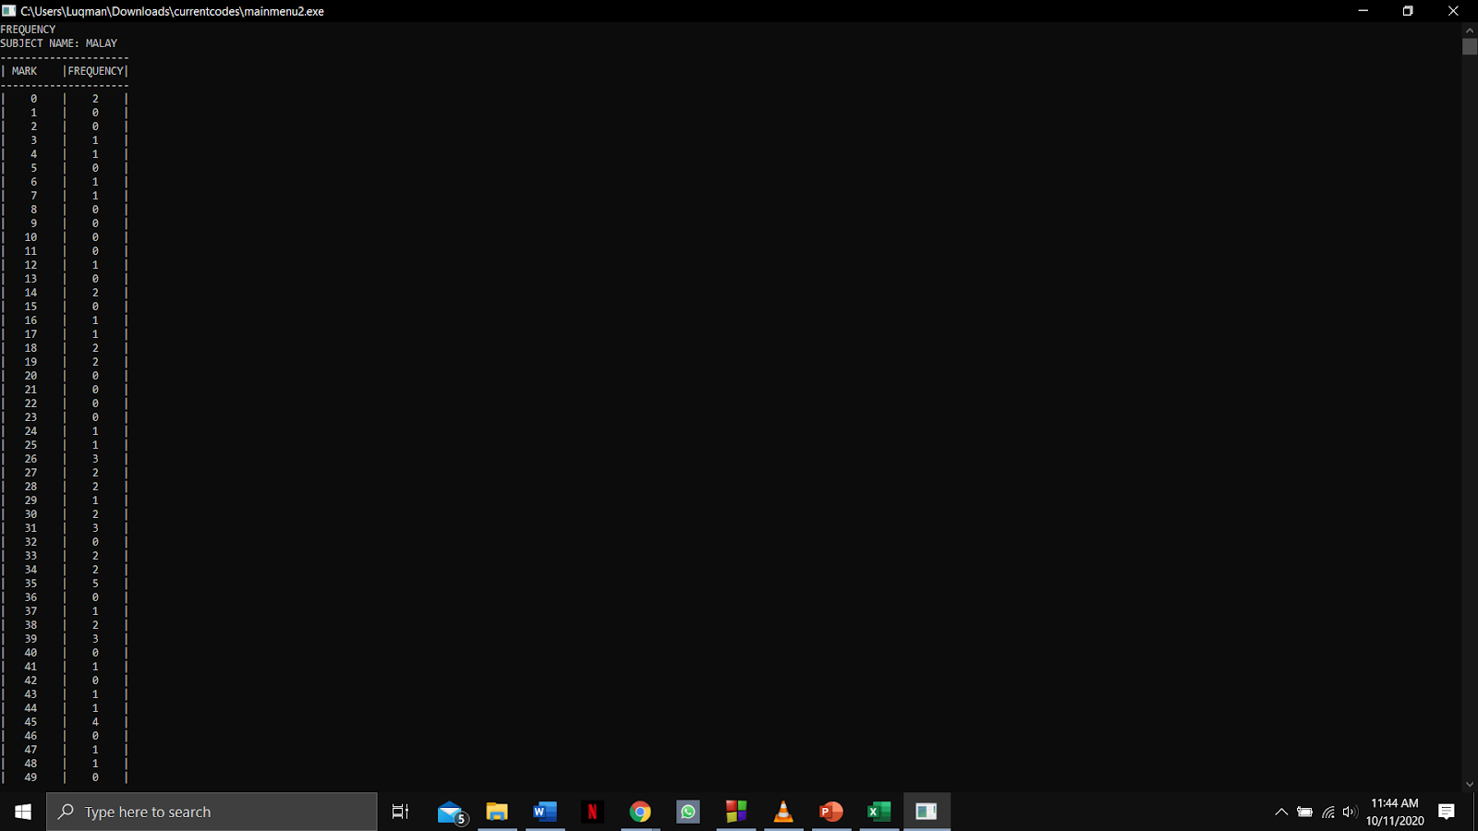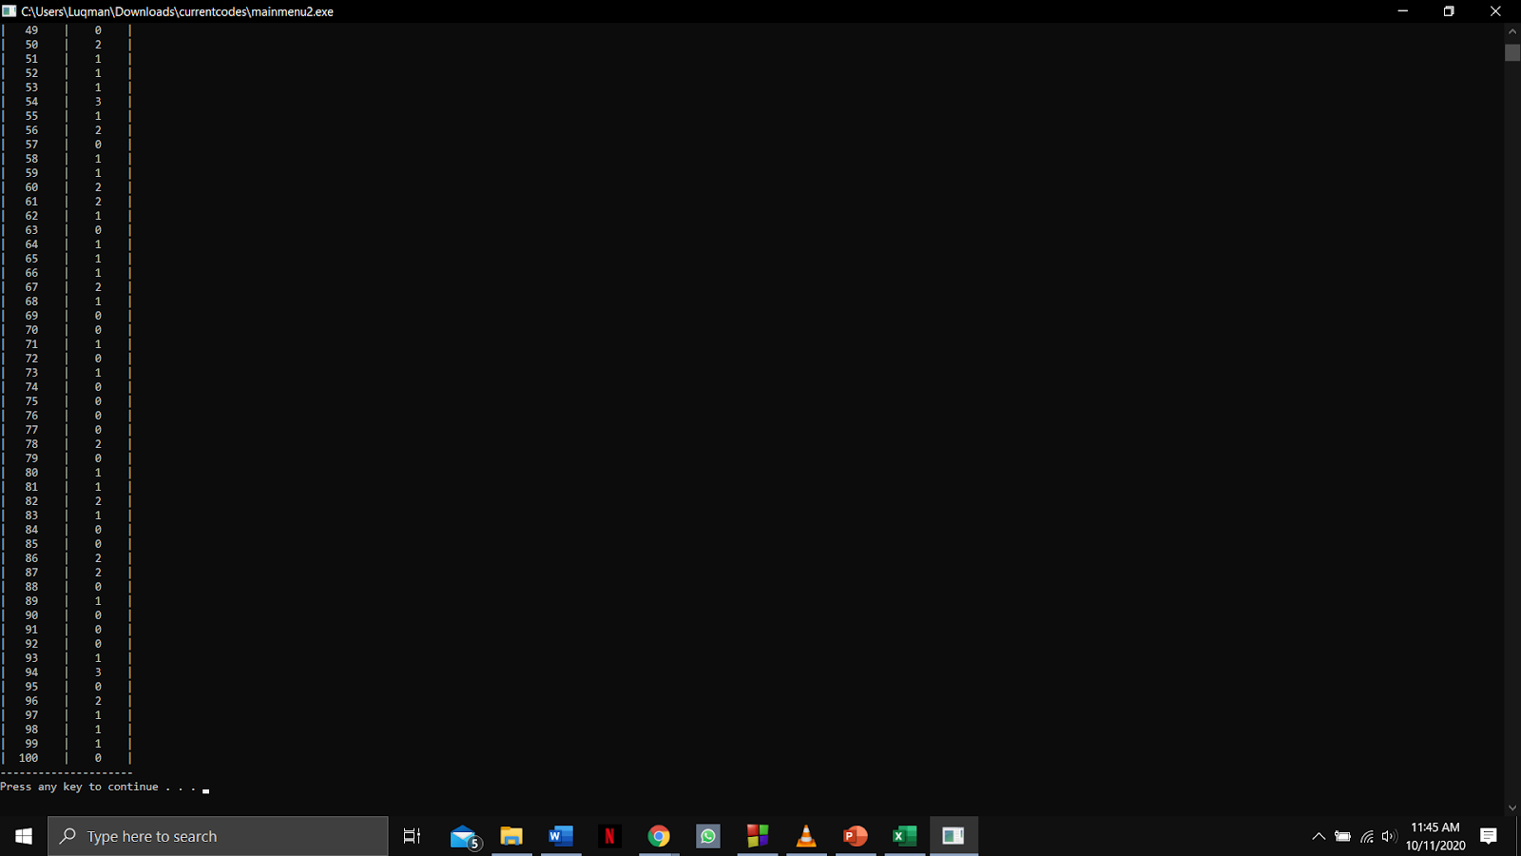

Function name: **findmaxFirst, histogramfreq and Plot_Histogram_Malay**

Input:

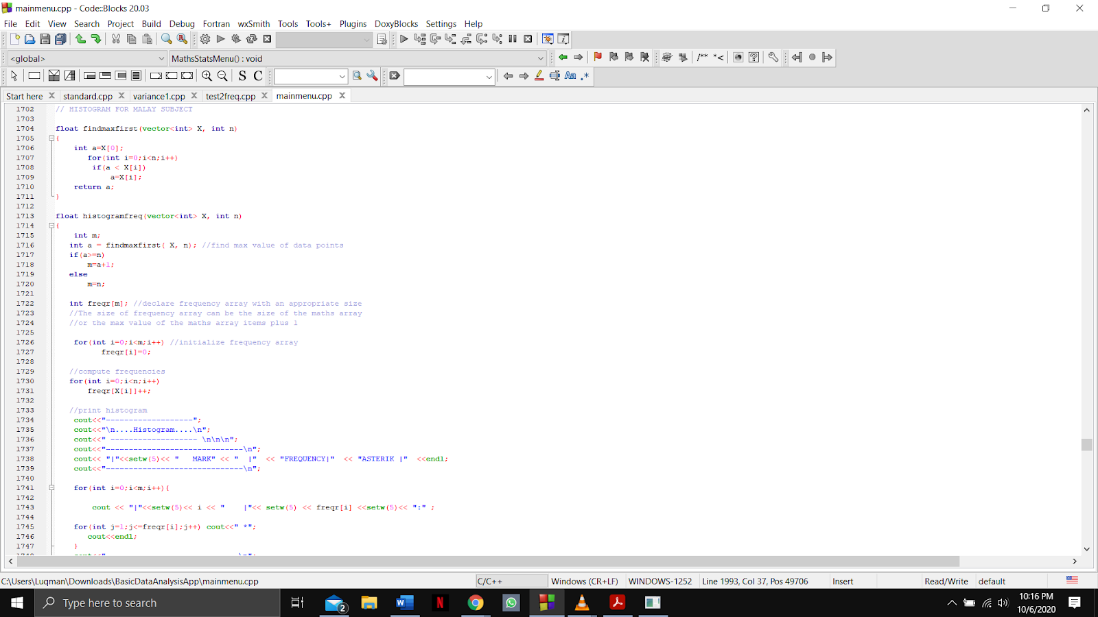

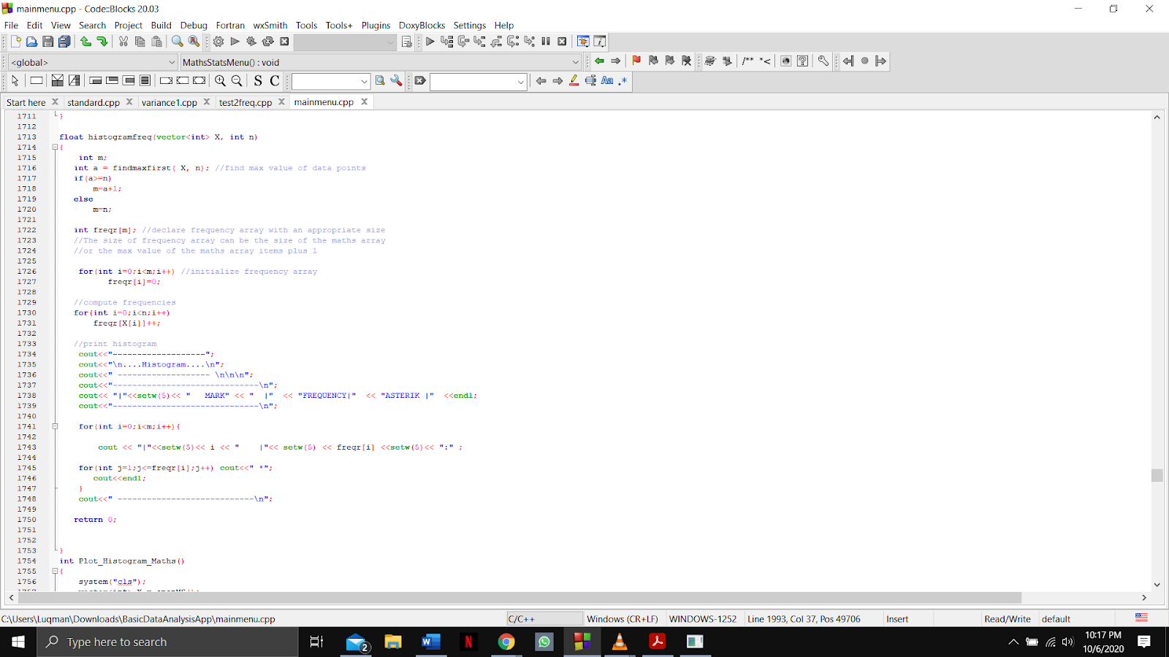

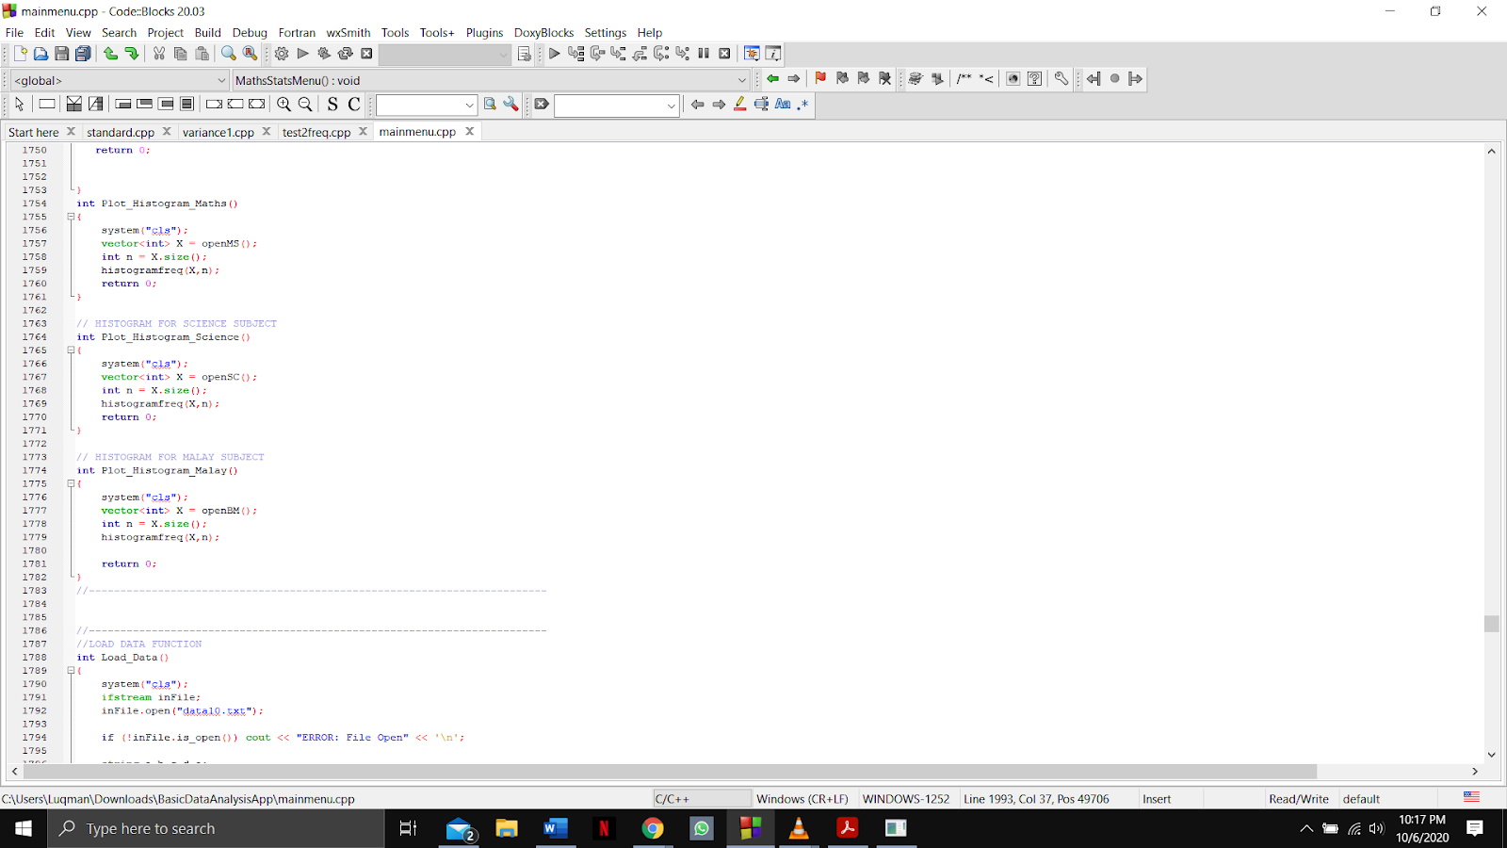

Output:

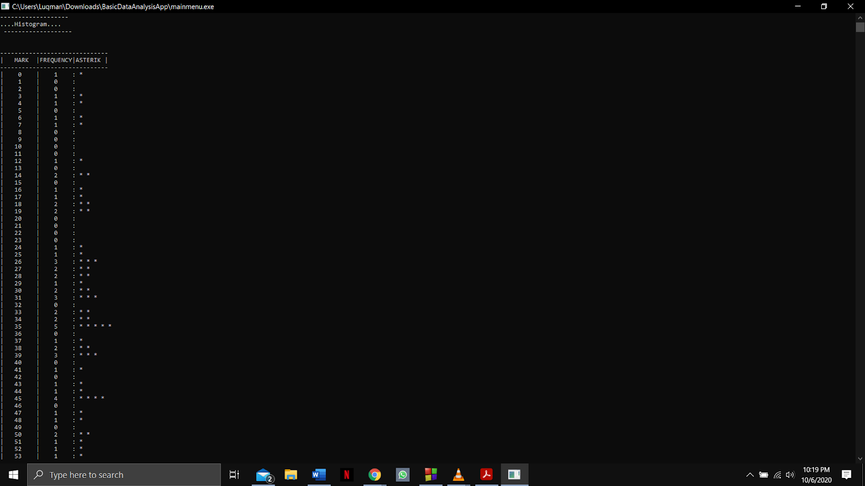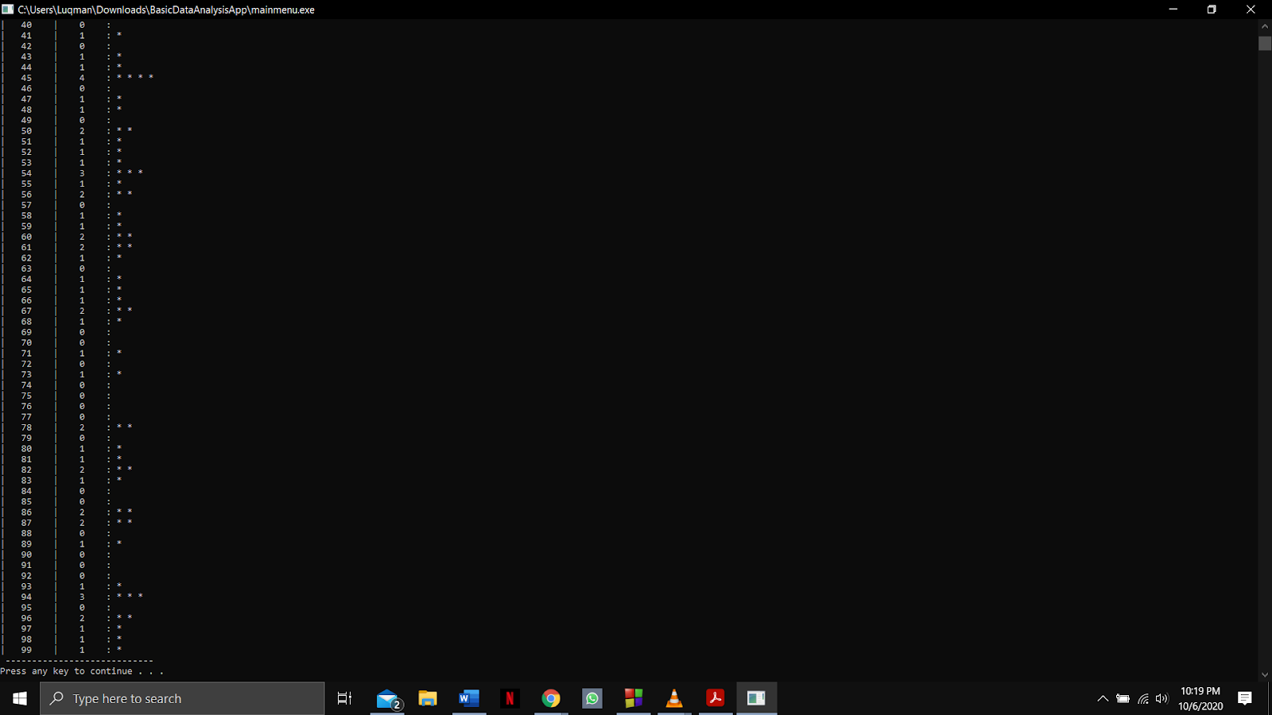

Function name: **ascending, descending and Ascending_Descending_Malay**

Input: 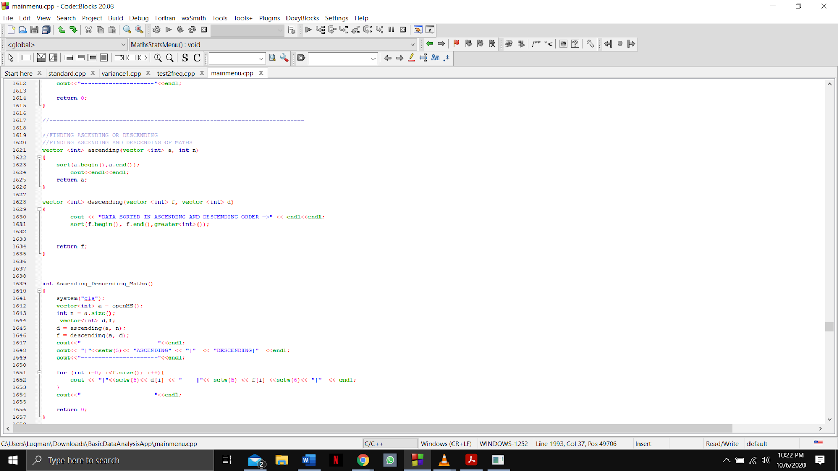

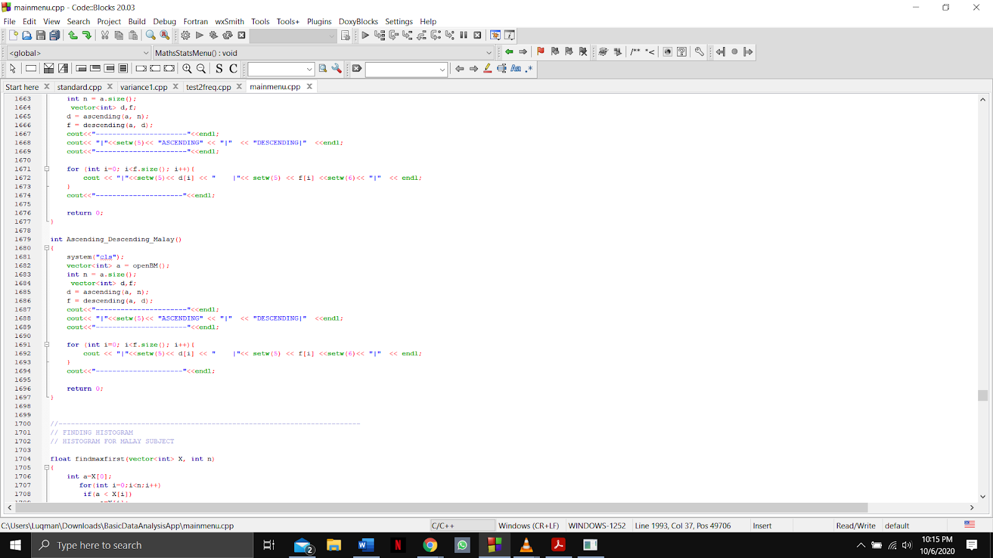

Output:

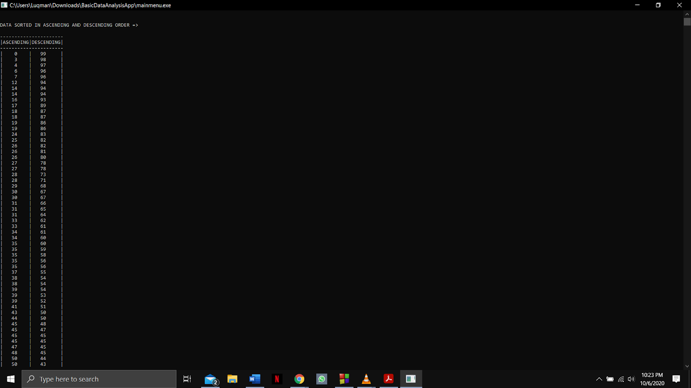

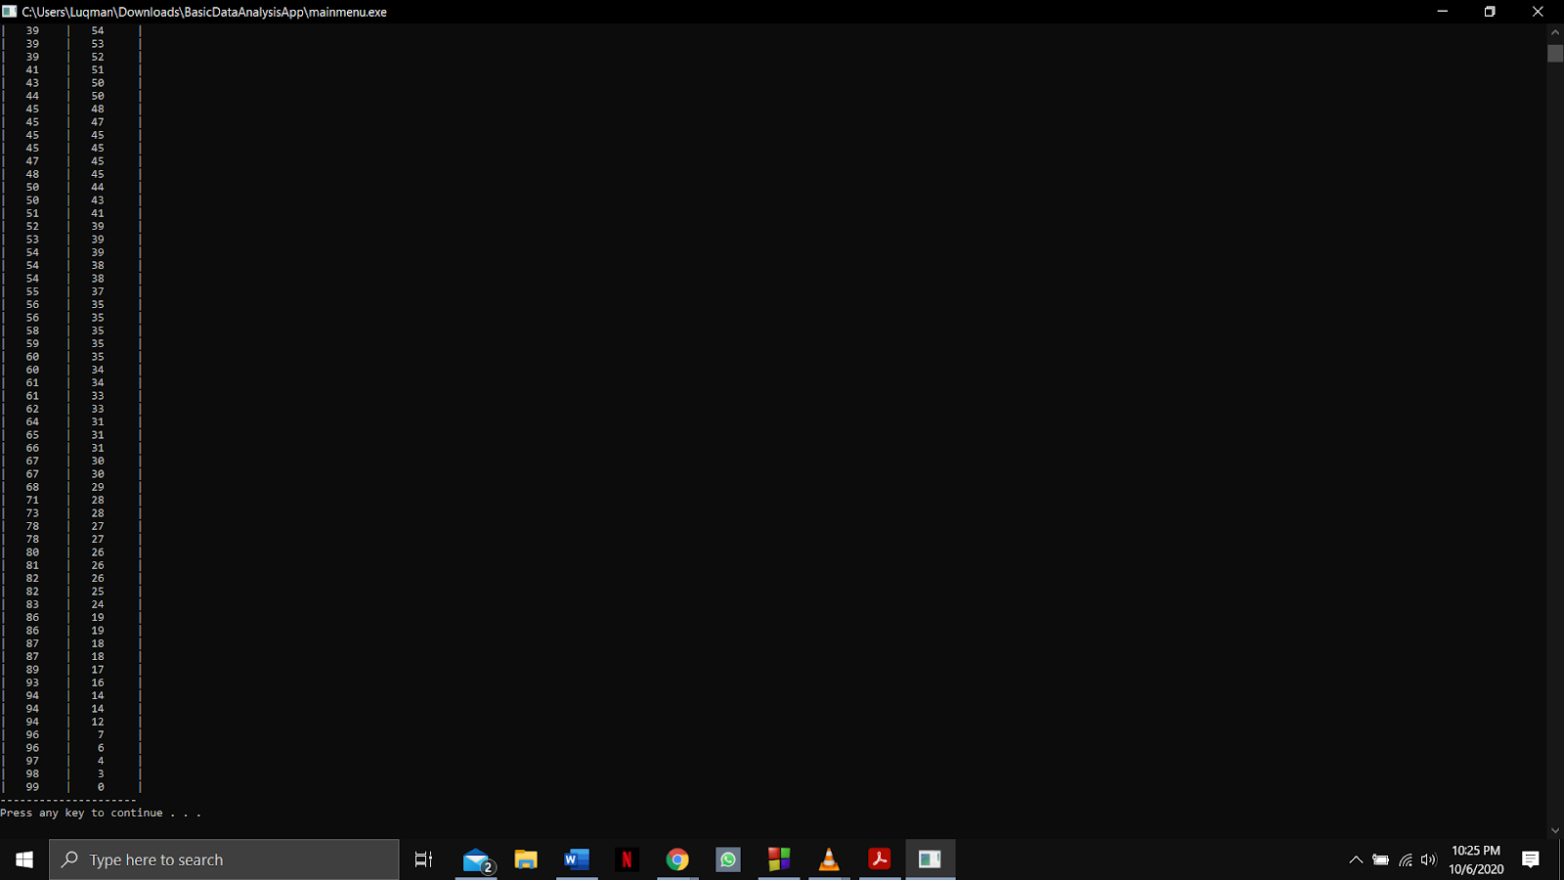

Function name: **What_Sub_Pearson and getChoice**

Input:

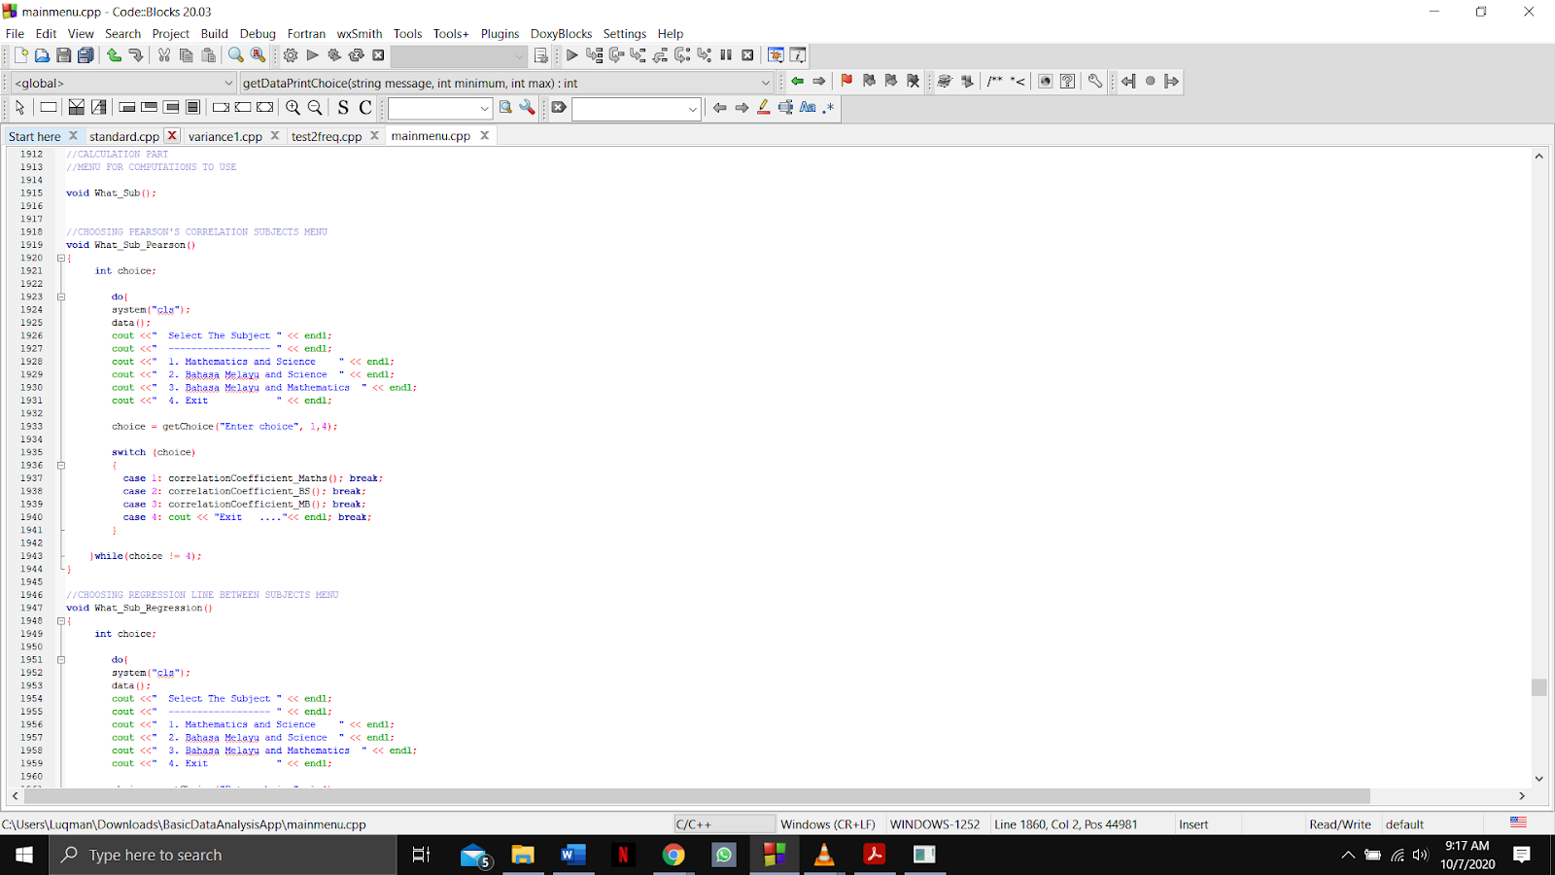



Output:

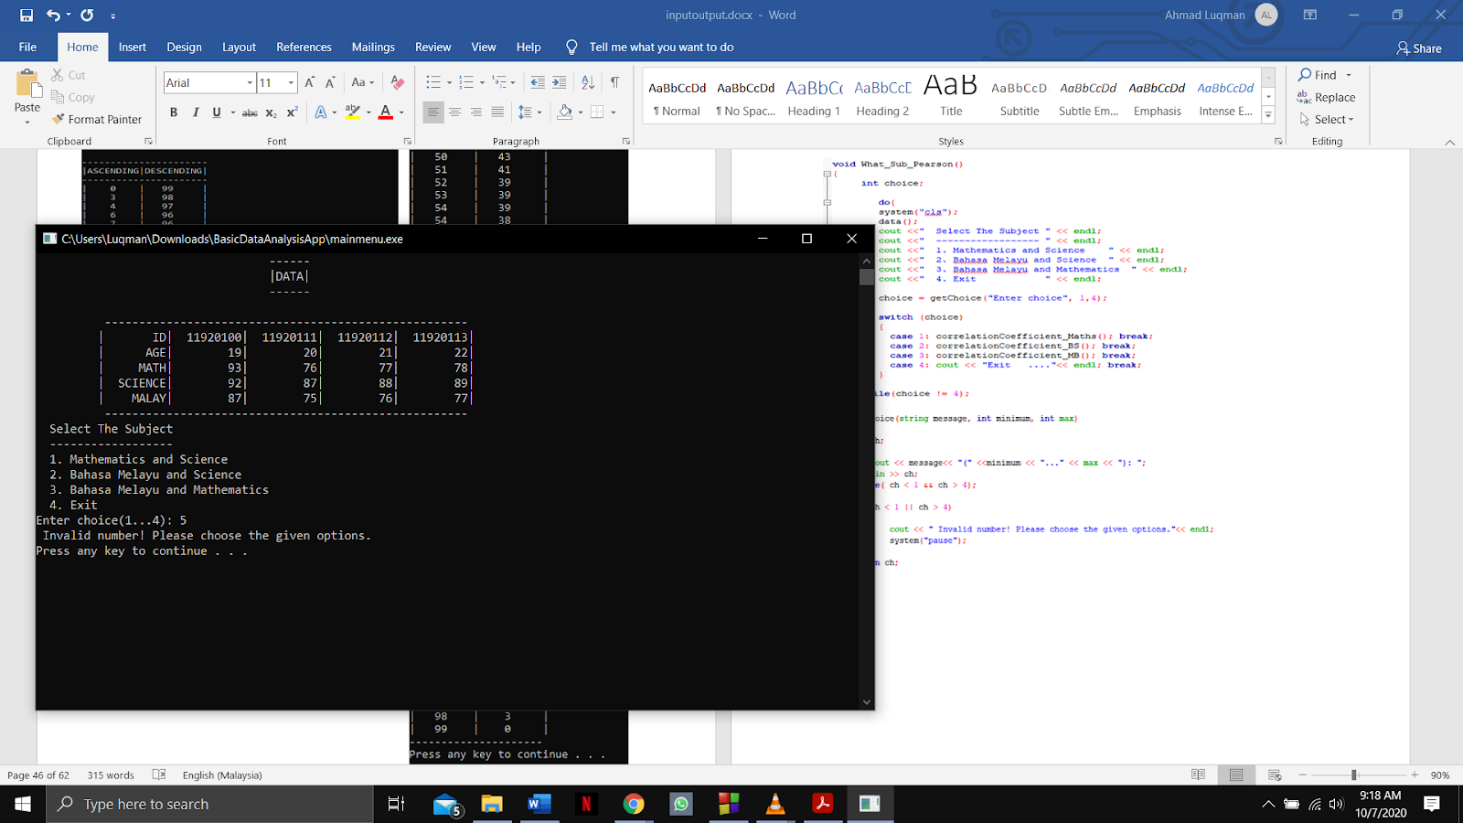

Function name: **correlationCoefficient_a and correlationCoefficient_Maths**

Input:

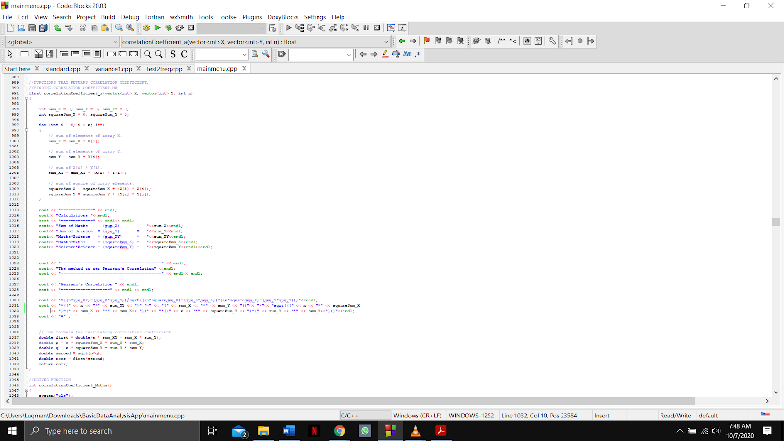

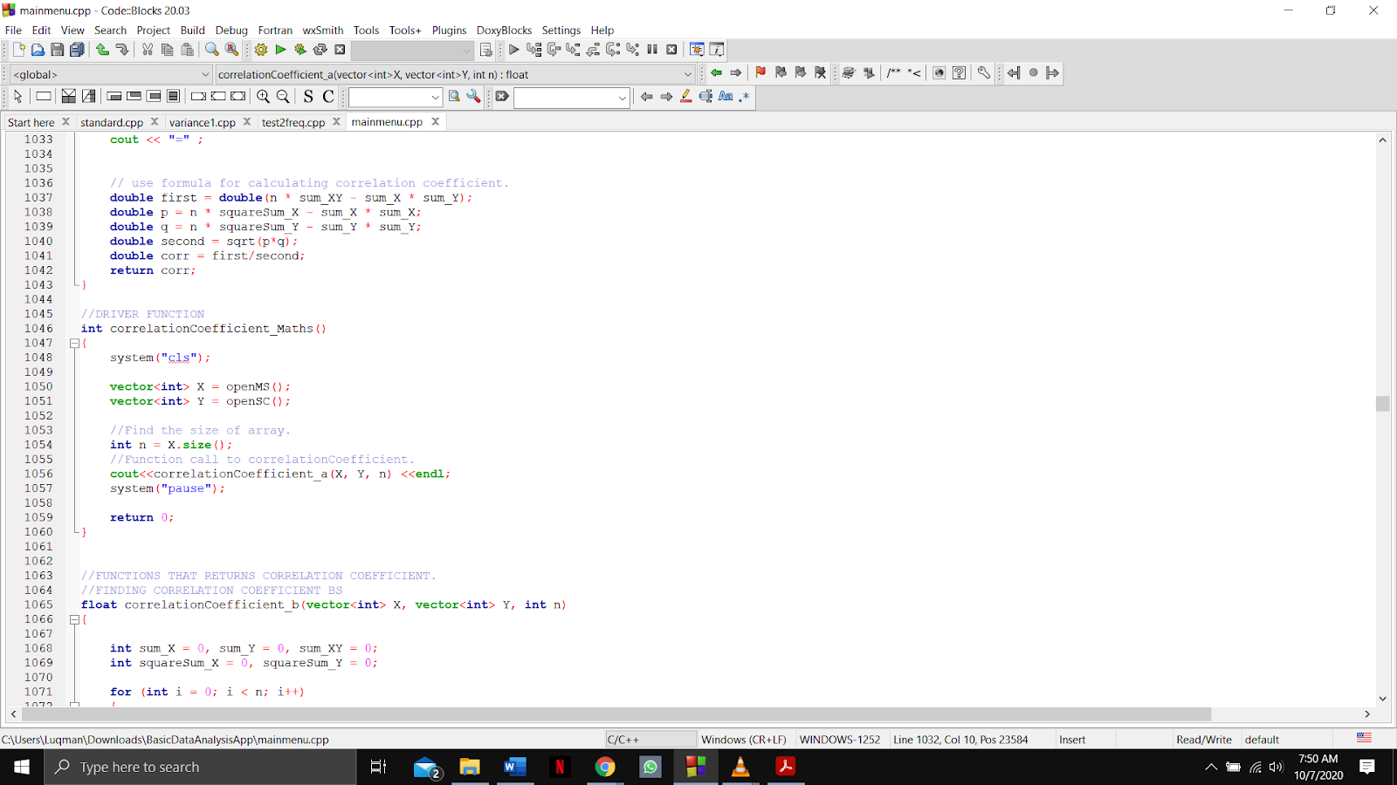

Output:

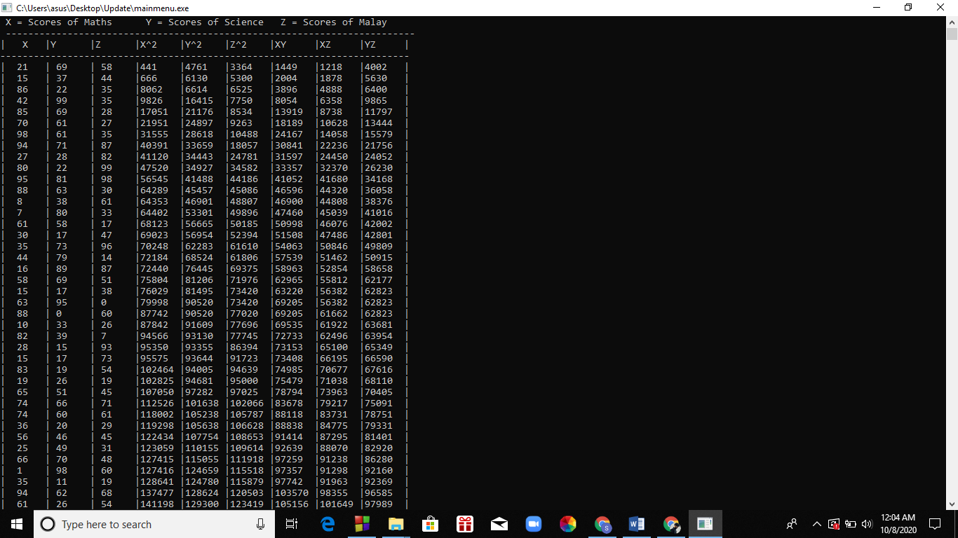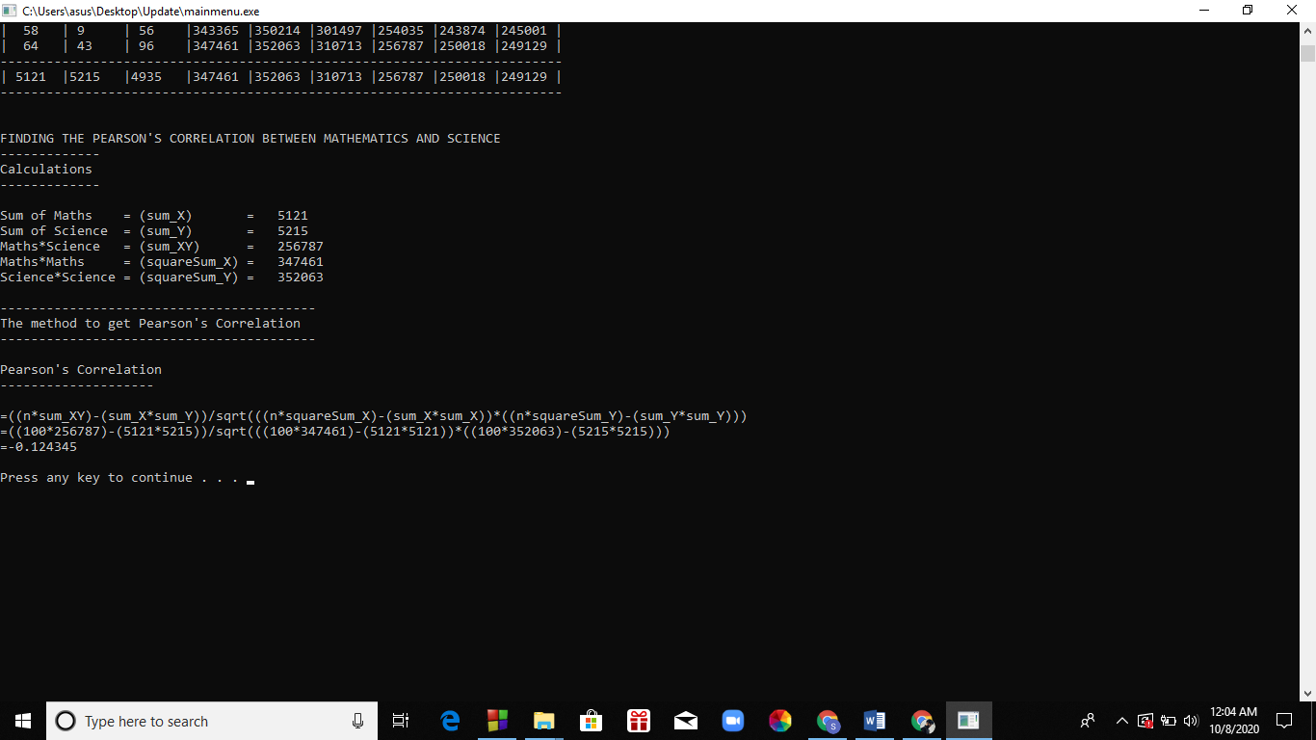

Function name: **correlationCoefficient_b and correlationCoefficient_BS**

Input: 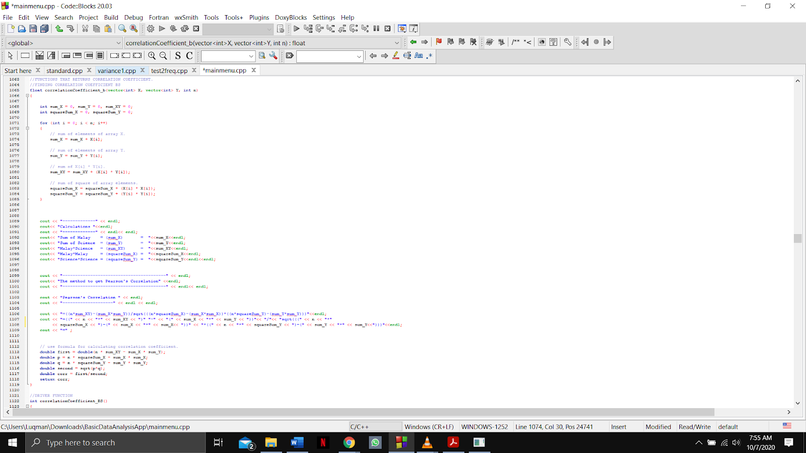

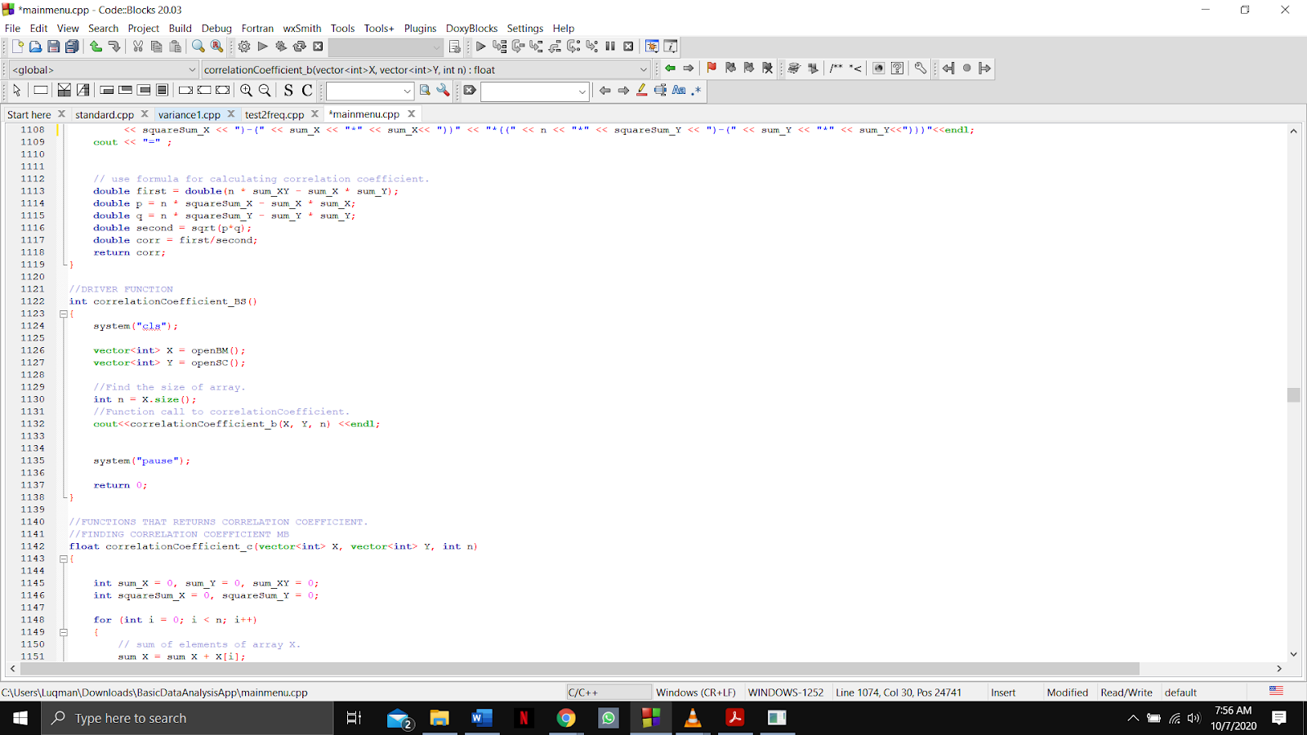

Output

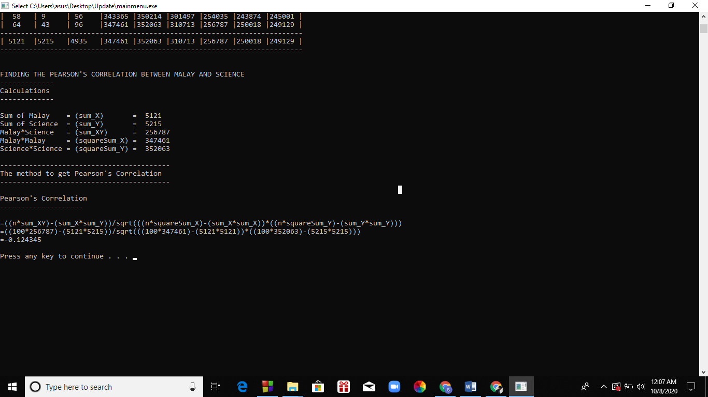

Function name: **correlationCoefficient_c and correlationCoefficient_MB**

Input:

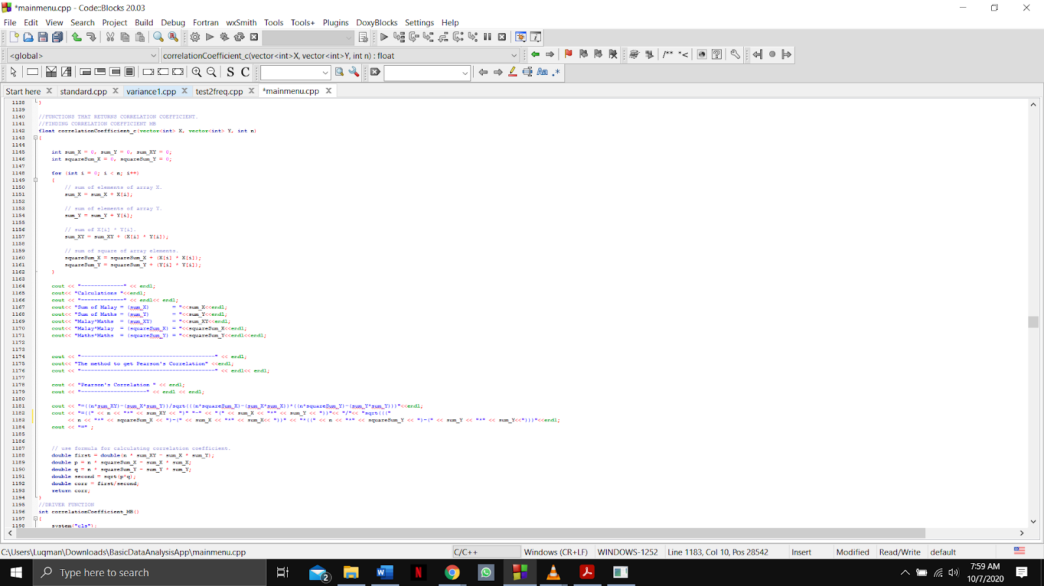

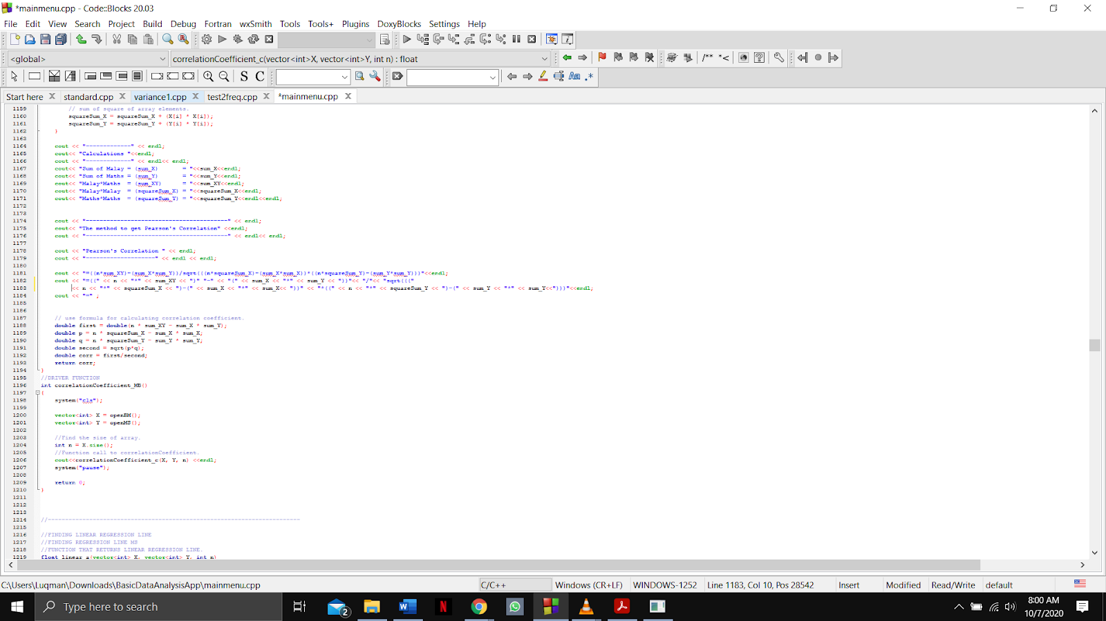

Output

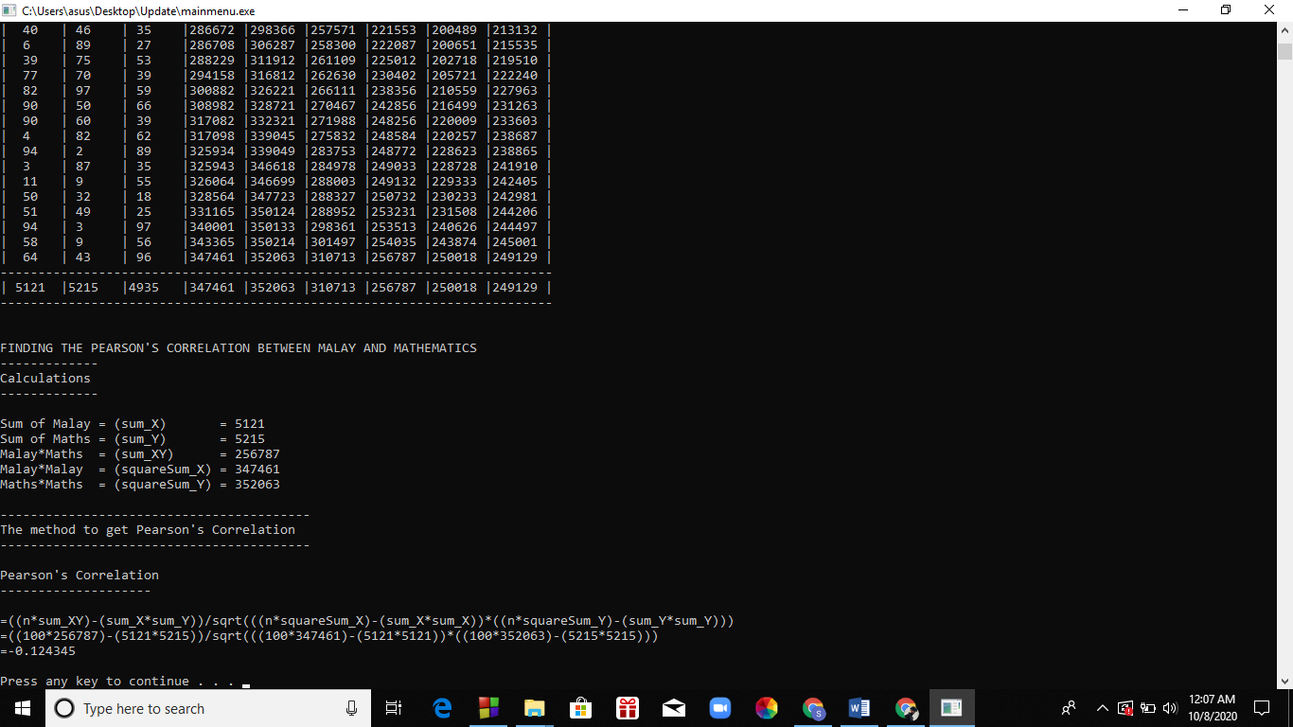

Function name: **What_Sub_Regression and getChoice**

Input:

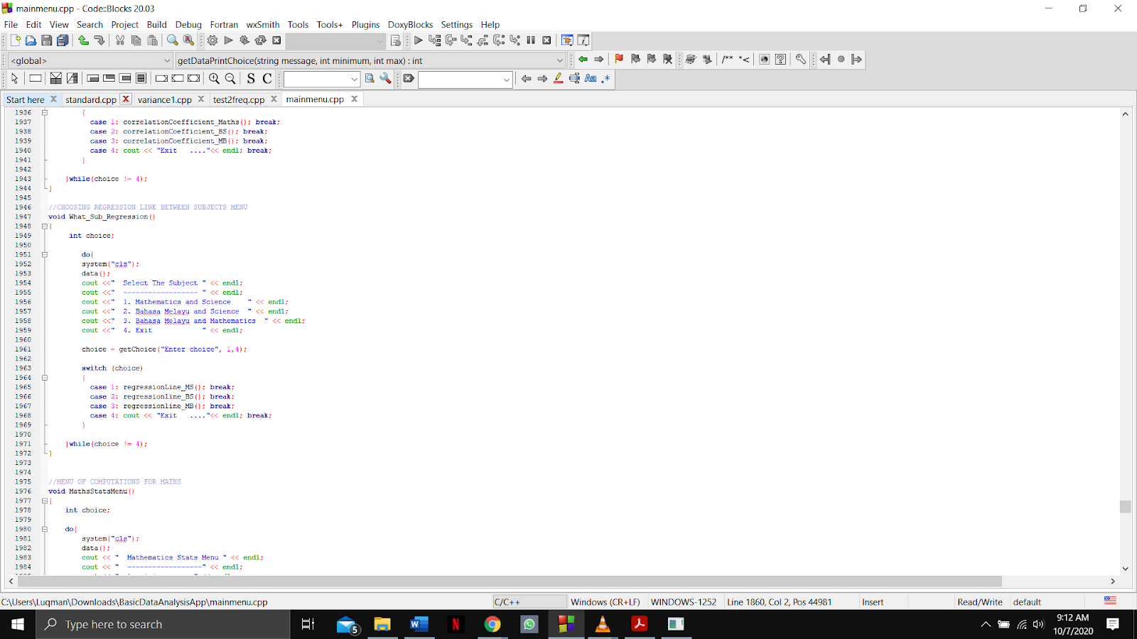



Output:

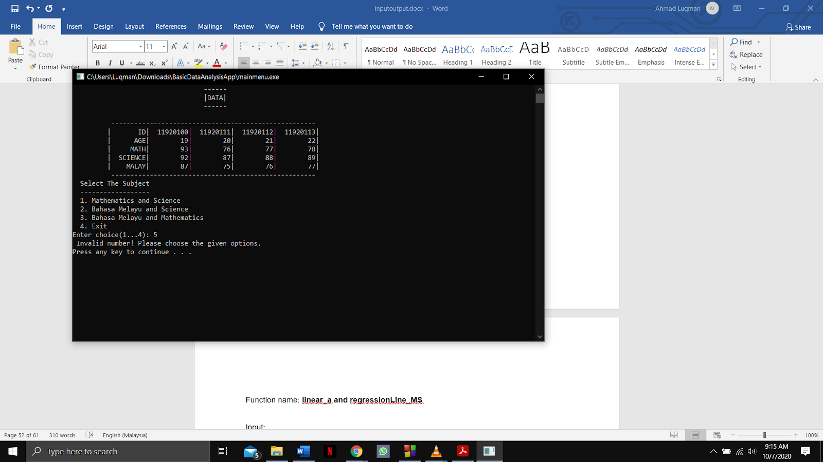

Function name: **linear_a and regressionLine_MS**

Input:

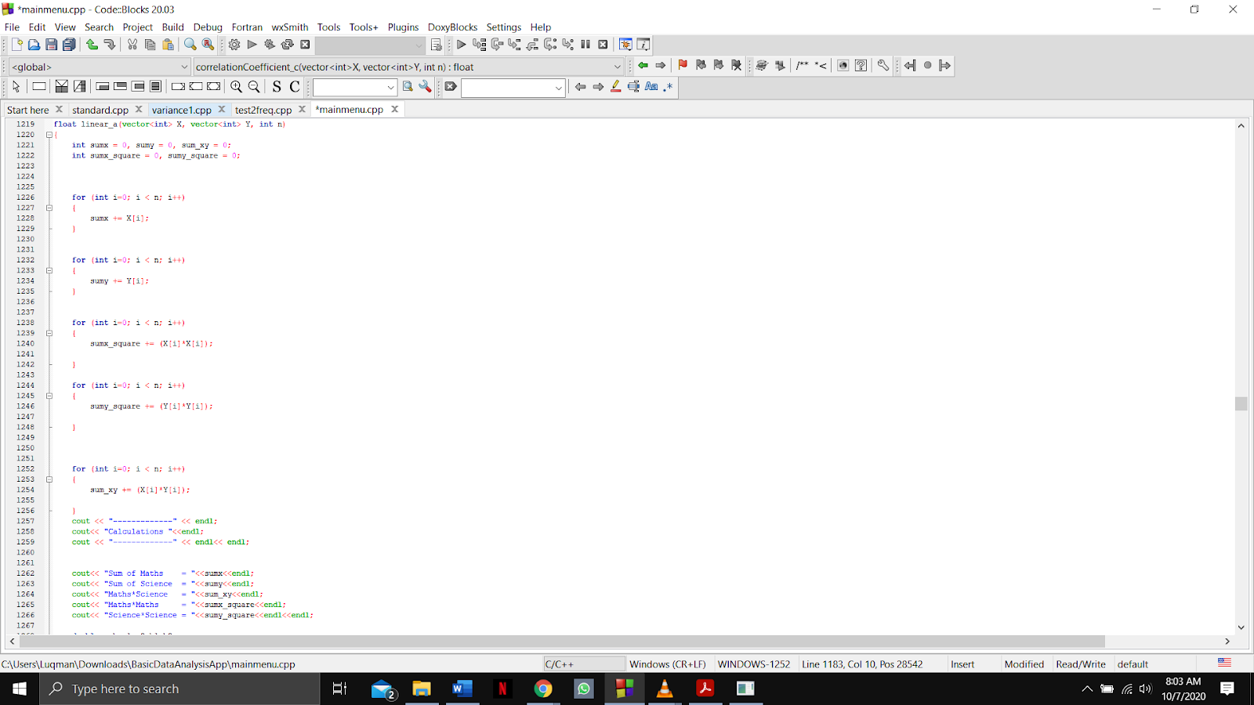

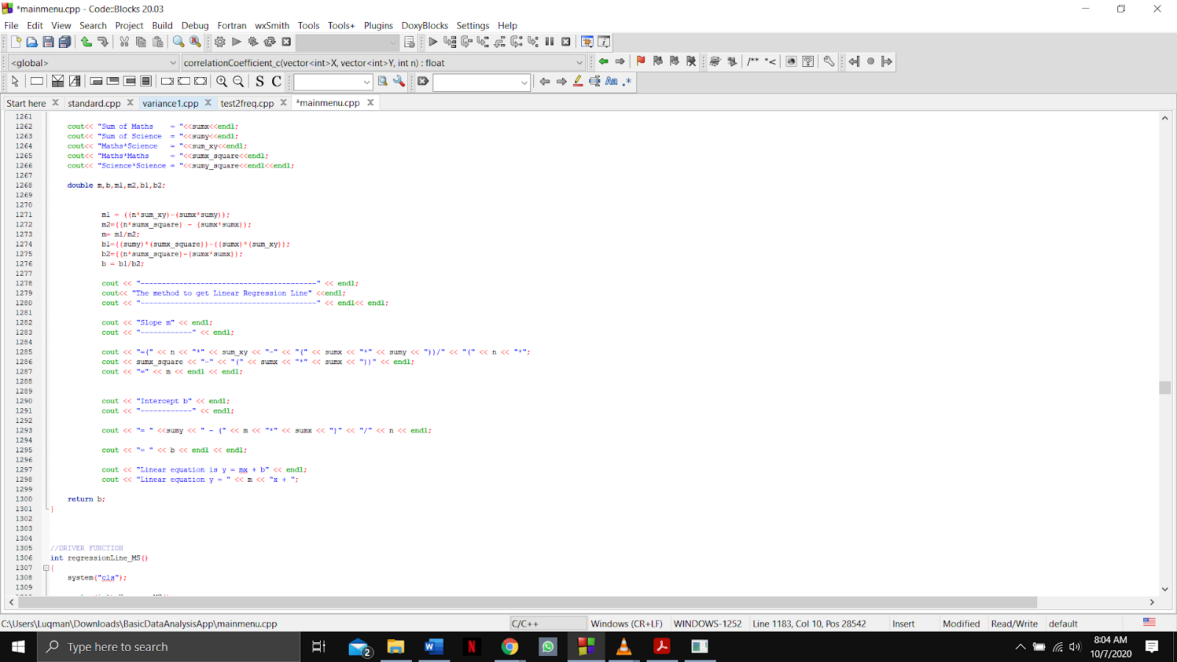

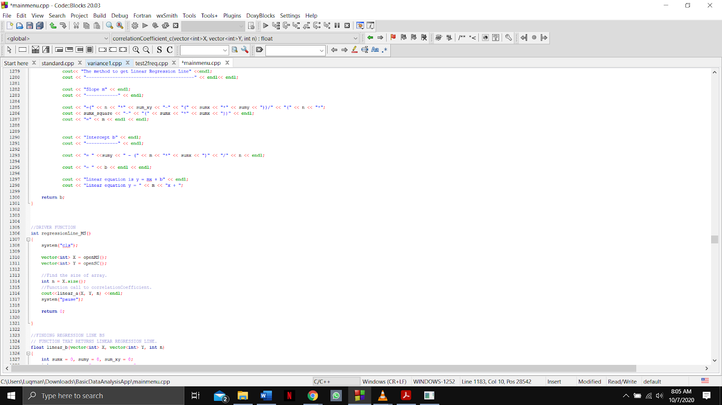

Output

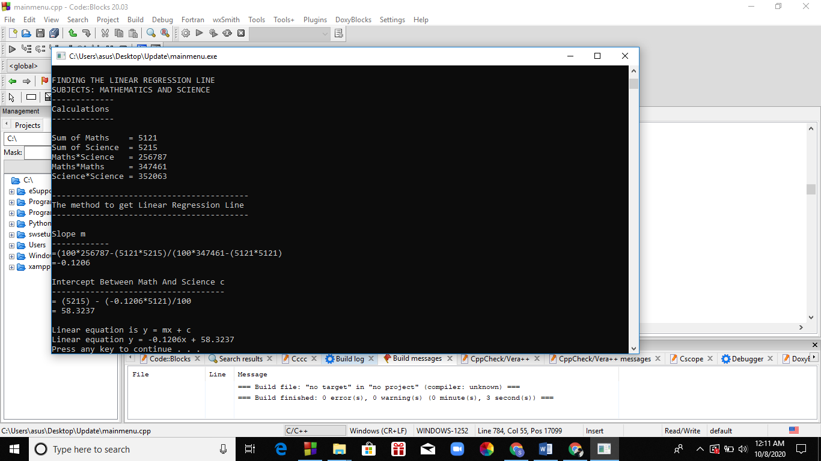

Function name: **linear_b and regressionLine_BS**

Input:

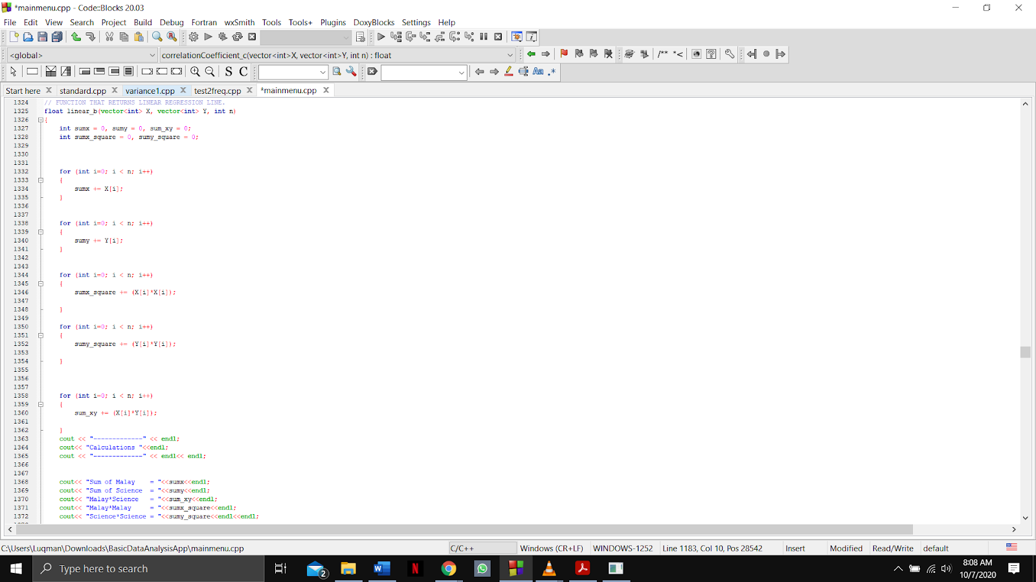

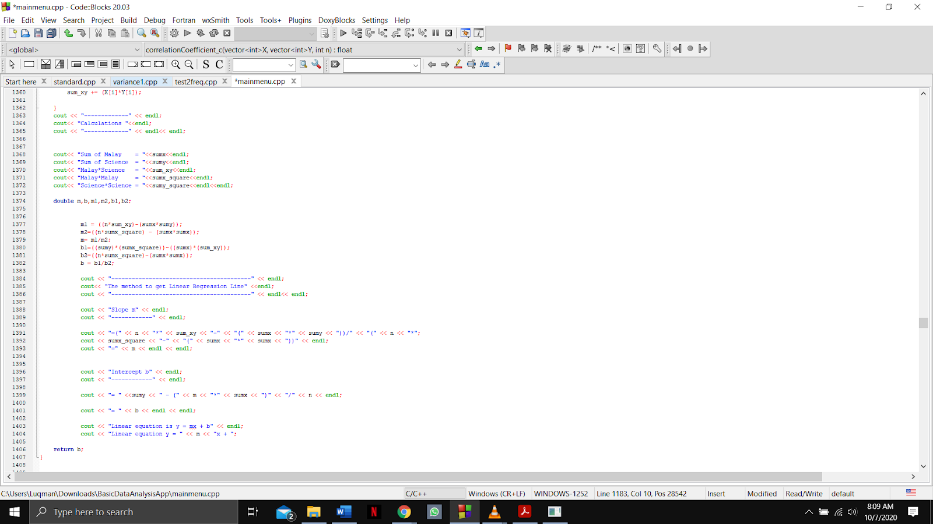

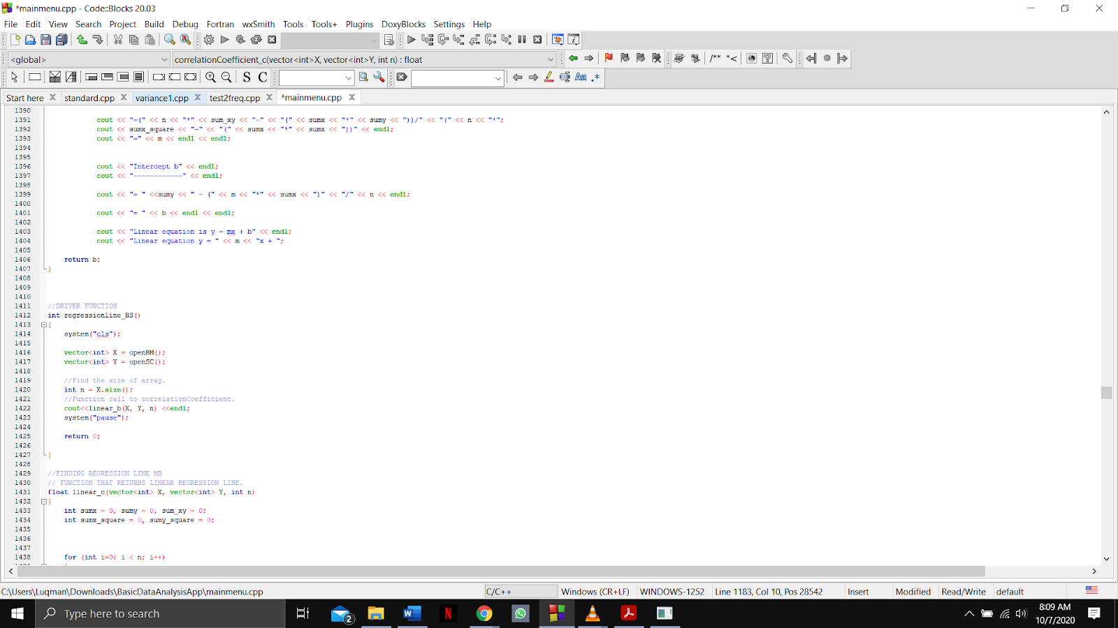

Output

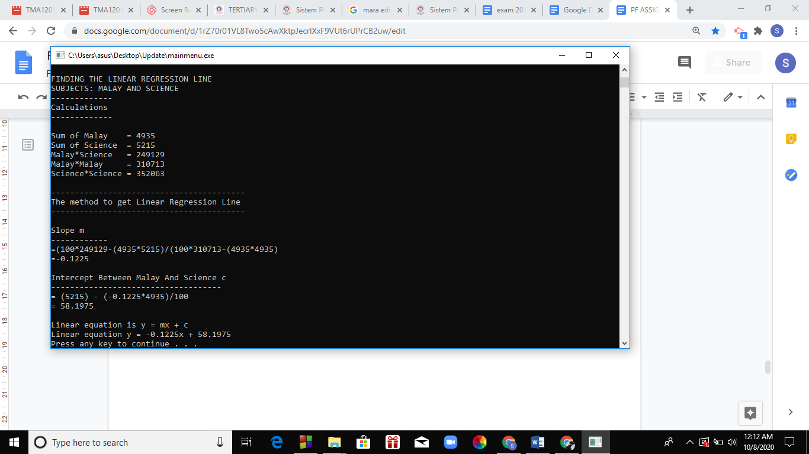

Function name: **linear_c and regressionLine_MB**

Input: 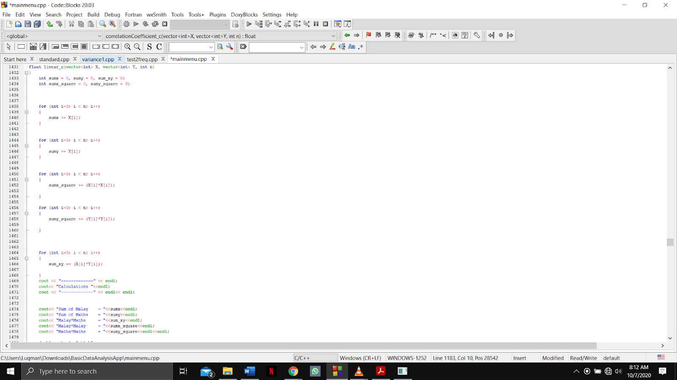

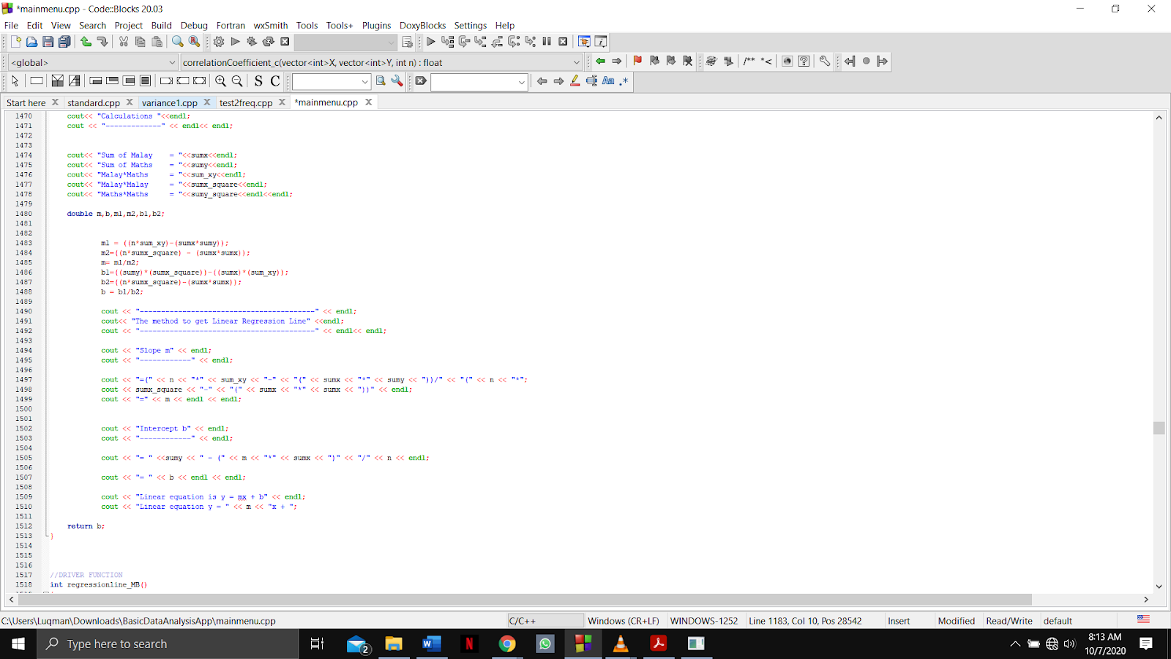

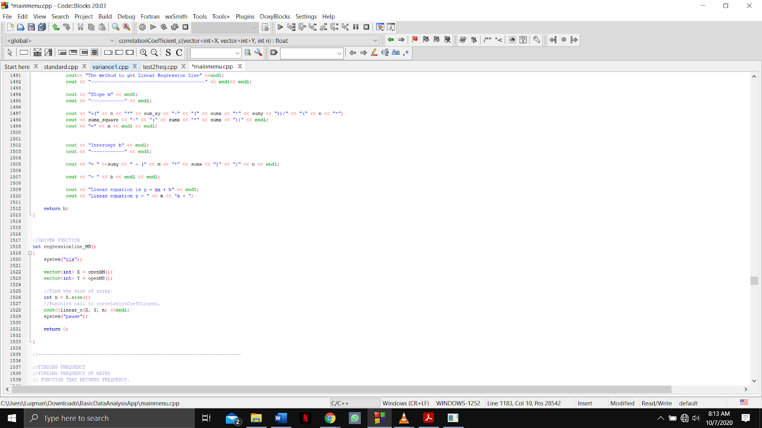

Output

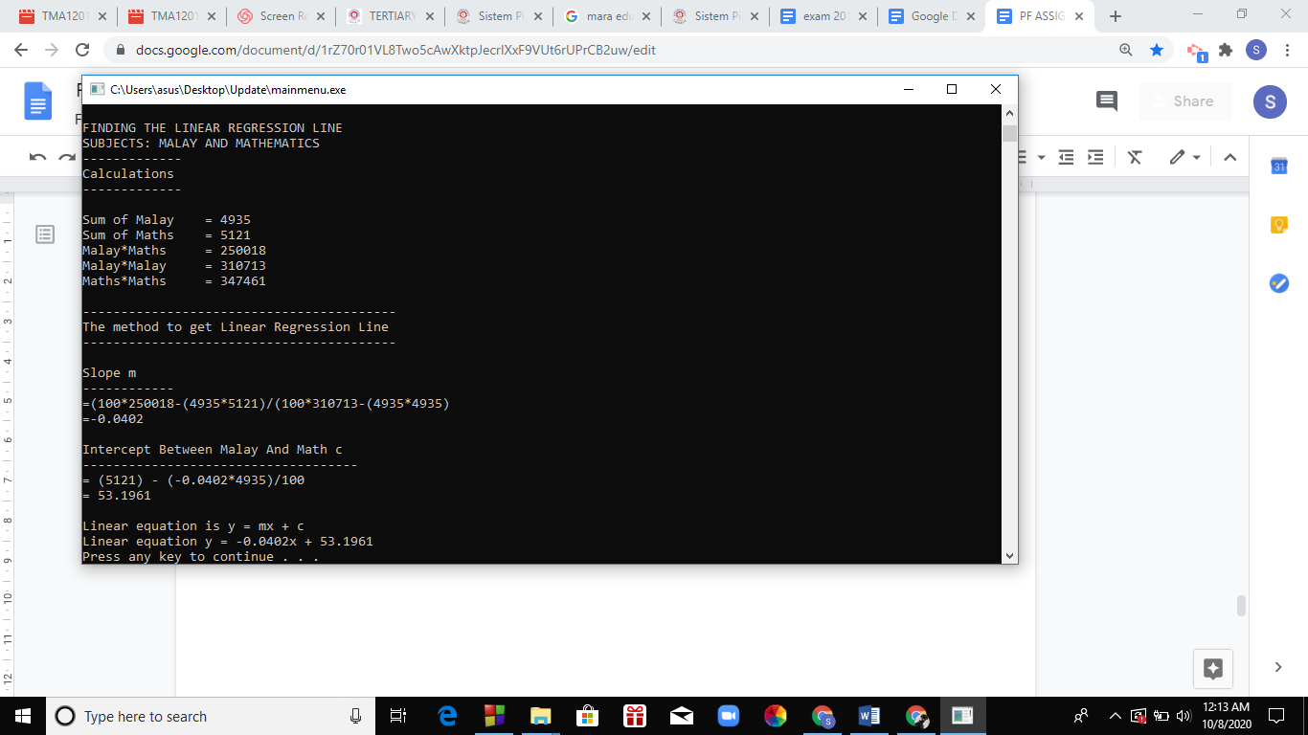

Function name: **ending**

Input:

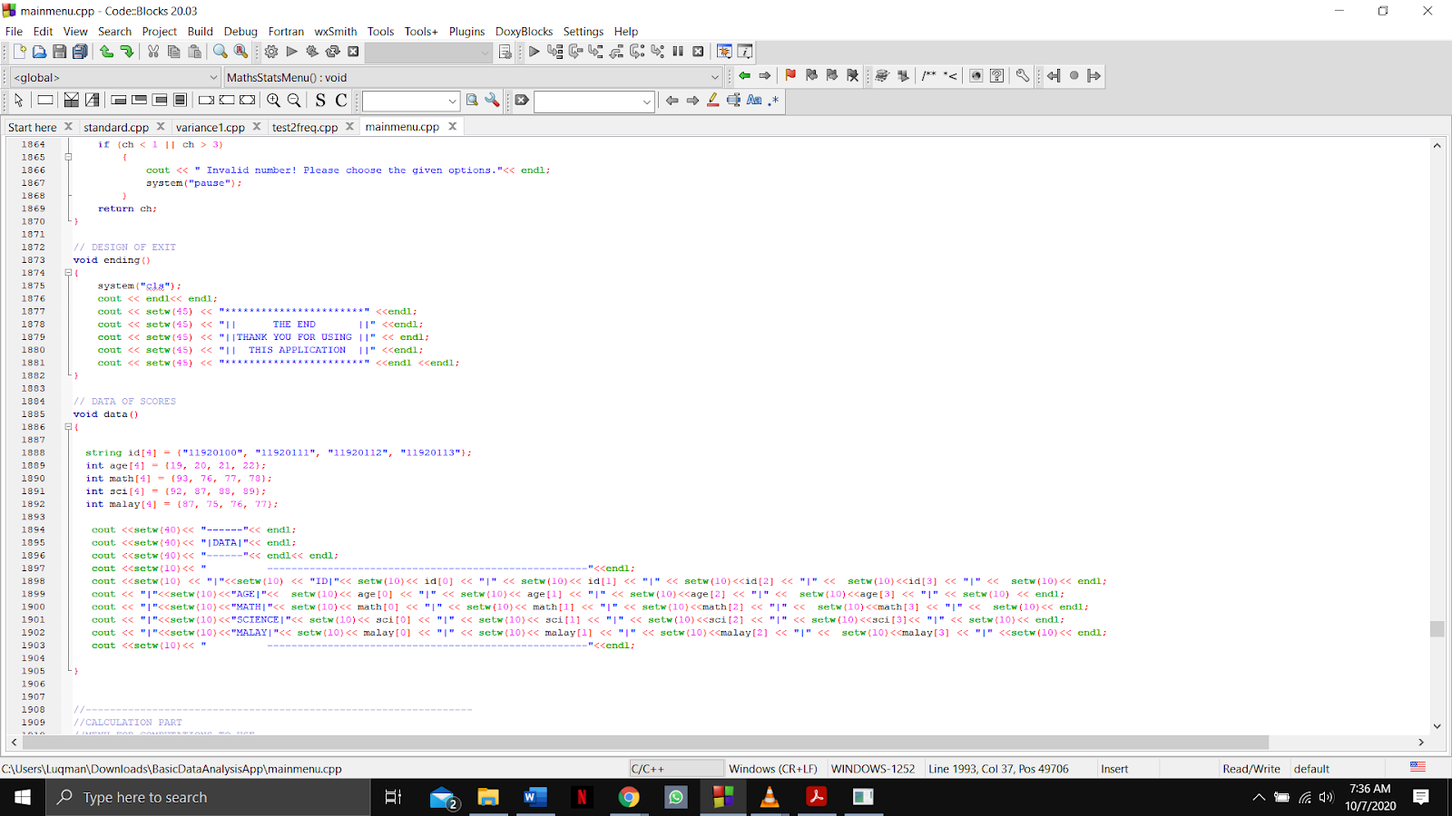

Output:

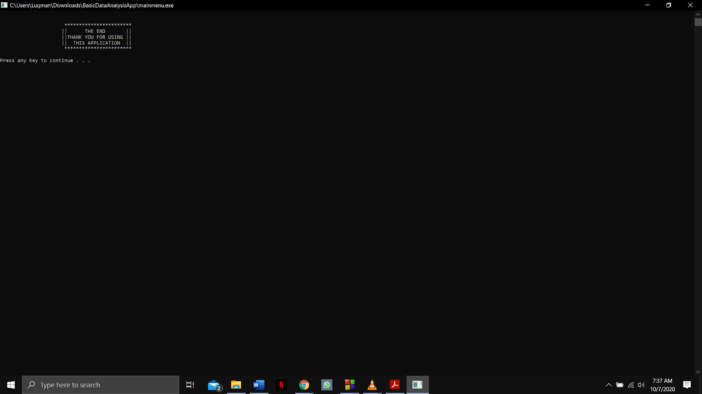

**Section 8: Students must cite and reference in APA style their sources of information about major algorithms such as correlation, regression, and other algorithms used in their programs**

|  |
| --- |
| Reference list  Dharmendra Kumar. (2018). Program to find correlation coefficient. Retrieved from  https://www.geeksforgeeks.org/program-find-correlation-coefficient/  kartik. (2018). Sorting a vector in C++. Retrieved from  https://www.geeksforgeeks.org/sorting-a-vector-in-c/  NAYONIKA. (2018). CSV file management using C++. Retrieved from  https://www.geeksforgeeks.org/csv-file-management-using-c/  Programiz. (n.d.). C++ Program to Calculate Standard Deviation. Retrieved from  https://www.programiz.com/cpp-programming/examples/standard-deviation  include help.com. (n.d.). C++ program to sort an array in Ascending Order. Retrieved from  https://www.includehelp.com/cpp-programs/sort-an-array-in-ascending-order.aspx  include help.com. (n.d.). C++ program to sort an array in Descending Order. Retrieved from  https://www.includehelp.com/cpp-programs/sort-an-array-in-descending-order.aspx  worldbestlearningcenter.com (n.d.) C++ program for histogram. Retrieved from  <https://www.worldbestlearningcenter.com/index_files/cpp-example-histogram.htm>  w3schools (n.d.) HTML tables allow web developers to arrange data into rows and columns. Retrieved from https://www.w3schools.com/html/html_tables.asp  In-text citation  An article where it has source codes to calculate correlation coefficient where it is an equation that is used to determine the strength of relation between two variables  (Dharmendra Kumar, 2018).  An article where it has source codes to sort a vector in either descending order or particular order  (kartik, 2018).  This article discusses about how to create, update and delete records in a CSV file  (NAYONIKA, 2018).  This program calculates the standard deviation of an individual series using arrays (Programiz[APA], n.d.).  This program will read total number of elements (N) and check value of N must be valid between 1-N, program will read N integer values (as array elements), print input elements with sorted array element after sorting elements in Ascending Order (include help.com[APA], n.d.).  This program will read total number of elements (N) and check value of N must be valid between 1-N, program will read N integer values (as array elements), print input elements with sorted array element after sorting elements in Descending Order (include help.com[APA], n.d.). |

**Section 9: Conclusion**

Example

|  |
| --- |
| ----------------------------------------------------------------------------------  The following functions have been completed correctly:  ----------------------------------------------------------------------------------  1. Minimum  2. Max  3. Median  4. Mean  5. Variance  6. Standard Deviation  7. Frequency  8. Histogram  9. Table below mean & Table above mean  10. Pearson’s Correlation  11. Linear regression Line  12. Sort by ascending or sort by descending  13. Statistical Report in TEXT File  14. Statistical Report in HTML File  ----------------------------------------------------------------------------------  The following functions have NOT been completed or NOT correct:  ----------------------------------------------------------------------------------  - check csv file format  - check keyboard input error |

**Conclusion.** *(satishnair)*

*There are several important things that I have learned from this project and they are how to code in C++ and how to work as a team to complete a project. Furthermore, I discovered how potential my teammates are when I worked with them. As I went through each part of the calculations I understood the lecture slides even better because I covered every slide and implemented the knowledge I gained in our assignment. For instance, infiling data,median, vector and so on. What I wish to be improved in the future is clear instructions for the project and better guidance throughout the project as I witnessed how everyone struggled when the rubrics have been altered at last minutes.*

**Section 10: Fill in the checklist table properly with student names for all the functions**

Assignment Checklist for Student to fill in

Total Marks: 160, to be scaled down to 40%, subject to change

Coding [40] section 1

Put only one [X] for each item in the checklist below

|  |  |  |  |  |  |
| --- | --- | --- | --- | --- | --- |
|  | Good Var Names | Good Func Names | Good Indentation | Good Spacing | Function count |
| 0 | >= 9 violations  **[]** | >= 9 violations  **[]** | >= 9 violations  **[]** | >= 9 violations  **[]** | <= 2  **[]** |
| 1 | 7 - 8 violations  **[]** | 7 - 8 violations  **[]** | 7 - 8 violations  **[]** | 7 - 8 violations  **[]** | 3 – 4  **[]** |
| 2 | 5 - 6 violations  **[]** | 5 - 6 violations  **[]** | 5 - 6 violations  **[]** | 5 - 6 violations  **[]** | 5 – 6  **[]** |
| 3 | 3 - 4 violations  **[]** | 3 - 4 violations  **[]** | 3 - 4 violations  **[]** | 3 - 4 violations  **[]** | 7 – 8  **[]** |
| 4 | <= 2 violations  **[]** | <= 2 violations  **[]** | <= 2 violations  **[]** | <= 2 violations  **[]** | >= 9  **[]** |

Comments with proofs

|  |
| --- |
|  |

Coding [40] section 2

Put only one [X] for each item in the checklist below

|  |  |  |  |  |
| --- | --- | --- | --- | --- |
|  | Func. (single purpose, not generalized) | Comments were used appropriately | Self-Documenting | Code Efficiency & Strategy  (weight x 2) |
| 0 | >= 5 violations  **[]** | 0 comments  **[]** | Very hard for others to figure out  **[]** | [0] Not working at all  **[]** |
| 1 | 4 violations  **[]** | Very little useful comments  **[]** | Can figure out only a little bit  **[]** | [2] A lot of redundant code  **[]** |
| 2 | 3 violations  **[]** | Have useful comments but can be better  **[]** | Moderately clear  **[]** | [4]Some redundant code but not serious  **[]** |
| 3 | 2 violations  **[]** | Excessive comments  **[]** | Almost perfect, can improve a bit  **[]** | [6]Almost perfect, can improve a bit  **[]** |
| 4 | 0 – 1 violation  **[]** | Very appropriate (Not too little, nor too much)  **[]** | Code is very clear and easy to understand  **[]** | [8] Very well done  **[]** |

Comments with proofs

|  |
| --- |
|  |

Program Features of 14 functions [56] part 1, 40+56=96

Put only one [X] for each item in the checklist below

Put only one student full name for each function

|  |  |  |  |  |  |  |  |  |
| --- | --- | --- | --- | --- | --- | --- | --- | --- |
|  |  | Min | Max | Mean | Median | Var | S.D. | Occ/Freq |
| 0 | >=2 errors | **[]** | **[]** | **[]** | **[]** | **[]** | **[]** | **[]** |
|  |  |  |  |  |  |  |  |  |
| 2 | 1 error | **[]** | **[]** | **[]** | **[]** | **[]** | **[]** | **[]** |
|  |  |  |  |  |  |  |  |  |
| 4 | no error | **[]** | **[]** | **[]** | **[]** | **[]** | **[]** | **[]** |
|  | Put only one student full name for each function | **Satish Nair** | **Satish Nair** | **Satish Nair** | **Satish Nair** | **Ahmad Luqman** | **Ahmad Luqman** | **Ahmad Luqman** |

Comments with proofs

|  |
| --- |
|  |

Program Features of 14 functions [56] part 2, 40+56=96

Put only one [X] for each item in the checklist below

Put only one student full name for each function

|  |  |  |  |  |  |  |  |  |
| --- | --- | --- | --- | --- | --- | --- | --- | --- |
|  |  | Histogram | Table below mean & above mean | Pearson’s  correl. | Linear regr. line | Sorting (Ascending  &  Descending) | Stat.  TXT  Report | Stat.  HTML Report |
| 0 | >=2 errors | **[]** | **[]** | **[]** | **[]** | **[]** | **[]** | **[]** |
|  |  |  |  |  |  |  |  |  |
| 2 | 1 error | **[]** | **[]** | **[]** | **[]** | **[]** | **[]** | **[]** |
|  |  |  |  |  |  |  |  |  |
| 4 | no error | **[]** | **[]** | **[]** | **[]** | **[]** | **[]** | **[]** |
|  | Put only one student full name for each function | **Avinash Imanuel a/l Gana Raj Imanuel** | **Kishen Kumar** | **Satish Nair** | **Kishen Kumar** | **Kishen Kumar** | **Avinash Imanuel a/l Gana Raj Imanuel** | **Avinash Imanuel a/l Gana Raj Imanuel** |

Comments with proofs

|  |
| --- |
|  |

Error Handling, User Interface, Report [8 + 8 + 48] part 1, 96 + 8 + 8 + 48 = 160

Put only one [X] for each item in the checklist below

|  |  |  |  |  |  |  |
| --- | --- | --- | --- | --- | --- | --- |
| Error Handling [8] | | |  | User Interface [8] | | |
|  | Robust Input | Run-Time-Error |  |  | User Experience | Consistency |
| 0 | None  **[]** | >= 4 sources of RTE  **[]** |  | 0 | Frustrated to use  **[]** | Not consistent at all  **[]** |
| 1 | Can handle only numeric input errors  **[]** | 3 sources of RTE  **[]** |  | 1 | Confusing, non-intuitive  **[]** | Need many (>=3) improvements  **[]** |
| 2 | Can handle only char input errors  **[]** | 2 sources of RTE  **[]** |  | 2 | Usable, clear, but boring  **[]** | Need some (2) improvements  **[]** |
| 3 | Can handle only string input errors  **[]** | 1 source of RTE  **[]** |  | 3 | Nice and interesting  **[]** | Need a little (1) improvement  **[]** |
| 4 | Can handle all kinds of input errors  **[]** | None  **[]** |  | 4 | A joy to use  **[]** | Very consistent  **[]** |

Comments with proofs

|  |
| --- |
|  |

Error Handling, User Interface, Report [8 + 8 + 48] part 2, 96 + 8 + 8 + 48 = 160

Put only one [X] for each item in the checklist below

|  |  |  |  |  |
| --- | --- | --- | --- | --- |
|  | Report [48] | | | |
|  | Struct. Chart  AP1 | Flowcharts  >= 14 functions  (weight x 3)  AP1 | Documentation  AP1 (0-4) & AP2(0-4)  AP1 docu = ?  AP2 docu = ? | Video |
| 0  >=7 errors | **[]** | 0  **[]** | **[]** | **[]** |
| 2  4-6 errors | **[]** | 6  **[]** | **[]** | **[]** |
| 4  3-4 errors | **[]** | 12  **[]** | **[]** | **[]** |
| 6  1-2 errors | **[]** | 18  **[]** | **[]** | **[]** |
| 8  0 errors | **[]** | 24  **[]** | **[]** | **[]** |

Comments with proofs

|  |
| --- |
|  |

**Section 11: one mp4 video file where each student explains his contributions and a sample run of the program with all the completed correct working functions**

My group one video mp4 file name is ?

Satishnair.mp4